1) Install Prometheus on a server and configure prometheus.yml.

Architecture
+-------------------+
| Prometheus |
| Port: 9090 |
+-------------------+
|
| Scrape Metrics
v
+-------------------+
| Node Exporter |
| Port: 9100 |
+-------------------+

Step 1 — Launch Server
Recommended:
- Ubuntu 22.04 EC2 / VM
- Minimum:
  - 2 CPU
  - 2 GB RAM
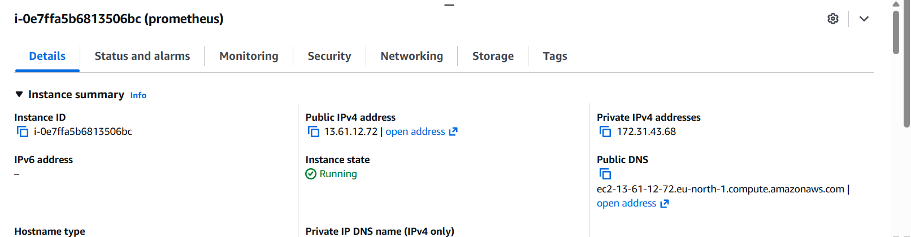

Login:
ssh -i key.pem ubuntu@<SERVER-IP>

Step 2 — Update Server
sudo apt update && sudo apt upgrade -y
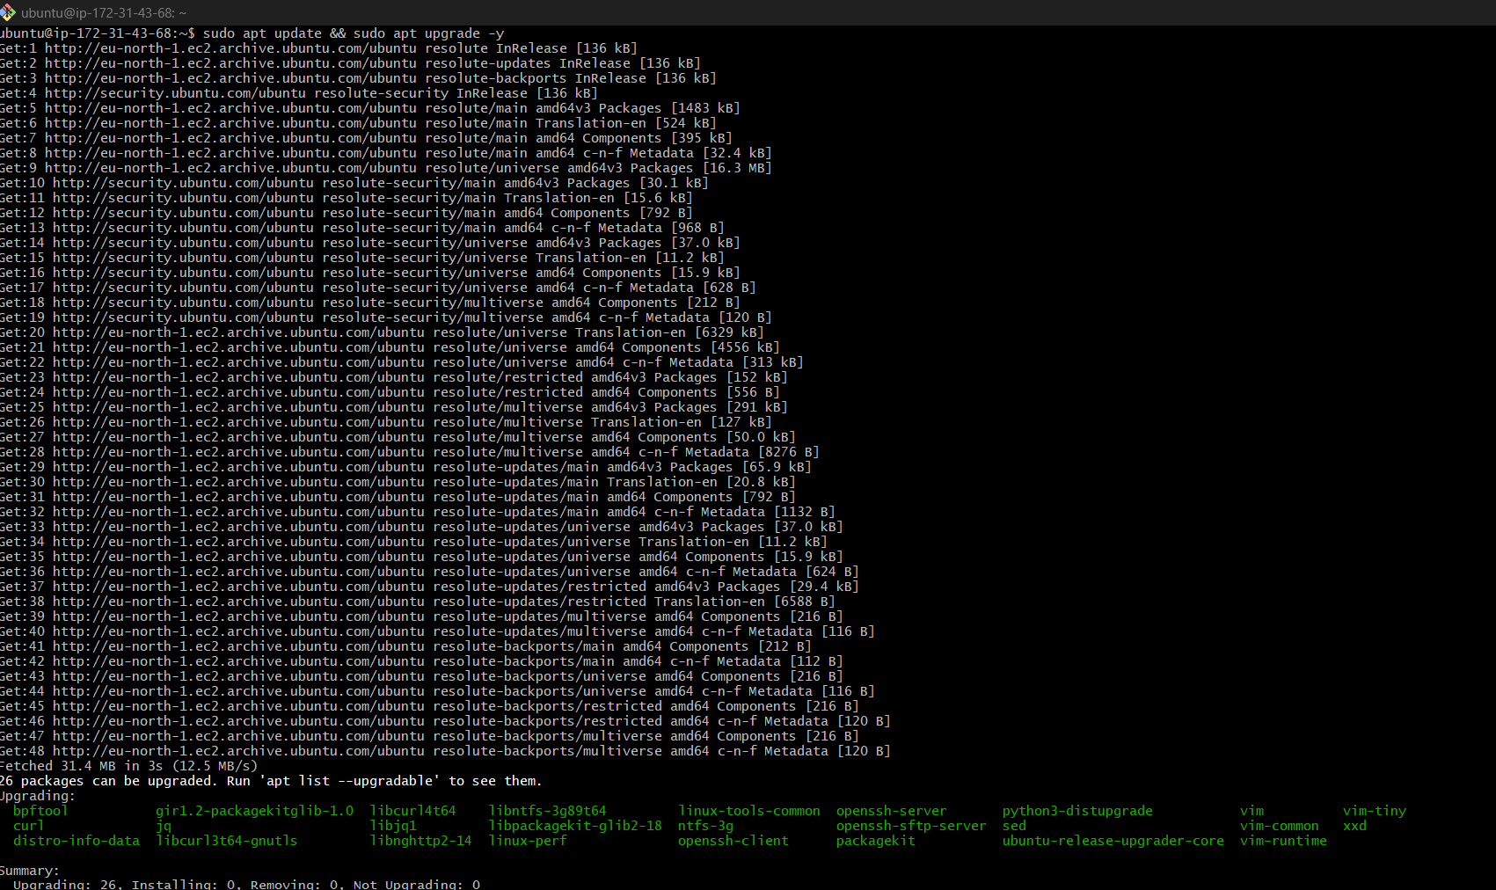
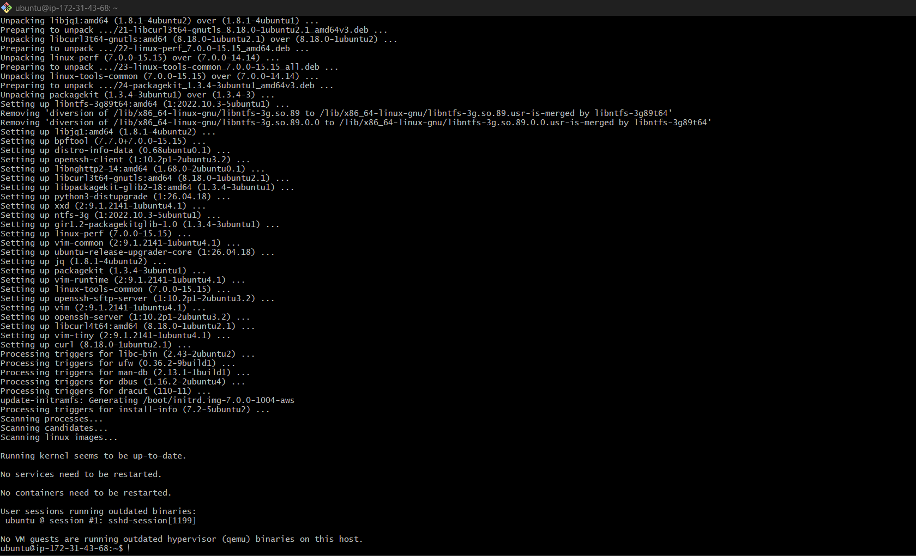

Install utilities:
sudo apt install wget curl tar unzip -y
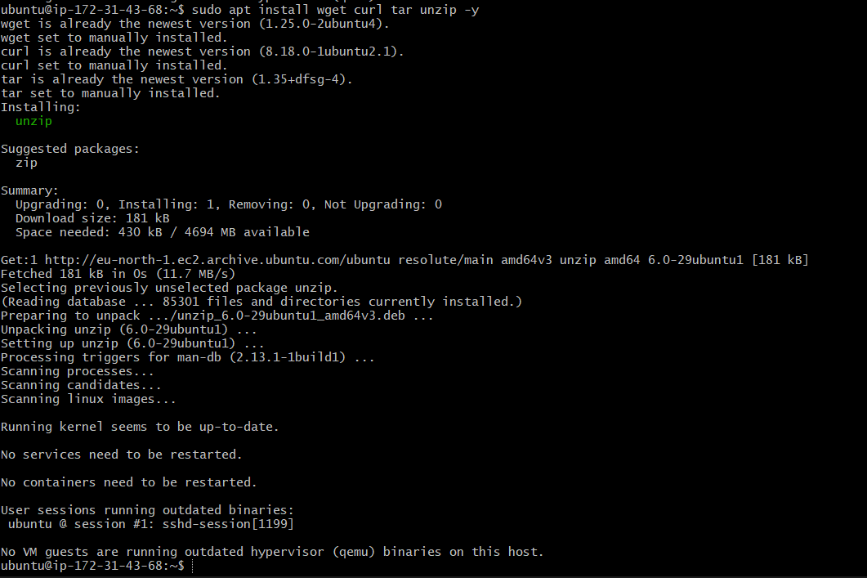

Step 3 — Create Prometheus User
Create dedicated service user:
sudo useradd --no-create-home --shell /bin/false Prometheus
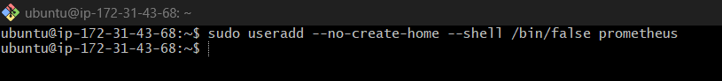
Create directories:
sudo mkdir /etc/prometheus
sudo mkdir /var/lib/Prometheus
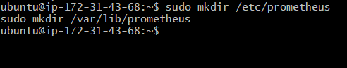
Set ownership:
sudo chown prometheus:prometheus /etc/prometheus
sudo chown prometheus:prometheus /var/lib/Prometheus

Step 4 — Download Prometheus
Go to /tmp:
cd /tmp
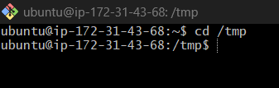
Download latest version:
wget https://github.com/prometheus/prometheus/releases/download/v3.11.3/prometheus-3.11.3.linux-amd64.tar.gz
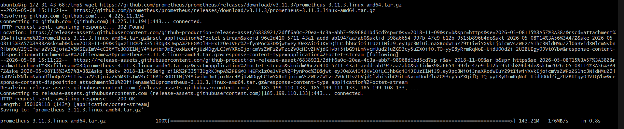
Extract:
tar -xvf prometheus-3.11.3.linux-amd64.tar.gz
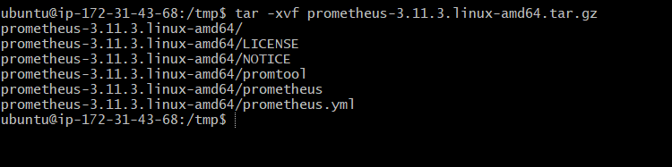
Move into folder:
cd prometheus-3.11.3.linux-amd64


Step 5 — Copy Prometheus Files
Copy binaries:
sudo cp prometheus /usr/local/bin/
sudo cp promtool /usr/local/bin/
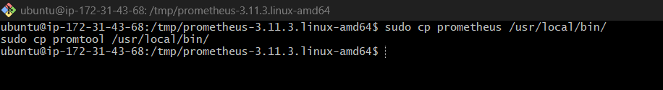
Set ownership:
sudo chown prometheus:prometheus /usr/local/bin/prometheus
sudo chown prometheus:prometheus /usr/local/bin/promtool
Copy consoles:
sudo cp -r consoles /etc/prometheus
sudo cp -r console_libraries /etc/Prometheus
Copy config:
sudo cp prometheus.yml /etc/prometheus/
Set permissions:
sudo chown -R prometheus:prometheus /etc/prometheus
sudo chown -R prometheus:prometheus /var/lib/Prometheus

Step 6 — Create prometheus.yml
Open config:
sudo nano /etc/prometheus/prometheus.yml
Replace with:
global:
scrape_interval: 15s
scrape_configs:
- job_name: 'prometheus'
static_configs:
- targets: ['localhost:9090']
- job_name: 'node-exporter'
static_configs:
- targets: ['localhost:9100']
Save and exit.
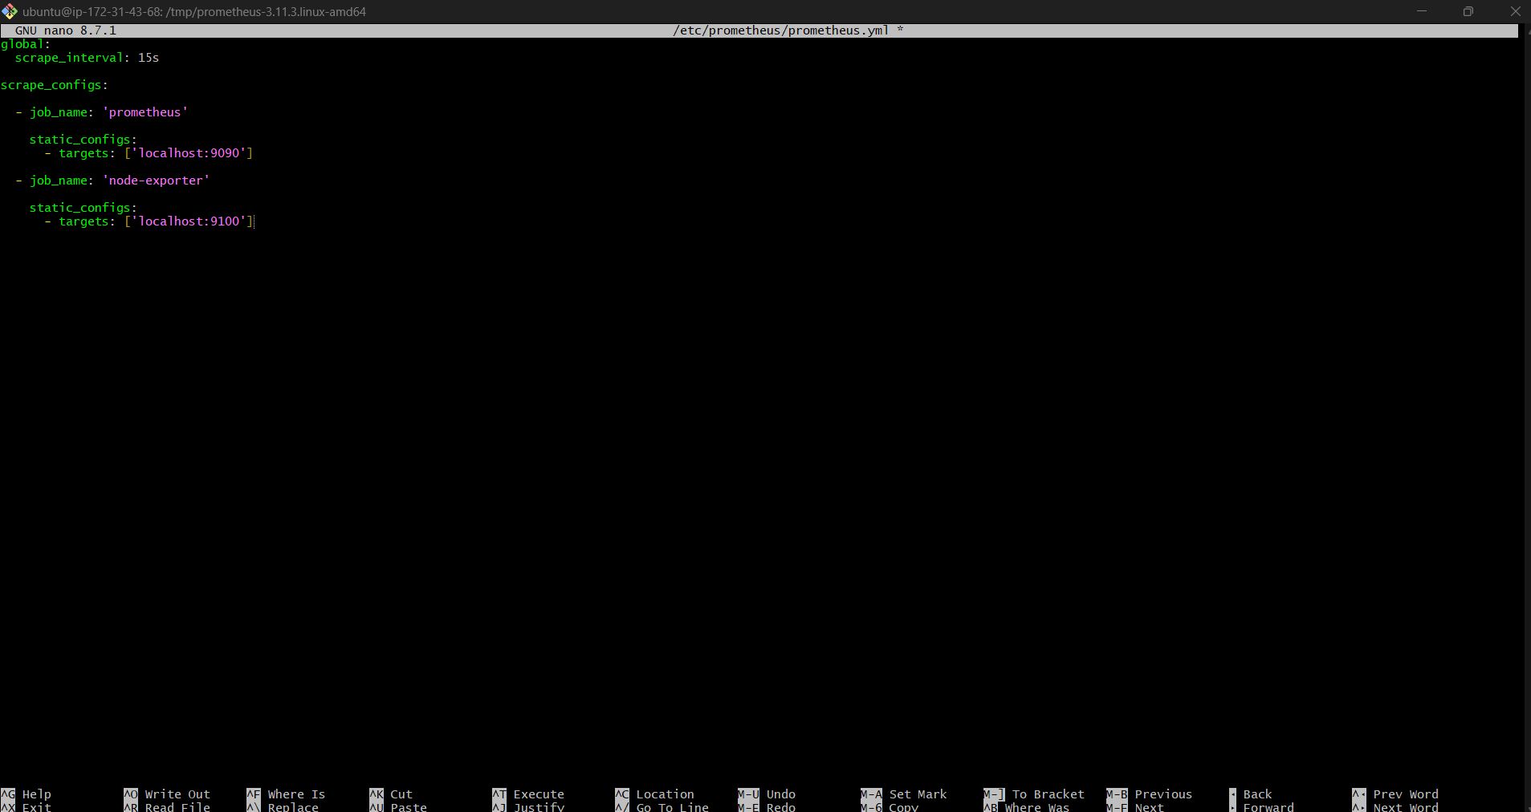

Step 7 — Validate Configuration
Run:
promtool check config /etc/prometheus/prometheus.yml
Expected:
SUCCESS: /etc/prometheus/prometheus.yml is valid
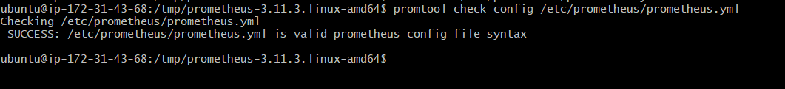

Step 8 — Create Systemd Service
Create service file:
sudo nano /etc/systemd/system/prometheus.service
Paste:
[Unit]
Description=Prometheus
Wants=network-online.target
After=network-online.target
[Service]
User=prometheus
Group=prometheus
Type=simple
ExecStart=/usr/local/bin/prometheus \
--config.file=/etc/prometheus/prometheus.yml \
--storage.tsdb.path=/var/lib/prometheus \
--web.console.templates=/etc/prometheus/consoles \
--web.console.libraries=/etc/prometheus/console_libraries
Restart=always
[Install]
WantedBy=multi-user.target
Save file.
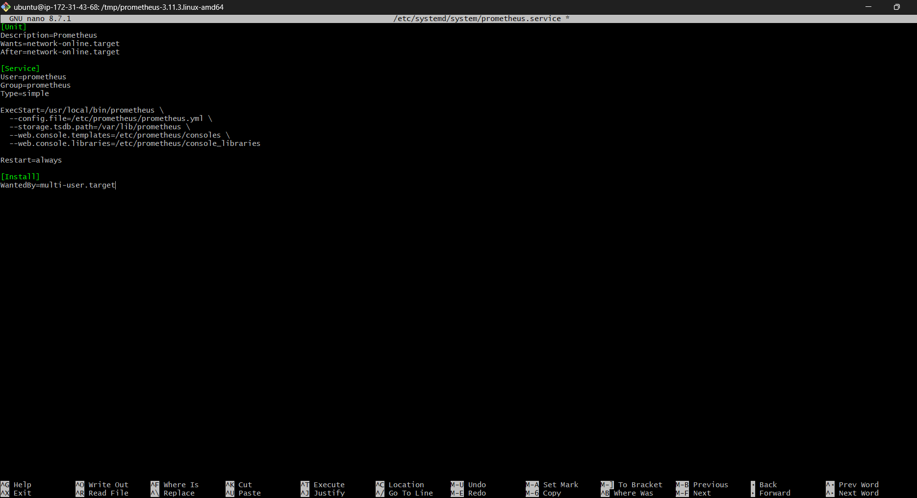

Step 9 — Reload Systemd
sudo systemctl daemon-reload

Enable Prometheus:
sudo systemctl enable Prometheus
Start Prometheus:
sudo systemctl start Prometheus
Check status:
sudo systemctl status prometheus
Expected:
active (running)
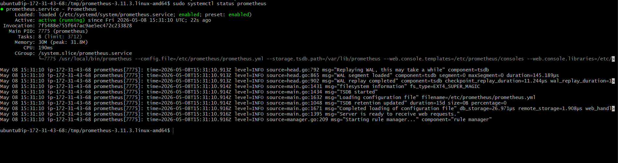

Step 10 — Open Firewall / Security Group
Allow:
- TCP 9090
If using AWS EC2:
Add inbound rule:
Type |  |  |  |  | Port |  |  |  |  |  |  |  | Source
Custom TCP |  |  |  |  | 9090 |  |  |  |  |  |  |  | 0.0.0.0/0
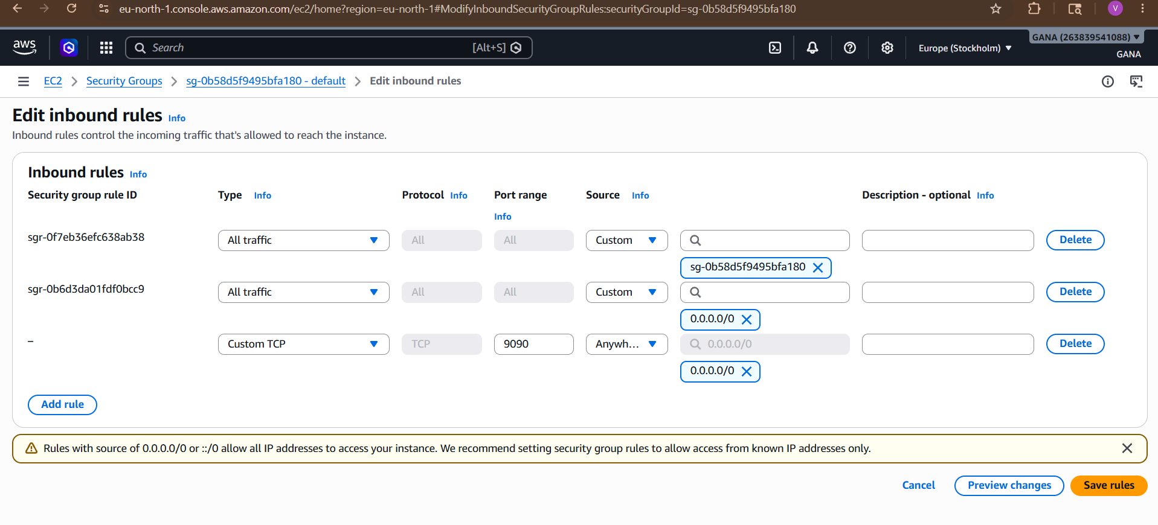

Step 11 — Access Prometheus UI
Open browser:
http://<SERVER-IP>:9090
http://13.61.12.72:9090

You should see the Prometheus dashboard.
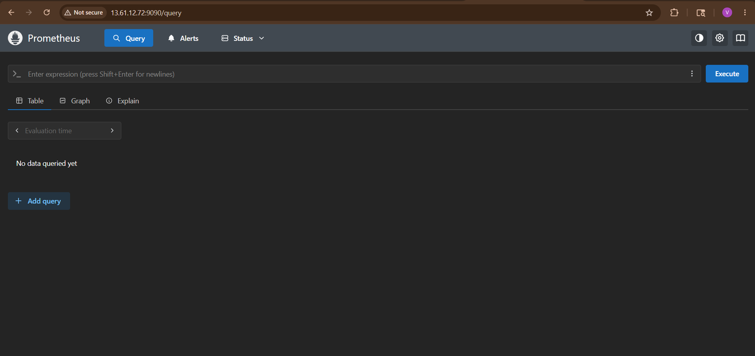

2. Install and configure Node Exporter for system monitoring.

Step 12 — Install Node Exporter
Prometheus collects metrics from exporters.
Create user:
sudo useradd --no-create-home --shell /bin/false node_exporter
Download:
cd /tmp
wget https://github.com/prometheus/node_exporter/releases/download/v1.11.1/node_exporter-1.11.1.linux-amd64.tar.gz
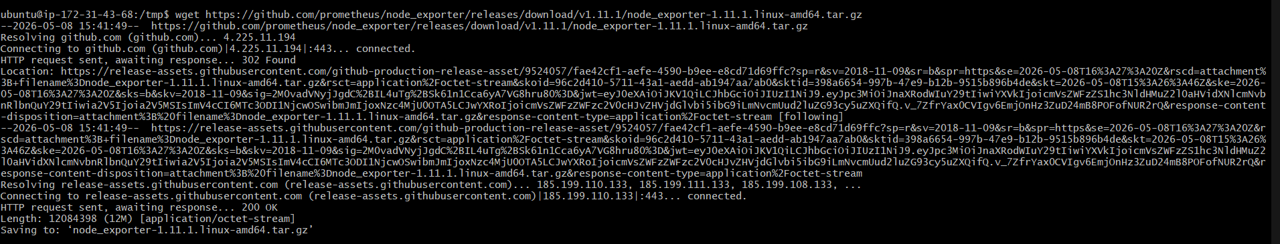
Extract:
tar -xvf node_exporter-1.11.1.linux-amd64.tar.gz
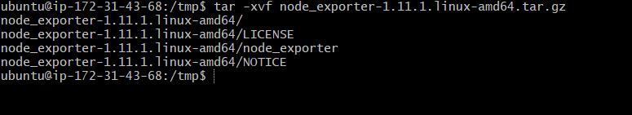
Go Inside
cd node_exporter-1.11.1.linux-amd64
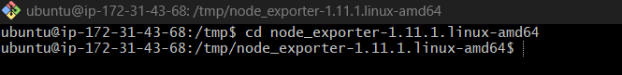

Verify
ls

Expected:
LICENSE
NOTICE
node_exporter
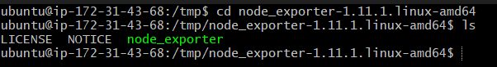

Continue Installation
Copy binary:
sudo cp node_exporter /usr/local/bin/
Set ownership:
sudo chown node_exporter:node_exporter /usr/local/bin/node_exporter
Then continue with service creation.

Step 13 — Create Node Exporter Service
Create service:
sudo nano /etc/systemd/system/node_exporter.service
Paste:
[Unit]
Description=Node Exporter
Wants=network-online.target
After=network-online.target
[Service]
User=node_exporter
Group=node_exporter
Type=simple
ExecStart=/usr/local/bin/node_exporter
Restart=always
[Install]
WantedBy=multi-user.target
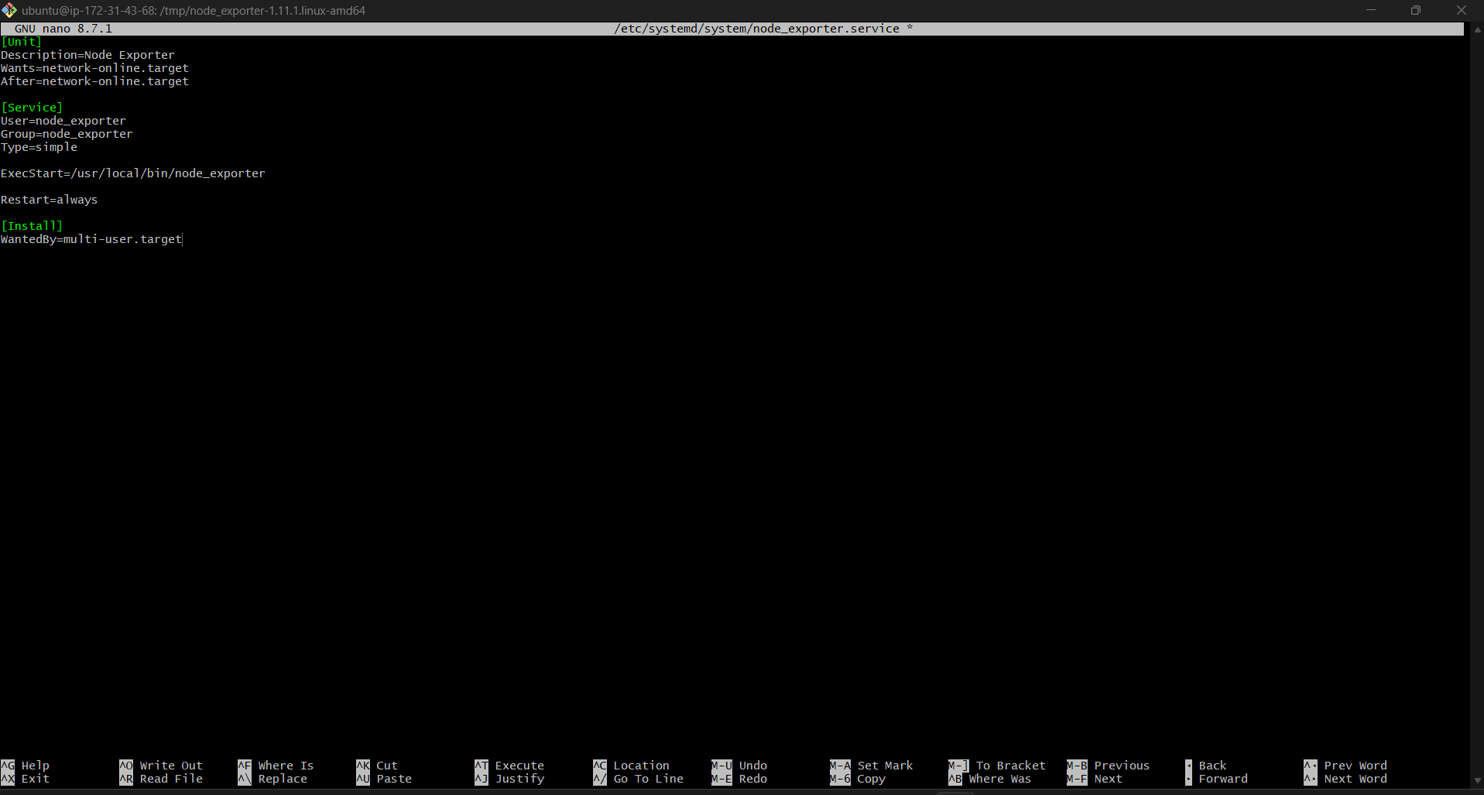

Step 14 — Start Node Exporter
Reload:
sudo systemctl daemon-reload
Enable service:
sudo systemctl enable node_exporter
Start:
sudo systemctl start node_exporter
Check:
sudo systemctl status node_exporter
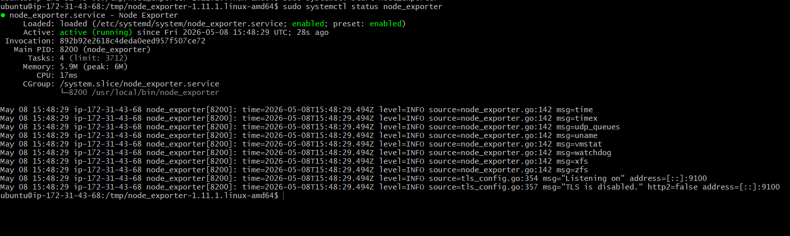

Step 15 — Verify Targets
Open:
http://<SERVER-IP>:9090/targets
http://13.61.12.72:9090/targets

Expected:
UP
for:
- prometheus
- node-exporter
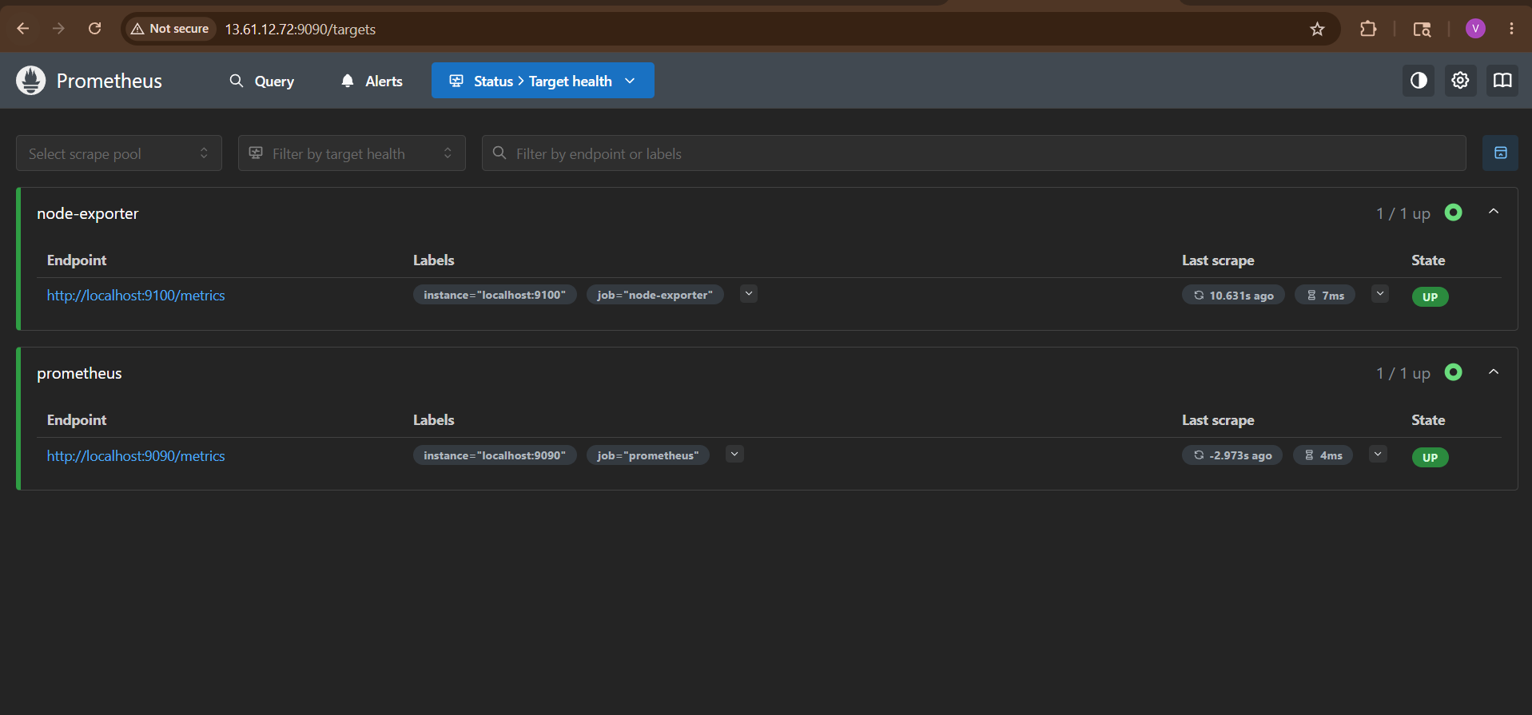
Step 16 — Test Metrics
Go to:
http://<SERVER-IP>:9090
Try queries:
CPU:
100 - (avg by(instance)(irate(node_cpu_seconds_total{mode="idle"}[5m])) * 100)
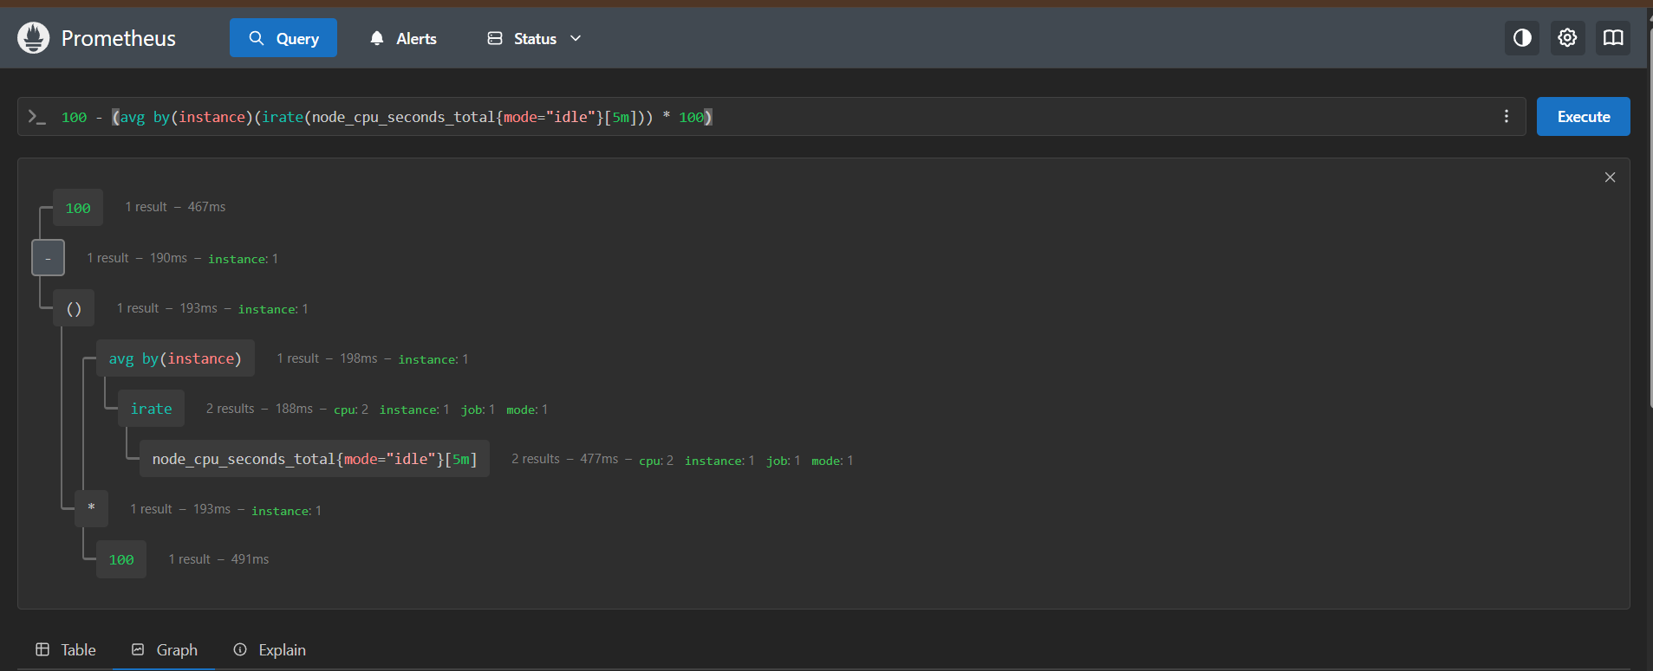

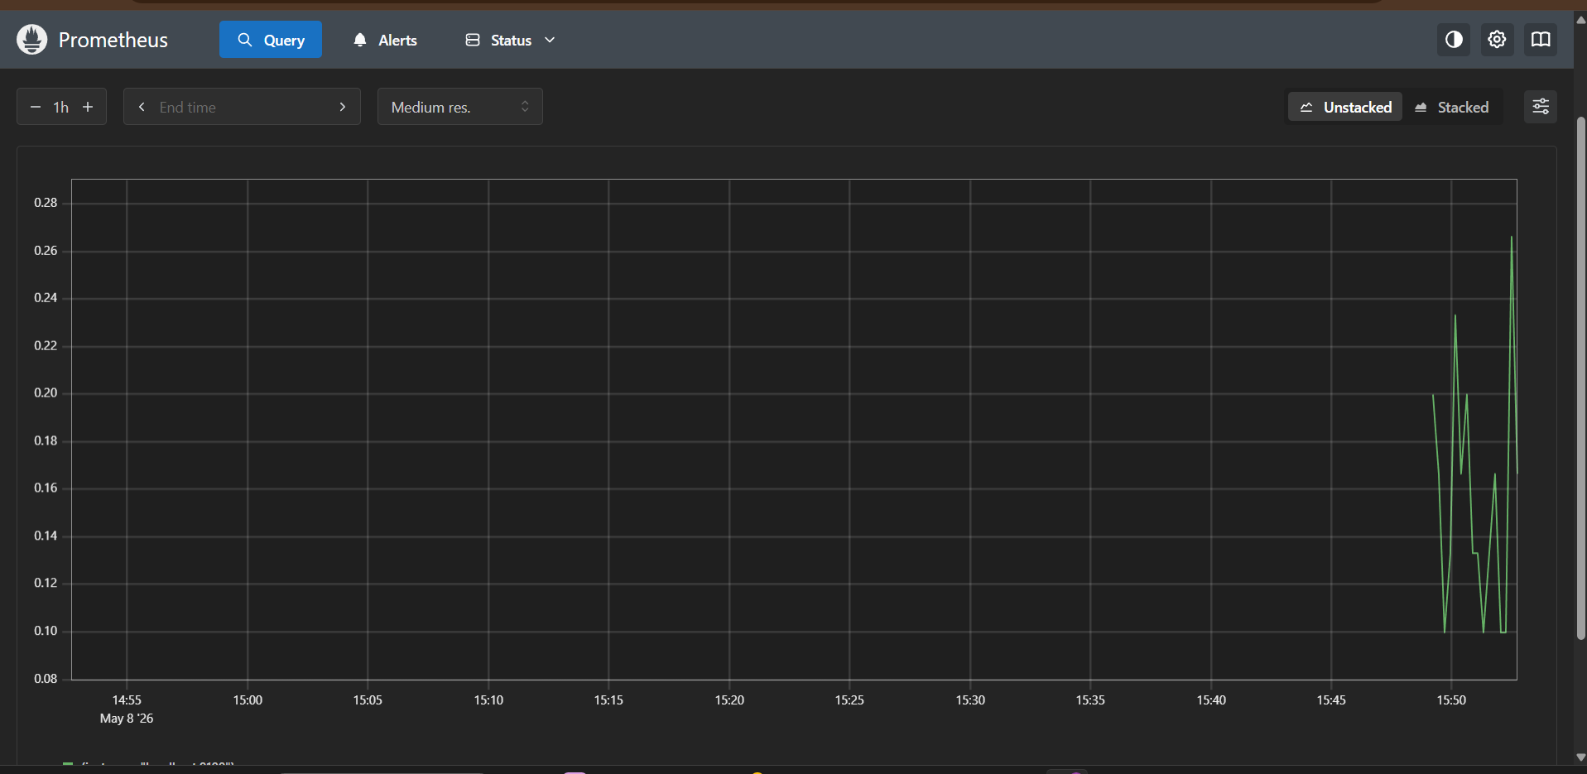

Memory:
(node_memory_MemTotal_bytes - node_memory_MemAvailable_bytes) / node_memory_MemTotal_bytes * 100
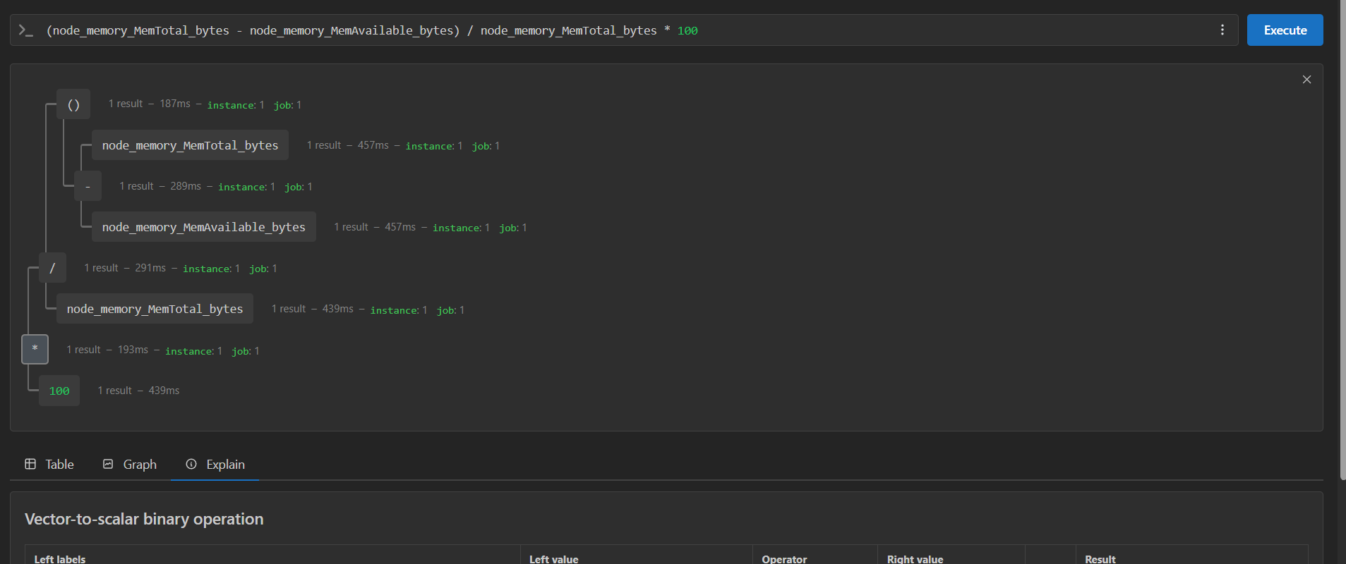

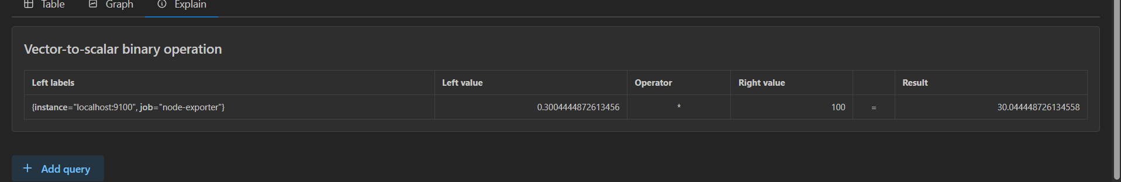

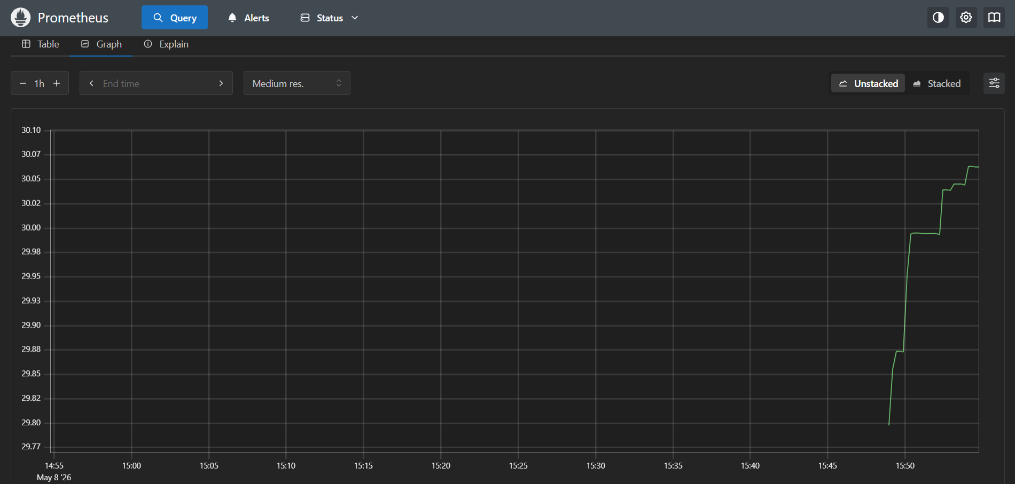

Disk:
(node_filesystem_size_bytes - node_filesystem_free_bytes) / node_filesystem_size_bytes * 100
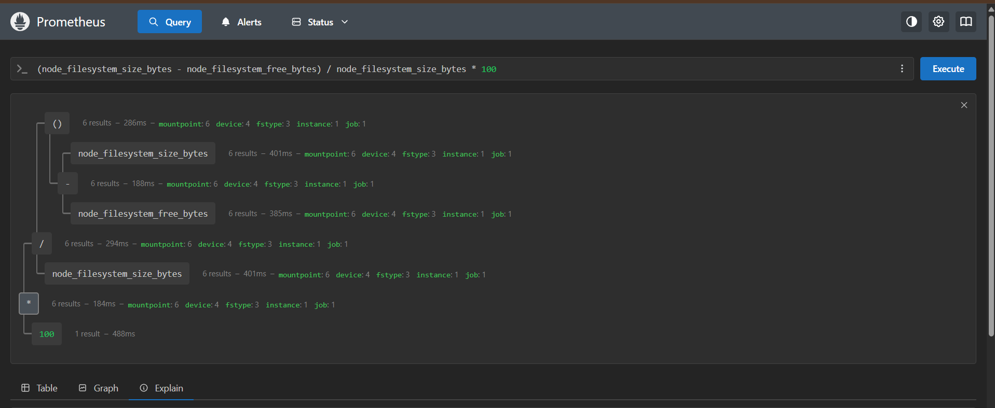

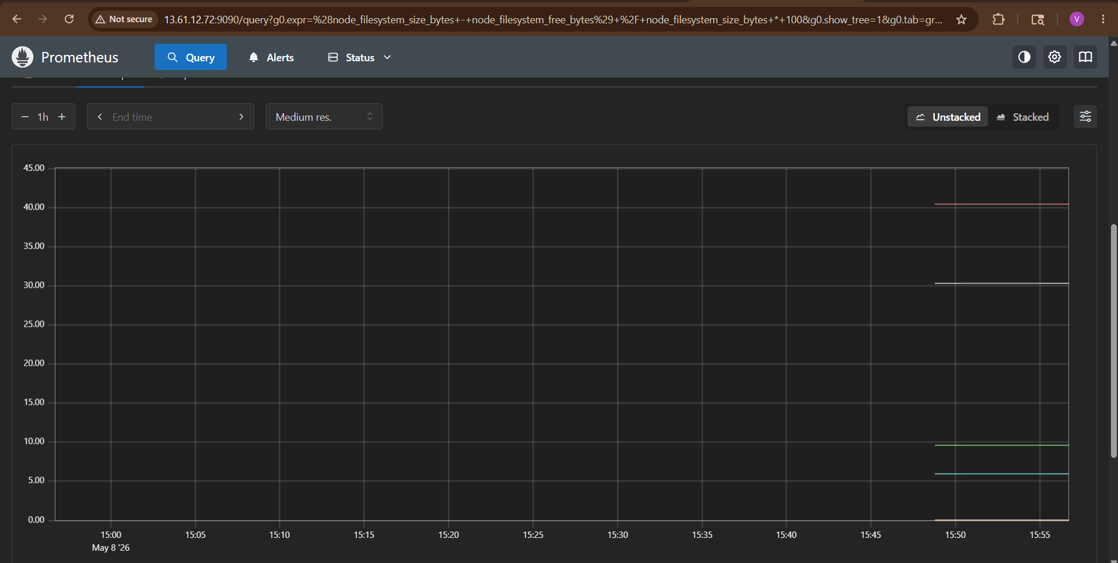

Important Prometheus Commands
Restart:
sudo systemctl restart prometheus
Logs:
journalctl -u prometheus -f
Reload config:
curl -X POST http://localhost:9090/-/reload

Common prometheus.yml Structure
global:
scrape_interval: 15s
rule_files:
- "alerts.yml"
scrape_configs:
- job_name: 'servers'
static_configs:
- targets:
- 10.0.1.10:9100
- 10.0.1.11:9100

Add Multiple Servers
Example:
- job_name: 'linux-servers'
static_configs:
- targets:
- '192.168.1.10:9100'
- '192.168.1.11:9100'
- '192.168.1.12:9100'
Restart:
sudo systemctl restart prometheus
Recommended stack:
- Prometheus
- Node Exporter
- Alertmanager
- Grafana
- Loki

Troubleshooting :
Port Already Used

Check:
sudo netstat -tulnp | grep 9090
Service Failed
Check logs:
journalctl -u prometheus -xe
Target DOWN
Check:
- Node exporter running?
- Port 9100 open?
- Security group/firewall?
- Correct IP?

Verify Everything
Prometheus
curl http://localhost:9090/-/healthy
Expected:
Prometheus is Healthy.
Node Exporter
curl http://localhost:9100/metrics
Expected:
- Huge metrics output
Final Result
You now have:
✅ Prometheus installed
✅ prometheus.yml configured
✅ Node Exporter configured
✅ Systemd services running
✅ Metrics scraping working
✅ Monitoring dashboard accessible on port 9090

3. Set up SNMP Exporter to monitor network devices.

Set Up SNMP Exporter to Monitor Network Devices (Step-by-Step)
This setup allows Prometheus to monitor:
- Routers
- Switches
- Firewalls
- Load balancers
- Printers
- Network appliances
using SNMP protocol.

Architecture
+-------------------+
| Prometheus |
| Port: 9090 |
+-------------------+
|
| Scrape Metrics
v
+-------------------+
| SNMP Exporter |
| Port: 9116 |
+-------------------+
|
| SNMP Queries
v
+-------------------+
| Network Device |
| Router / Switch |
| SNMP Port: 161 |
+-------------------+

Prerequisites
You already have:
✅ Prometheus installed
✅ prometheus.yml configured
✅ Linux server ready
Need:
- Ubuntu/Linux server
- Network device with SNMP enabled
- Access to device IP

Example device:
- Cisco Switch
- Fortigate Firewall
- Mikrotik
- Juniper
- Palo Alto
- HP Switch

Step 1 — Verify SNMP Enabled on Device
Example:
- Device IP: 192.168.1.1
- SNMP Version: v2c
- Community String: public

Step 2 — Install SNMP Utilities
On Prometheus server:
sudo apt update
sudo apt install snmp snmp-mibs-downloader -y
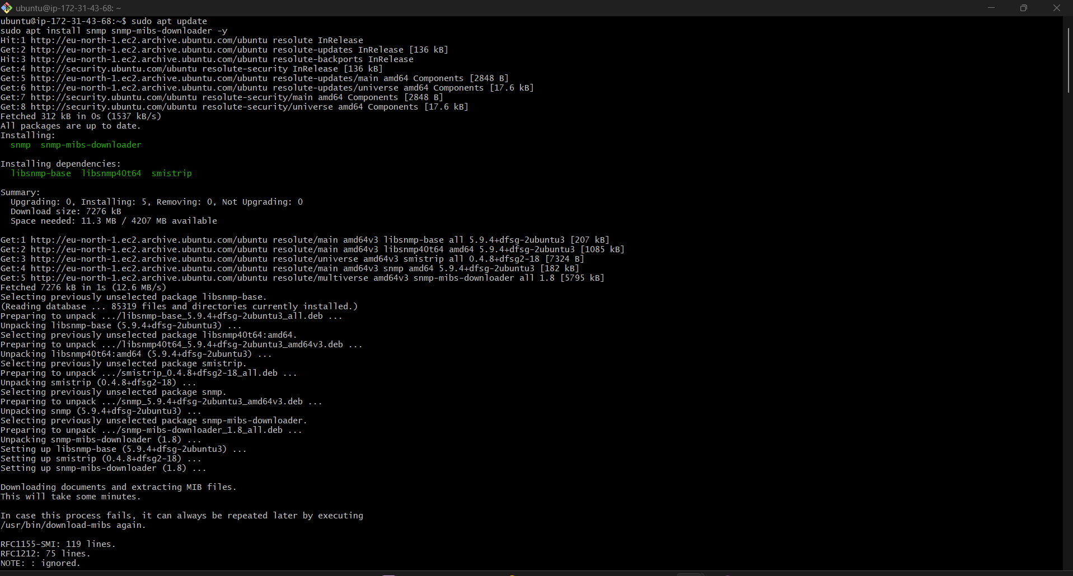
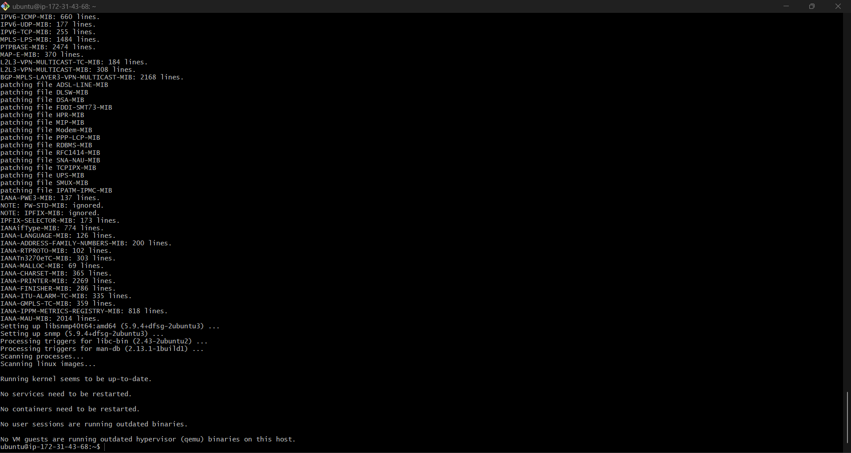
Verify SNMP connectivity:
snmpwalk -v2c -c public 13.61.12.72. system
The problem is now:
Timeout: No Response
That means SNMP service is not reachable on 13.61.12.72.

Usually one of these is the issue:
- SNMP daemon (snmpd) not running
- UDP 161 blocked
- Wrong SNMP config
- AWS Security Group blocking UDP 161
- SNMP listening only on localhost

Fix Step by Step
Go to the target server:
13.61.12.72
SSH into it.

Step 1 — Install SNMP
Run:
sudo apt update
sudo apt install snmp snmpd -y

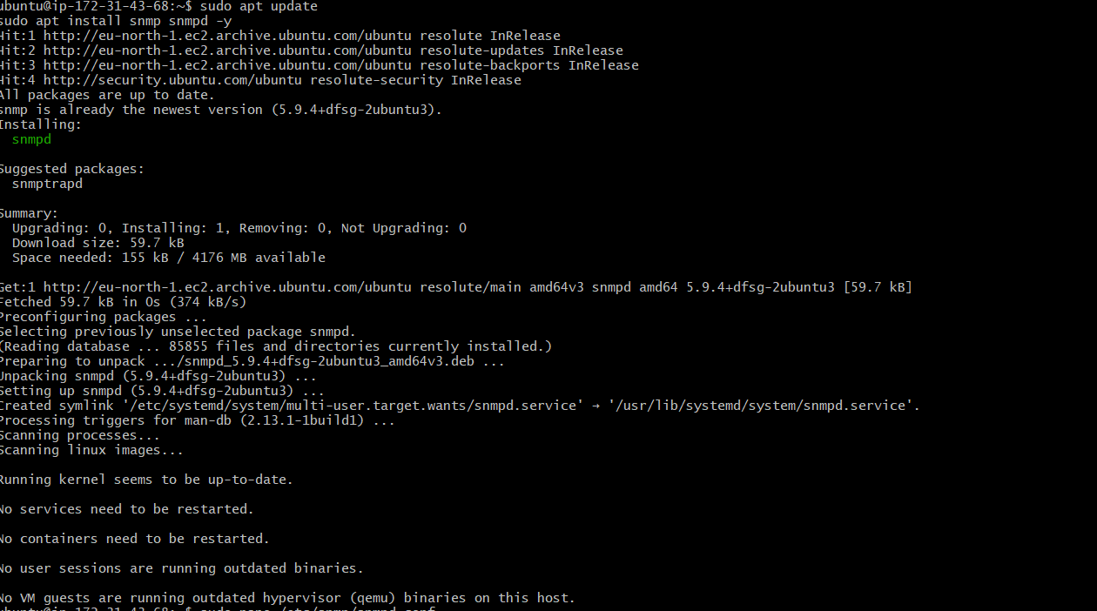

Step 2 — Configure SNMP
Open config:
sudo nano /etc/snmp/snmpd.conf
Comment this line if present:
agentAddress udp:127.0.0.1:161
Change/add:
agentAddress udp:161
Add this line:
rocommunity public

Example Minimal Working Config
Replace full file with:
rocommunity public
agentAddress udp:161
sysLocation AWS
sysContact Admin

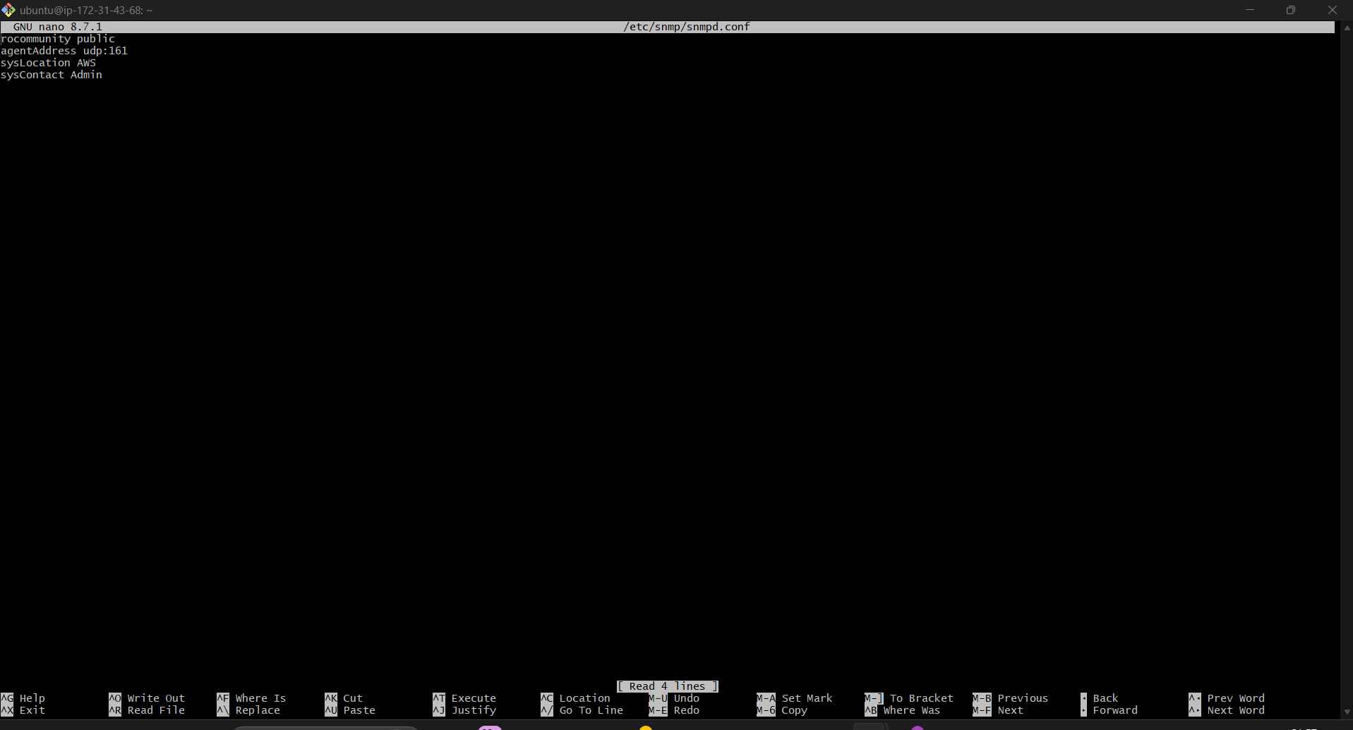

Step 3 — Restart SNMP
sudo systemctl restart snmpd
Enable:
sudo systemctl enable snmpd
Check:
sudo systemctl status snmpd
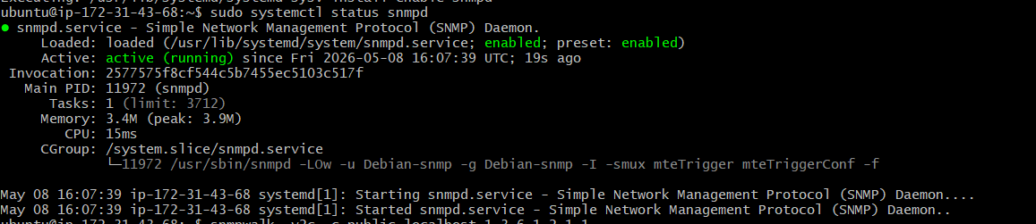
Expected:
active (running)
Step 4 — Verify SNMP Listening
Run:
sudo ss -tulnp | grep 161
Expected:
udp UNCONN 0 0 0.0.0.0:161
This is VERY important.
If you still see:
127.0.0.1:161
then SNMP is only listening locally.
Step 5 — Open AWS Security Group
On EC2:
Add inbound rule:
Type | Protocol | Port | Source
Custom UDP | UDP | 161 | Your Prometheus Server IP
Or temporarily:
0.0.0.0/0
for testing.

Step 6 — Test Locally on Target
Run ON the SNMP server itself:
snmpwalk -v2c -c public localhost 1.3.6.1.2.1.1
If this works:
- SNMP daemon is correct

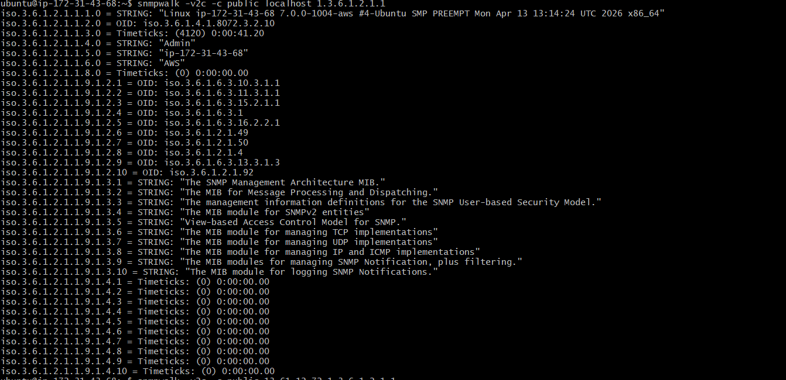
If remote still fails:
- firewall/security group issue

Step 7 — Test Remotely Again
From Prometheus server:
snmpwalk -v2c -c public 13.61.12.72 1.3.6.1.2.1.1
Now it should return SNMP data instead of timeout.
Expected:
- Device information output
If timeout:
- Check firewall
- Check SNMP enabled
- Check UDP 161 open
- Verify community string
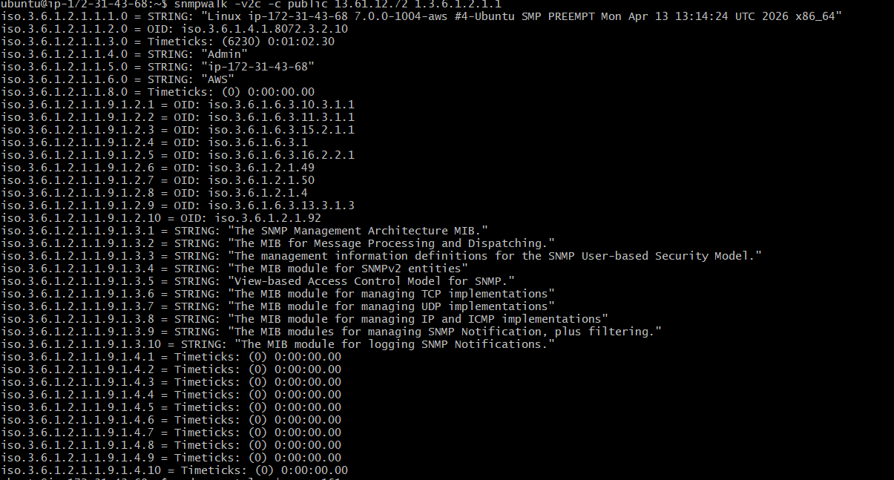

Step 3 — Create SNMP Exporter User
sudo useradd --no-create-home --shell /bin/false snmp_exporter
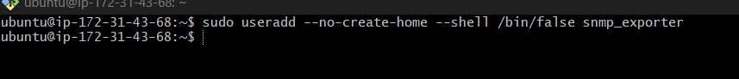

Step 4 — Download SNMP Exporter
Go to /tmp:
cd /tmp
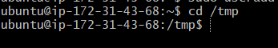

Download latest version:
wget https://github.com/prometheus/snmp_exporter/releases/download/v0.30.1/snmp_exporter-0.30.1.linux-amd64.tar.gz
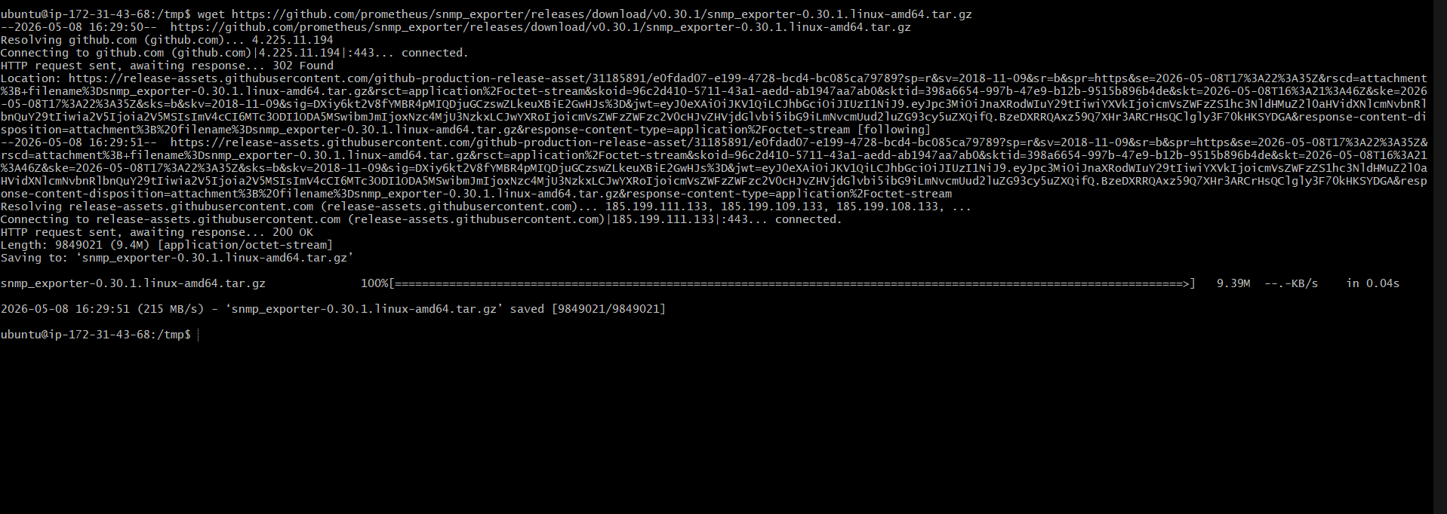
Extract:
tar -xvf snmp_exporter-0.30.1.linux-amd64.tar.gz
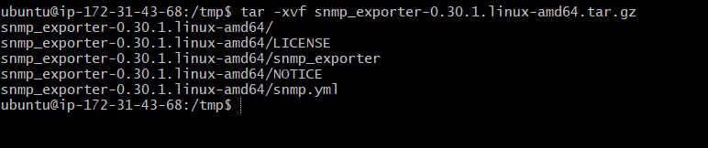
Enter directory:
cd snmp_exporter-0.30.1.linux-amd64

Step 5 — Copy Files
Verify
ls
Expected:
LICENSE
NOTICE
snmp.yml
snmp_exporter
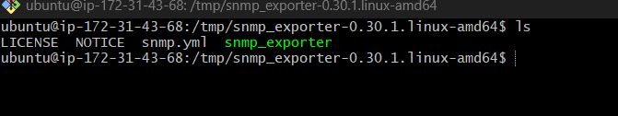

Continue
Copy files:
sudo cp snmp_exporter /usr/local/bin/
sudo mkdir -p /etc/snmp_exporter
sudo cp snmp.yml /etc/snmp_exporter/
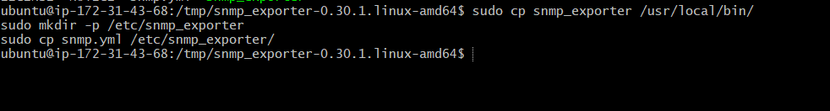
Set permissions:
sudo chown -R snmp_exporter:snmp_exporter /etc/snmp_exporter
sudo chown snmp_exporter:snmp_exporter /usr/local/bin/snmp_exporter
Then continue with service setup.

Step 6 — Create Systemd Service
Create service file:
sudo nano /etc/systemd/system/snmp_exporter.service
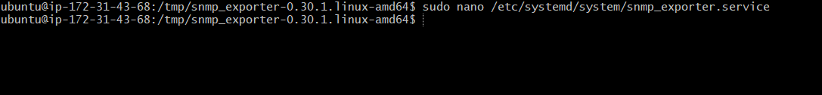
Paste:
[Unit]
Description=SNMP Exporter
After=network.target
[Service]
User=snmp_exporter
Group=snmp_exporter
Type=simple
ExecStart=/usr/local/bin/snmp_exporter \
--config.file=/etc/snmp_exporter/snmp.yml
Restart=always
[Install]
WantedBy=multi-user.target
Save file.
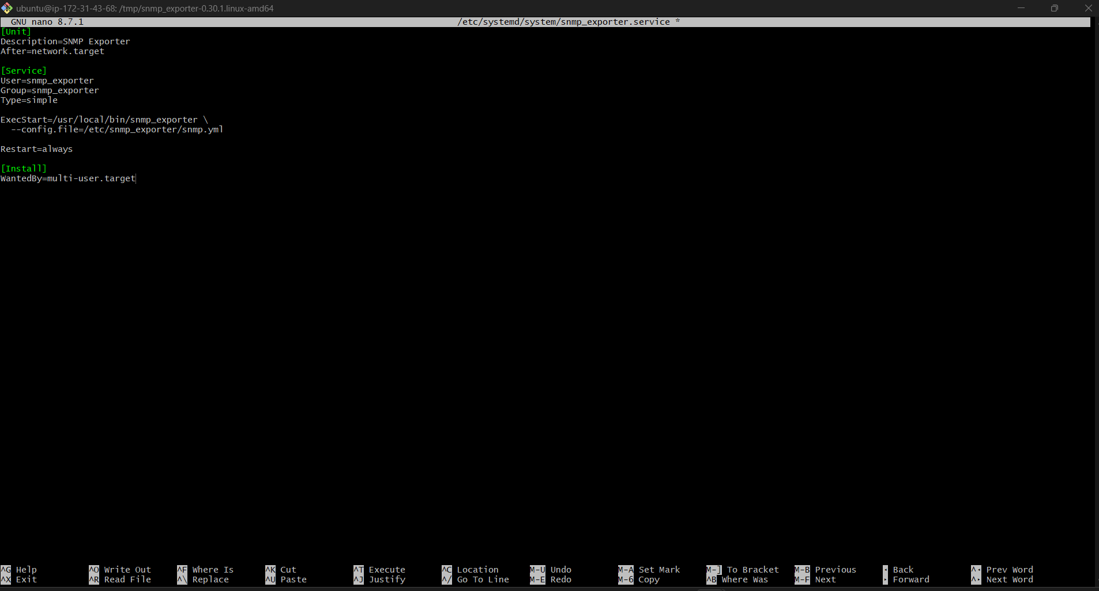

Step 7 — Start SNMP Exporter
Reload systemd:
sudo systemctl daemon-reload
Enable service:
sudo systemctl enable snmp_exporter
Start service:
sudo systemctl start snmp_exporter
Check status:
sudo systemctl status snmp_exporter
Expected:
active (running)
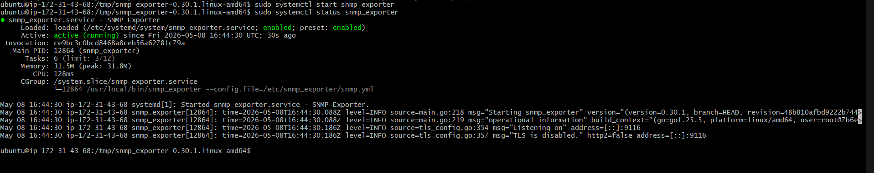

Step 8 — Verify SNMP Exporter
Open:
http://<SERVER-IP>:9116
http://13.61.12.72:9116/

You should see exporter page.
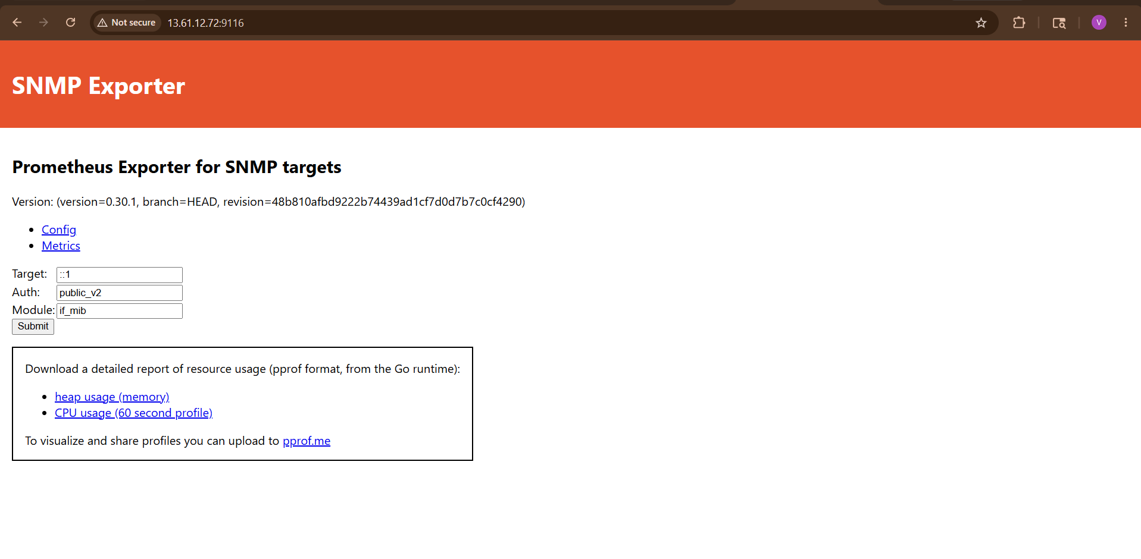

Step 9 — Configure prometheus.yml
Edit Prometheus config:
sudo nano /etc/prometheus/prometheus.yml

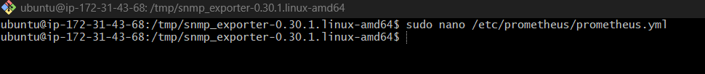

Add SNMP job:
- job_name: 'snmp'
static_configs:
- targets:
- 192.168.1.1 #Change With Your Public IP
metrics_path: /snmp
params:
module: [if_mib]
relabel_configs:
- source_labels: [__address__]
target_label: __param_target
- source_labels: [__param_target]
target_label: instance
- target_label: __address__
replacement: localhost:9116
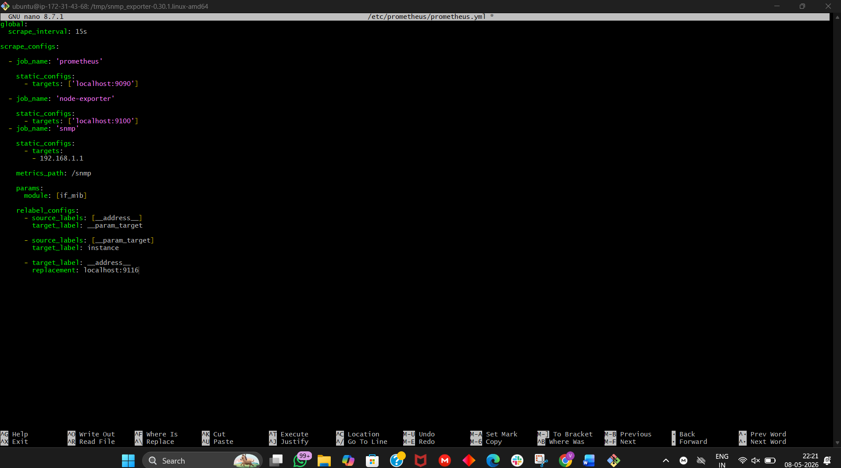

Step 10 — Validate Config
promtool check config /etc/prometheus/prometheus.yml
Expected:
SUCCESS
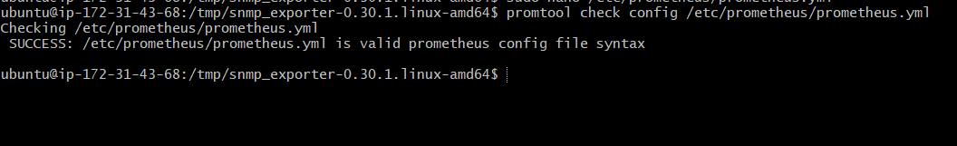

Step 11 — Restart Prometheus
sudo systemctl restart Prometheus

Step 12 — Verify Targets
Open:
http://<SERVER-IP>:9090/targets
Expected:
- snmp target = UP
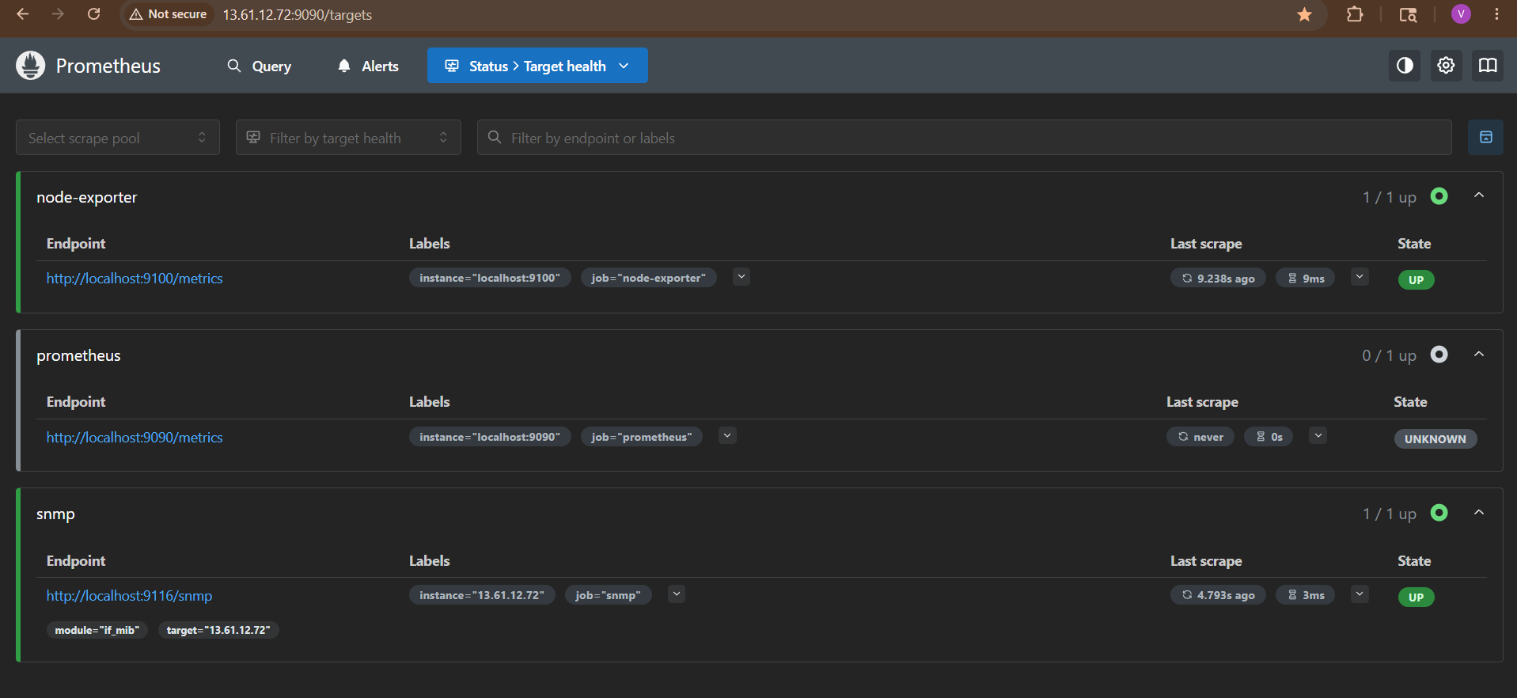

Step 13 — Test Metrics
Go to Prometheus UI:
http://<SERVER-IP>:9090
Try queries:
Interface traffic:
ifHCInOctets
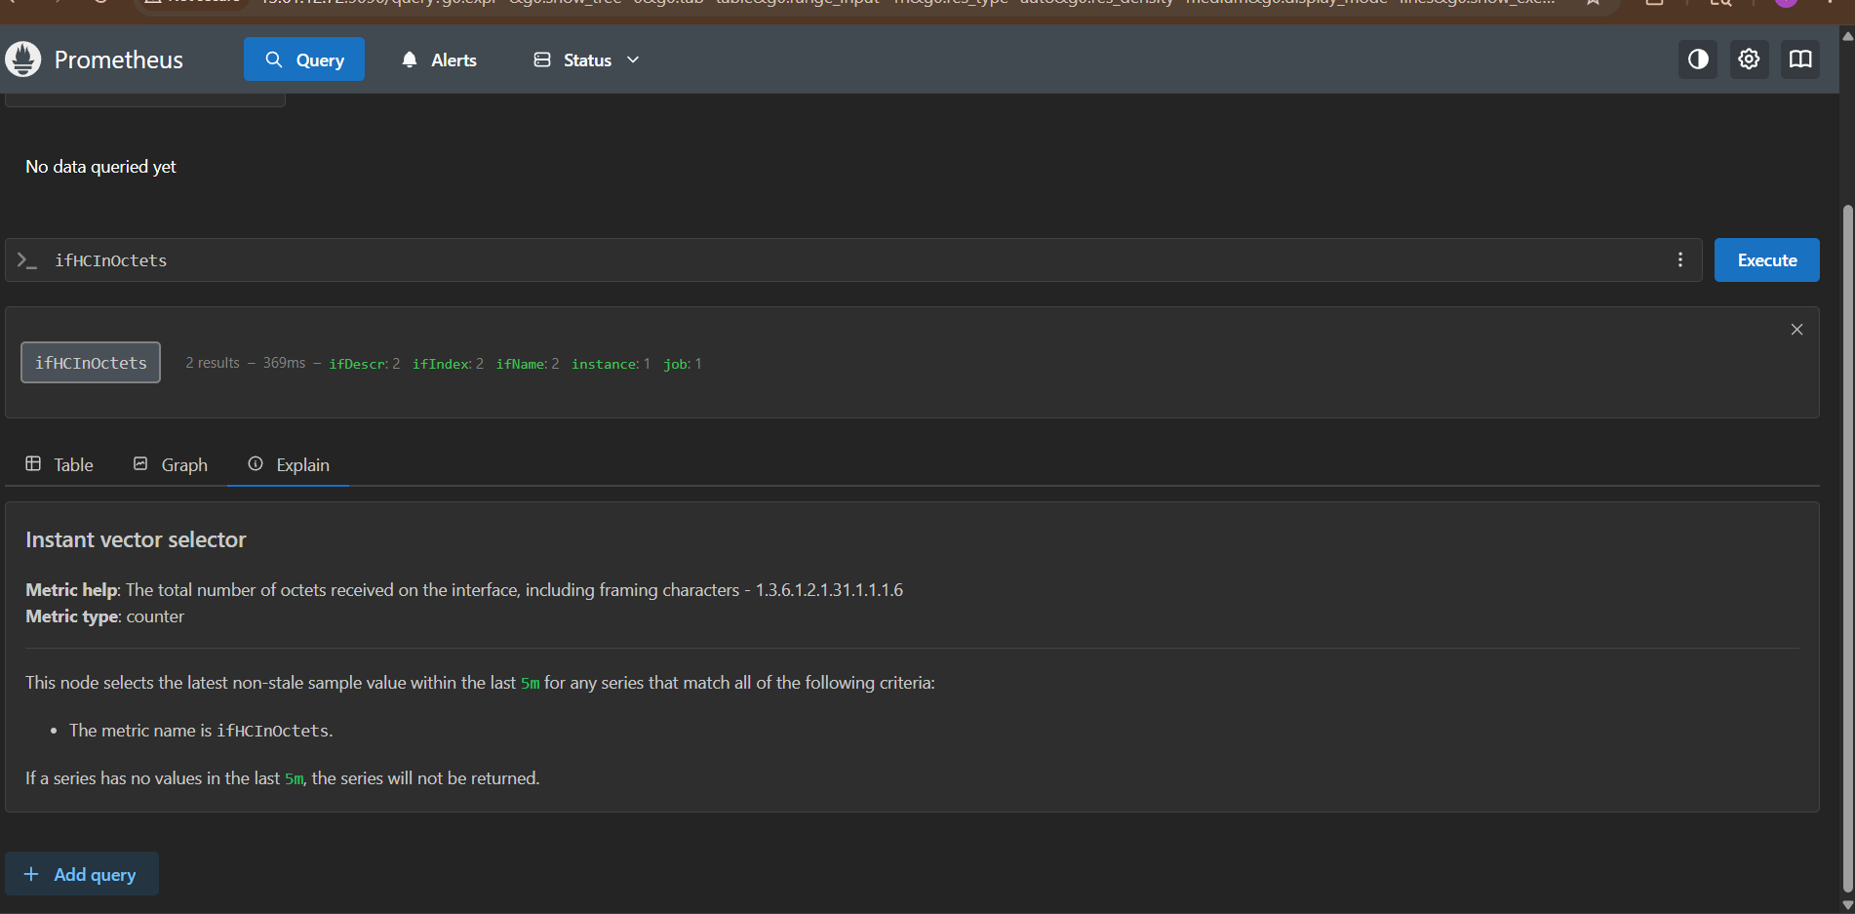

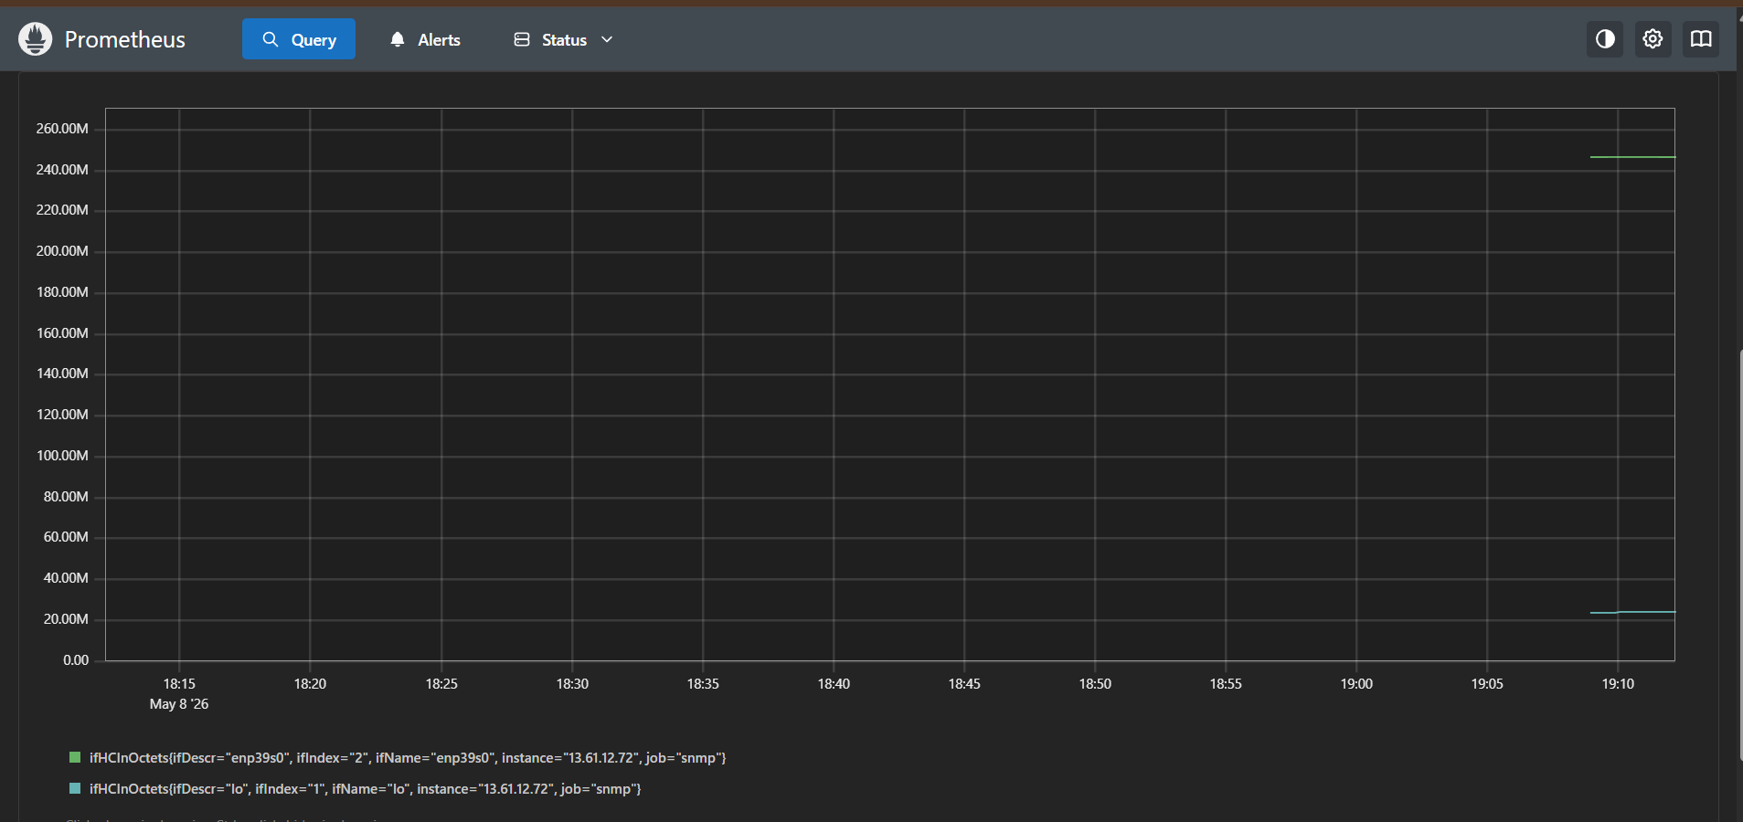

CPU:
hrProcessorLoad
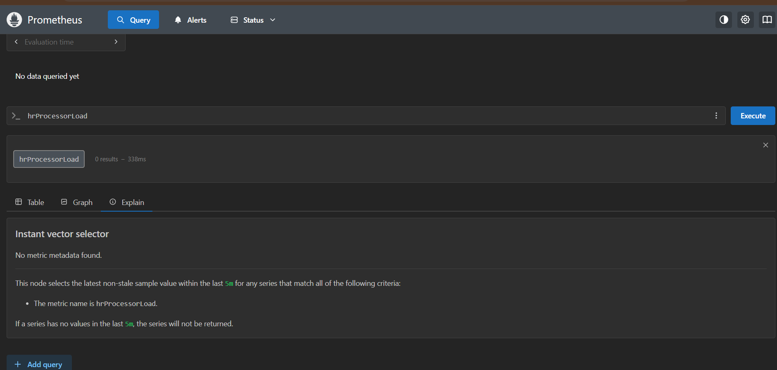
Memory:
hrStorageUsed
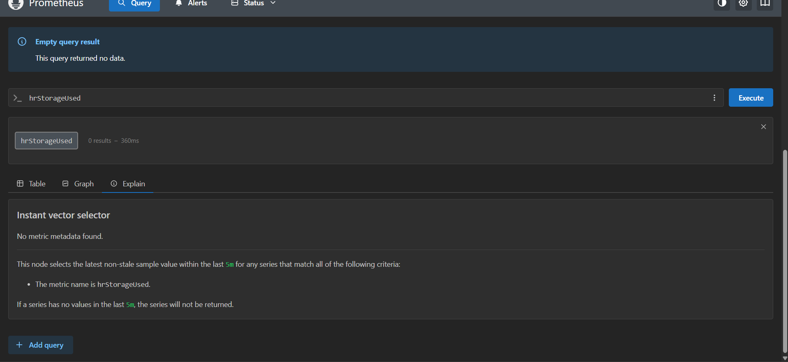

Important SNMP Metrics
Metric | Meaning
ifInOctets | Incoming traffic
ifOutOctets | Outgoing traffic
ifOperStatus | Interface status
ifAdminStatus | Admin status
hrProcessorLoad | CPU usage
hrStorageUsed | Memory usage

Common SNMP Modules
Inside snmp.yml:
Module | Use
if_mib | Network interfaces
system | System info
hrSystem | CPU/memory
cisco | Cisco devices
juniper | Juniper devices

Monitor Multiple Devices
Example:
static_configs:
- targets:
- 192.168.1.1
- 192.168.1.2
- 192.168.1.3

SNMP Versions
Version | Authentication
v1 | Basic
v2c | Community string
v3 | Secure authentication

SNMP v3 Example
params:
module: [if_mib]
auth: [my_secure_auth]

Firewall Rules
Allow:
- UDP 161 → SNMP device
- TCP 9116 → SNMP Exporter
- TCP 9090 → Prometheus
Troubleshooting
SNMP Timeout
Test:
snmpwalk -v2c -c public 192.168.1.1
Check:
- SNMP enabled?
- Community string?
- Firewall?
- Device reachable?
Target DOWN
Check exporter logs:
journalctl -u snmp_exporter -f
Config Error
Validate:
promtool check config /etc/prometheus/prometheus.yml
Real Production Stack
Routers/Switches
|
SNMP
|
SNMP Exporter
|
Prometheus
|
Grafana
|
Alertmanager

Final Result
You now have:
✅ SNMP Exporter installed
✅ Network devices monitored
✅ Prometheus scraping SNMP metrics
✅ Router/switch metrics visible
✅ Ready for Grafana dashboards

4. Set up Prometheus to run as a systemd service for automatic startup.

Running Prometheus as a systemd service ensures:
✅ Starts automatically after reboot
✅ Runs in background
✅ Auto-restarts on failure
✅ Managed using systemctl
✅ Production-ready setup

Architecture
Linux Server
|
systemd
|
Prometheus Service
|
Port 9090

Prerequisites
You already installed:
- Prometheus binary
- prometheus.yml

Example paths:
Item | Path
Prometheus binary | /usr/local/bin/prometheus
Config file | /etc/prometheus/prometheus.yml
Data directory | /var/lib/prometheus

Step 1 — Create Prometheus User
Create dedicated service account:
sudo useradd --no-create-home --shell /bin/false Prometheus
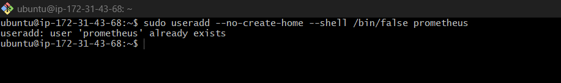

Step 2 — Create Required Directories
sudo mkdir -p /etc/prometheus
sudo mkdir -p /var/lib/Prometheus
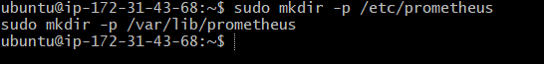

Step 3 — Set Permissions
sudo chown -R prometheus:prometheus /etc/prometheus
sudo chown -R prometheus:prometheus /var/lib/prometheus
sudo chown prometheus:prometheus /usr/local/bin/Prometheus

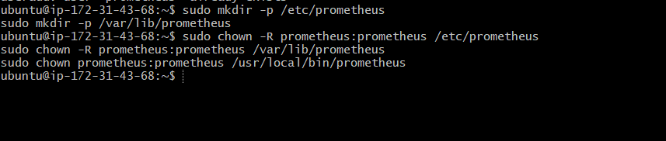

Step 4 — Create systemd Service File
Create:
sudo nano /etc/systemd/system/prometheus.service
Paste:
[Unit]
Description=Prometheus Monitoring System
Documentation=https://prometheus.io/docs/introduction/overview/
Wants=network-online.target
After=network-online.target
[Service]
User=prometheus
Group=prometheus
Type=simple
ExecStart=/usr/local/bin/prometheus \
--config.file=/etc/prometheus/prometheus.yml \
--storage.tsdb.path=/var/lib/prometheus \
--web.console.templates=/etc/prometheus/consoles \
--web.console.libraries=/etc/prometheus/console_libraries
Restart=always
RestartSec=5
LimitNOFILE=65536
[Install]
WantedBy=multi-user.target
Save file.
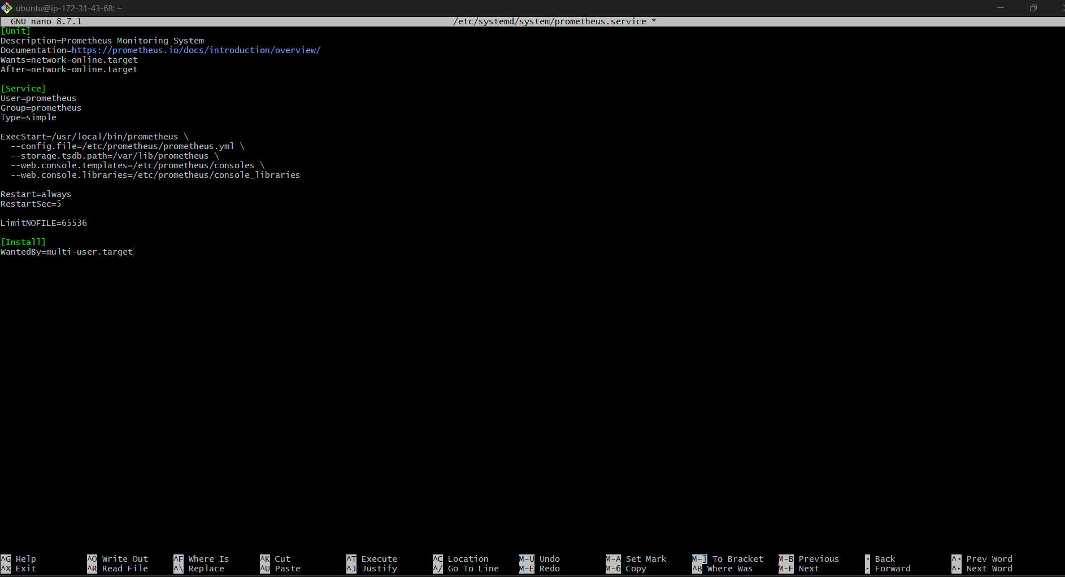

Step 5 — Reload systemd
Whenever new service created:
sudo systemctl daemon-reload


Step 6 — Enable Prometheus Service
Enable automatic startup during boot:
sudo systemctl enable prometheus
Expected:
Created symlink ...

Step 7 — Start Prometheus
sudo systemctl start Prometheus
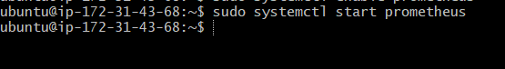

Step 8 — Verify Service Status
sudo systemctl status prometheus
Expected:
active (running)
Example:
● prometheus.service - Prometheus Monitoring System
Loaded: loaded
Active: active (running)
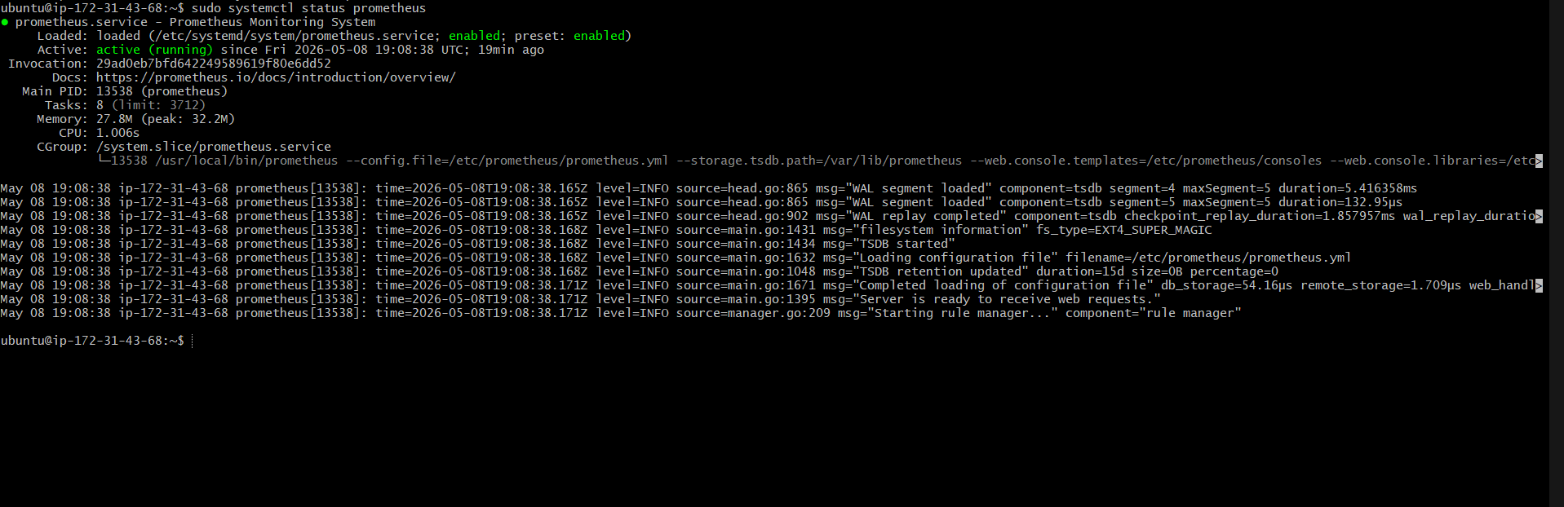

Step 9 — Verify Port 9090
Check listening port:
sudo netstat -tulnp | grep 9090
Or:
ss -tulnp | grep 9090
Expected:
LISTEN 0 4096 *:9090
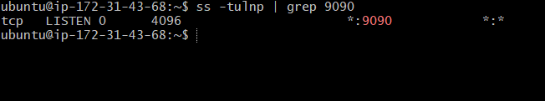

Step 10 — Access Prometheus UI
Open browser:
http://<SERVER-IP>:9090
http://13.61.12.72:9090/query

You should see Prometheus dashboard.
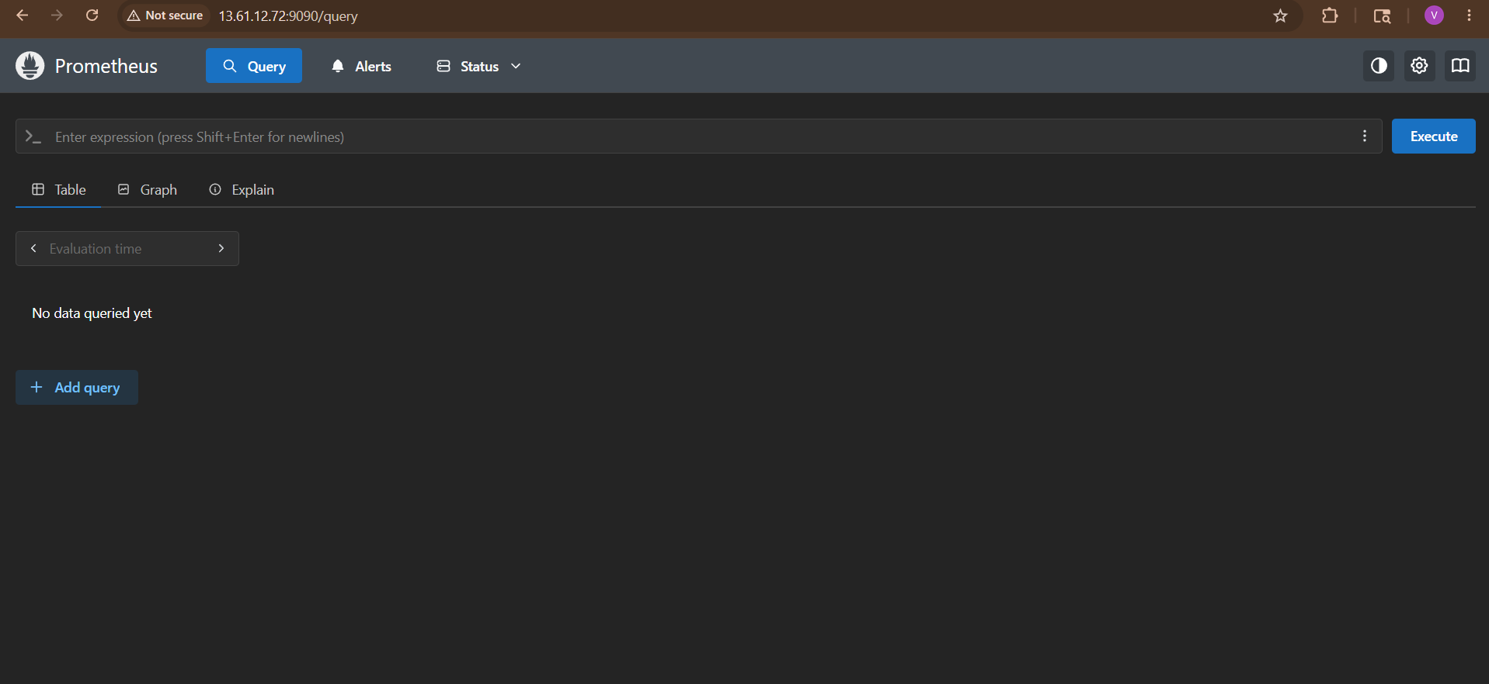

Important systemctl Commands
Start Service
sudo systemctl start Prometheus
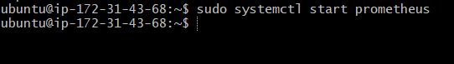

Stop Service
sudo systemctl stop Prometheus
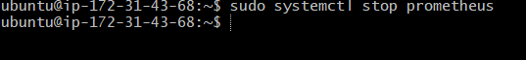

Restart Service
sudo systemctl restart Prometheus

Check Status
sudo systemctl status prometheus

Enable Auto Start
sudo systemctl enable prometheus

Disable Auto Start
sudo systemctl disable prometheus

Step 11 — Check Logs
View logs:
journalctl -u prometheus -f
Recent logs:
journalctl -u prometheus --since today

Step 12 — Verify Automatic Startup
Reboot server:
sudo reboot
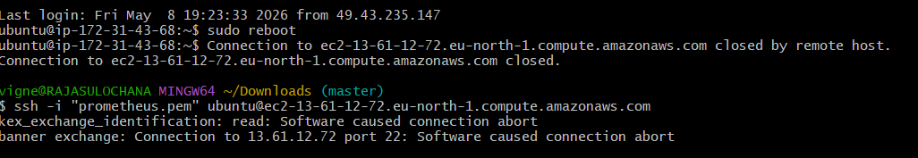

After reboot:
sudo systemctl status prometheus
Expected:
active (running)
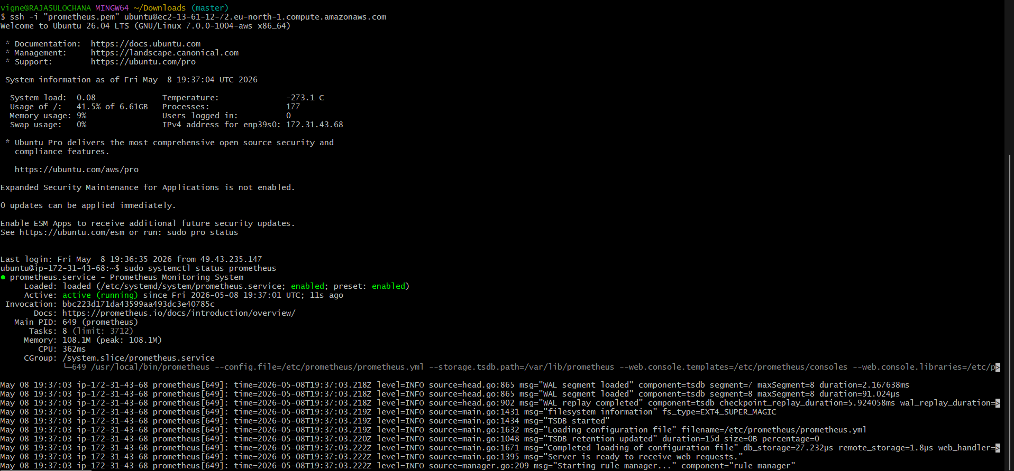

Troubleshooting
Service Failed
Check logs:
journalctl -xeu prometheus

Config Error
Validate:
promtool check config /etc/prometheus/prometheus.yml

Port Already Used
Check:
sudo lsof -i :9090
Kill process if needed:
sudo kill -9 <PID>

Permission Denied
Fix ownership:
sudo chown -R prometheus:prometheus /etc/prometheus
sudo chown -R prometheus:prometheus /var/lib/prometheus

Production Service Example
Advanced example:
Restart=always
RestartSec=5
LimitNOFILE=65536

Benefits:
- Auto restart after crash
- Better file handling
- Stable production operation

Final Result
You now have:
✅ Prometheus running as systemd service
✅ Automatic startup after reboot
✅ Managed via systemctl
✅ Production-ready service setup
✅ Logs accessible via journalctl

5. Install Alertmanager and configure an email alert.
Install Alertmanager and Configure Email Alerts (Step-by-Step)
Alertmanager handles alerts sent by Prometheus and can send notifications through:
- Email
- Slack
- PagerDuty
- Teams
- Webhooks
In this setup:
- Prometheus detects issue
- Alertmanager sends email alert

Architecture
Node Exporter
|
Prometheus
|
Alert Rules
|
Alertmanager
|
Email Notification
Prerequisites
Already installed:
✅ Prometheus
✅ Node Exporter
✅ prometheus.yml
✅ systemd services

Need:
- Gmail account (or SMTP server)
- App password for Gmail

Step 1 — Create Alertmanager User
sudo useradd --no-create-home --shell /bin/false alertmanager
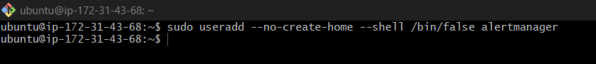

Step 2 — Create Directories
sudo mkdir /etc/alertmanager
sudo mkdir /var/lib/alertmanager
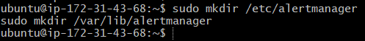

Step 3 — Download Alertmanager
Go to /tmp:
cd /tmp
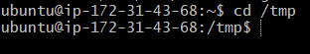
Download latest:
wget https://github.com/prometheus/alertmanager/releases/download/v0.28.1/alertmanager-0.28.1.linux-amd64.tar.gz
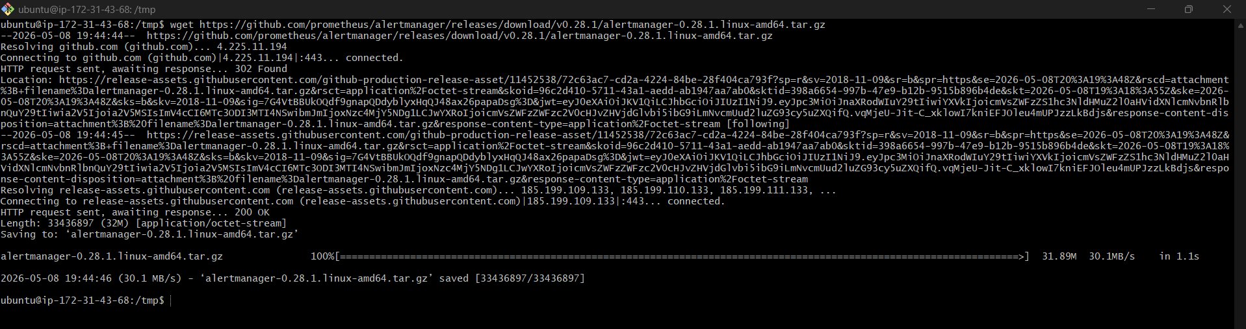
Extract:
tar -xvf alertmanager-0.28.1.linux-amd64.tar.gz
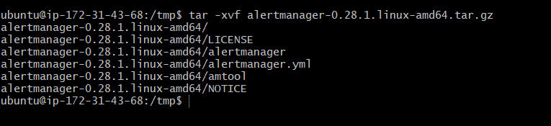
Enter directory:
cd alertmanager-0.28.1.linux-amd64
Verify
Ls
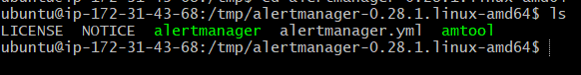
Expected:
alertmanager
amtool
alertmanager.yml
Then continue installation.

Step 4 — Copy Files
Copy binaries:
sudo cp alertmanager /usr/local/bin/
sudo cp amtool /usr/local/bin/
Copy config:
sudo cp alertmanager.yml /etc/alertmanager/
Set permissions:
sudo chown -R alertmanager:alertmanager /etc/alertmanager
sudo chown -R alertmanager:alertmanager /var/lib/alertmanager
sudo chown alertmanager:alertmanager /usr/local/bin/alertmanager
sudo chown alertmanager:alertmanager /usr/local/bin/amtool
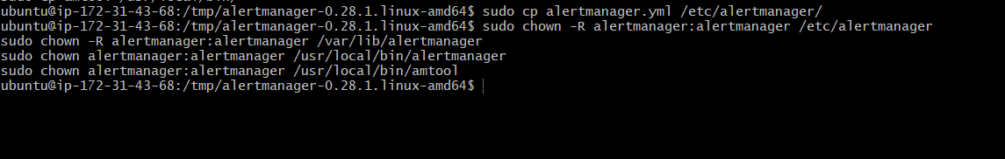

Step 5 — Configure Email Alert
Edit config:
sudo nano /etc/alertmanager/alertmanager.yml
Replace with:
global:
smtp_smarthost: 'smtp.gmail.com:587'
smtp_from: 'vigneshadlagatta1@gmail.com'
smtp_auth_username: 'vigneshadlagatta1@gmail.com'
smtp_auth_password: 'YOUR_GMAIL_APP_PASSWORD'
smtp_require_tls: true
route:
receiver: 'email-alert'
receivers:
- name: 'email-alert'
email_configs:
- to: 'vigneshadlagatta1@gmail.com'
from: 'vigneshadlagatta1@gmail.com'
smarthost: 'smtp.gmail.com:587'
auth_username: 'vigneshadlagatta1@gmail.com'
auth_password: 'YOUR_GMAIL_APP_PASSWORD'
require_tls: true
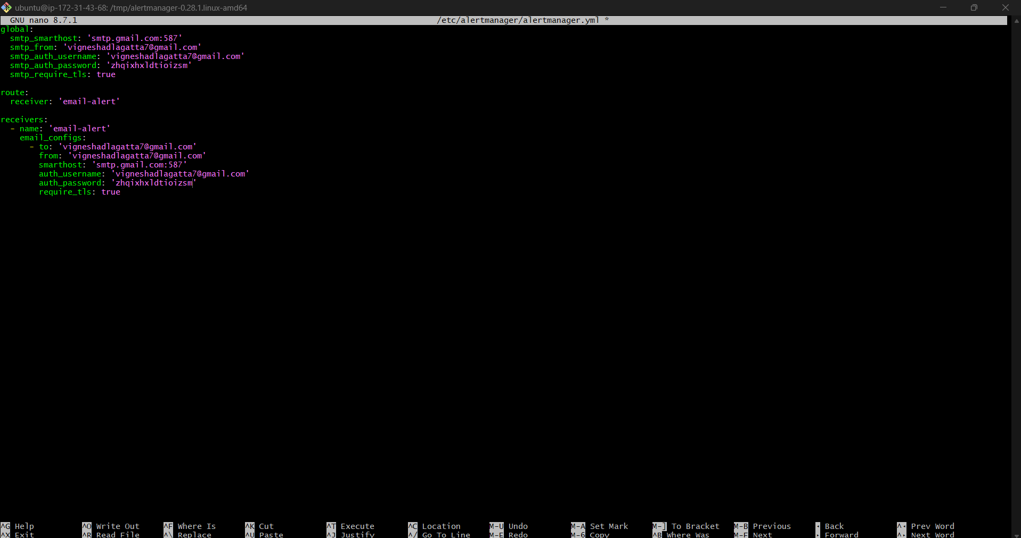

Step 6 — Generate Gmail App Password
For Gmail:
- Enable 2-Step Verification
- Open:
Google App Passwords
- Create App Password
- Use generated password
Example:
abcd efgh ijkl mnop
NOT your normal Gmail password.
Use this in config:
smtp_auth_password: 'abcdefghijklmnop'
(no spaces)

Step 7 — Validate Alertmanager Config
amtool check-config /etc/alertmanager/alertmanager.yml
Expected:
SUCCESS
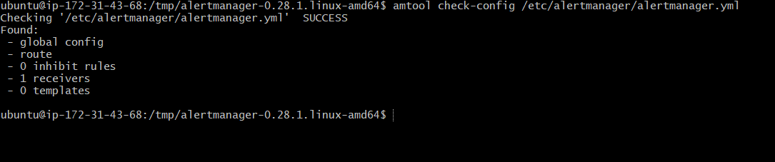

Step 8 — Create systemd Service
Create:
sudo nano /etc/systemd/system/alertmanager.service

Paste:
[Unit]
Description=Alertmanager
Wants=network-online.target
After=network-online.target
[Service]
User=alertmanager
Group=alertmanager
Type=simple
ExecStart=/usr/local/bin/alertmanager \
--config.file=/etc/alertmanager/alertmanager.yml \
--storage.path=/var/lib/alertmanager
Restart=always
[Install]
WantedBy=multi-user.target
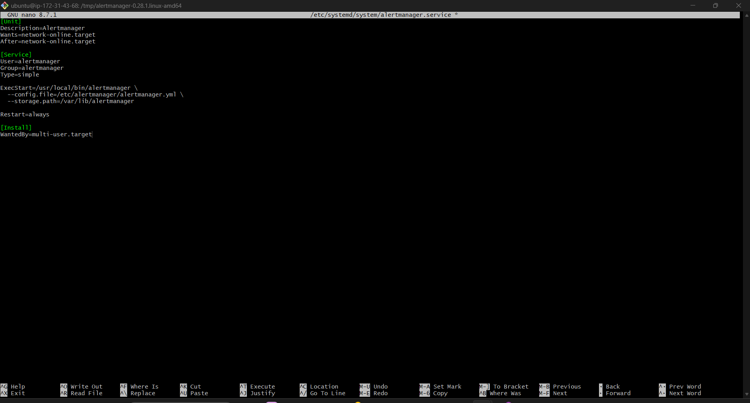

Step 9 — Start Alertmanager
Reload:
sudo systemctl daemon-reload
Enable:
sudo systemctl enable alertmanager
Start:
sudo systemctl start alertmanager
Check:
sudo systemctl status alertmanager
Expected:
active (running)
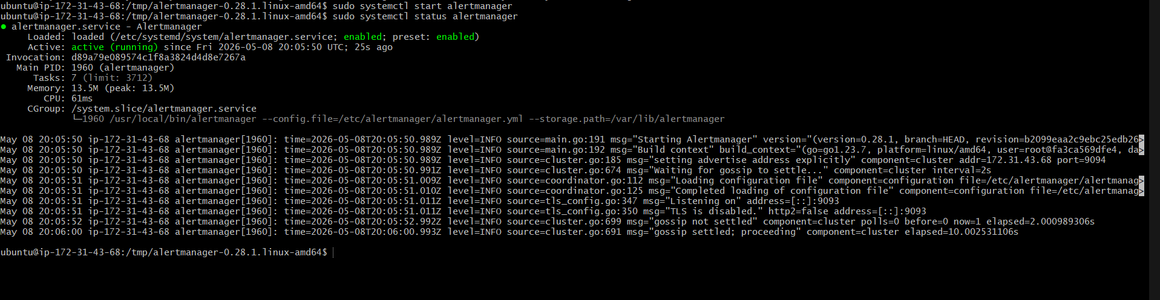

Step 10 — Open Firewall
Allow:
- TCP 9093
AWS Security Group:
Type | Port
Custom TCP | 9093

Step 11 — Access Alertmanager UI
Open:
http://<SERVER-IP>:9093
http://13.61.12.72:9093/#/alerts

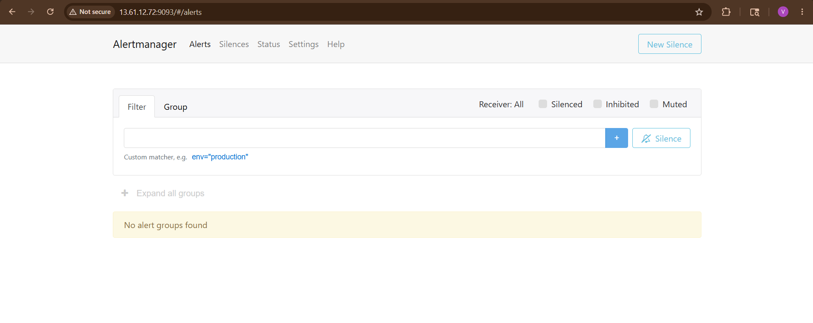
Step 12 — Configure Prometheus with Alertmanager
Edit:
sudo nano /etc/prometheus/prometheus.yml

global:
scrape_interval: 15s
rule_files:
- "alerts.yml"
alerting:
alertmanagers:
- static_configs:
- targets:
- localhost:9093
scrape_configs:
- job_name: 'prometheus'
static_configs:
- targets: ['localhost:9090']
- job_name: 'node-exporter'
static_configs:
- targets: ['localhost:9100']
- job_name: 'snmp'
static_configs:
- targets:
- 13.61.12.72
metrics_path: /snmp
params:
module: [if_mib]
relabel_configs:
- source_labels: [__address__]
target_label: __param_target
- source_labels: [__param_target]
target_label: instance

- target_label: __address__
replacement: localhost:9116
Add:
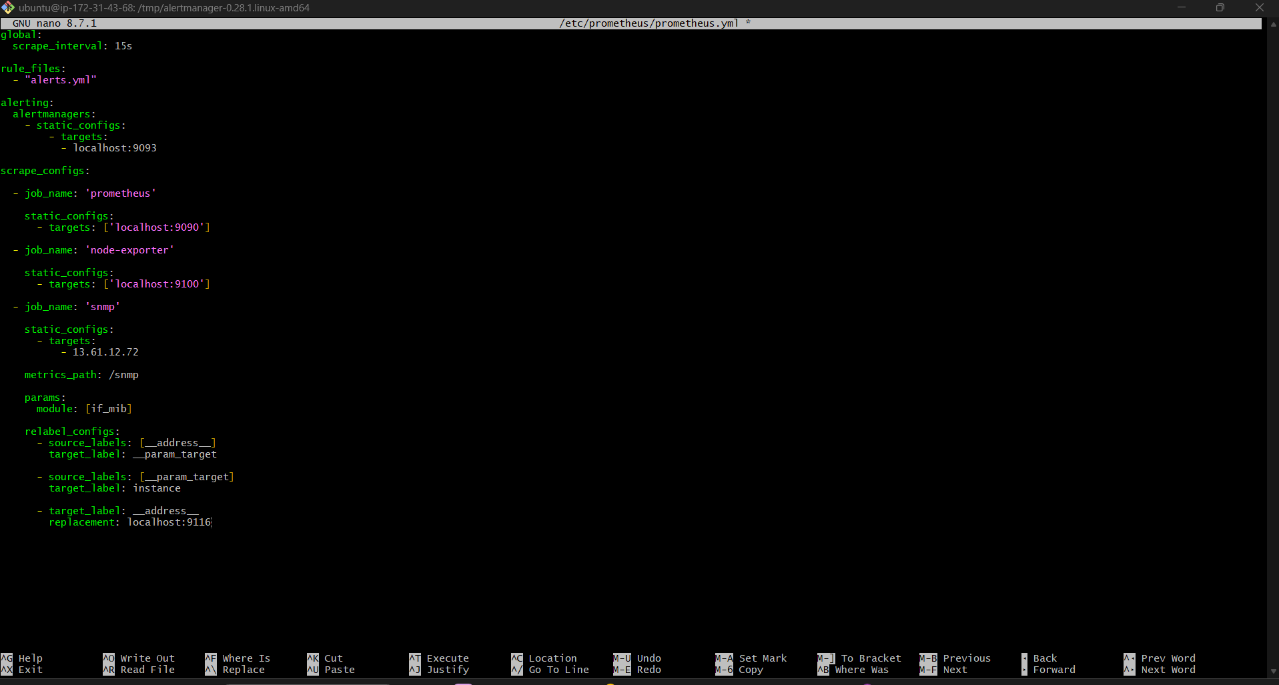

Step 13 — Create Alert Rules File
Create:
sudo nano /etc/prometheus/alerts.yml
Add:
groups:
- name: node-alerts
rules:
- alert: InstanceDown
expr: up == 0
for: 1m
labels:
severity: critical
annotations:
summary: "Instance Down"
description: "Prometheus target is down"
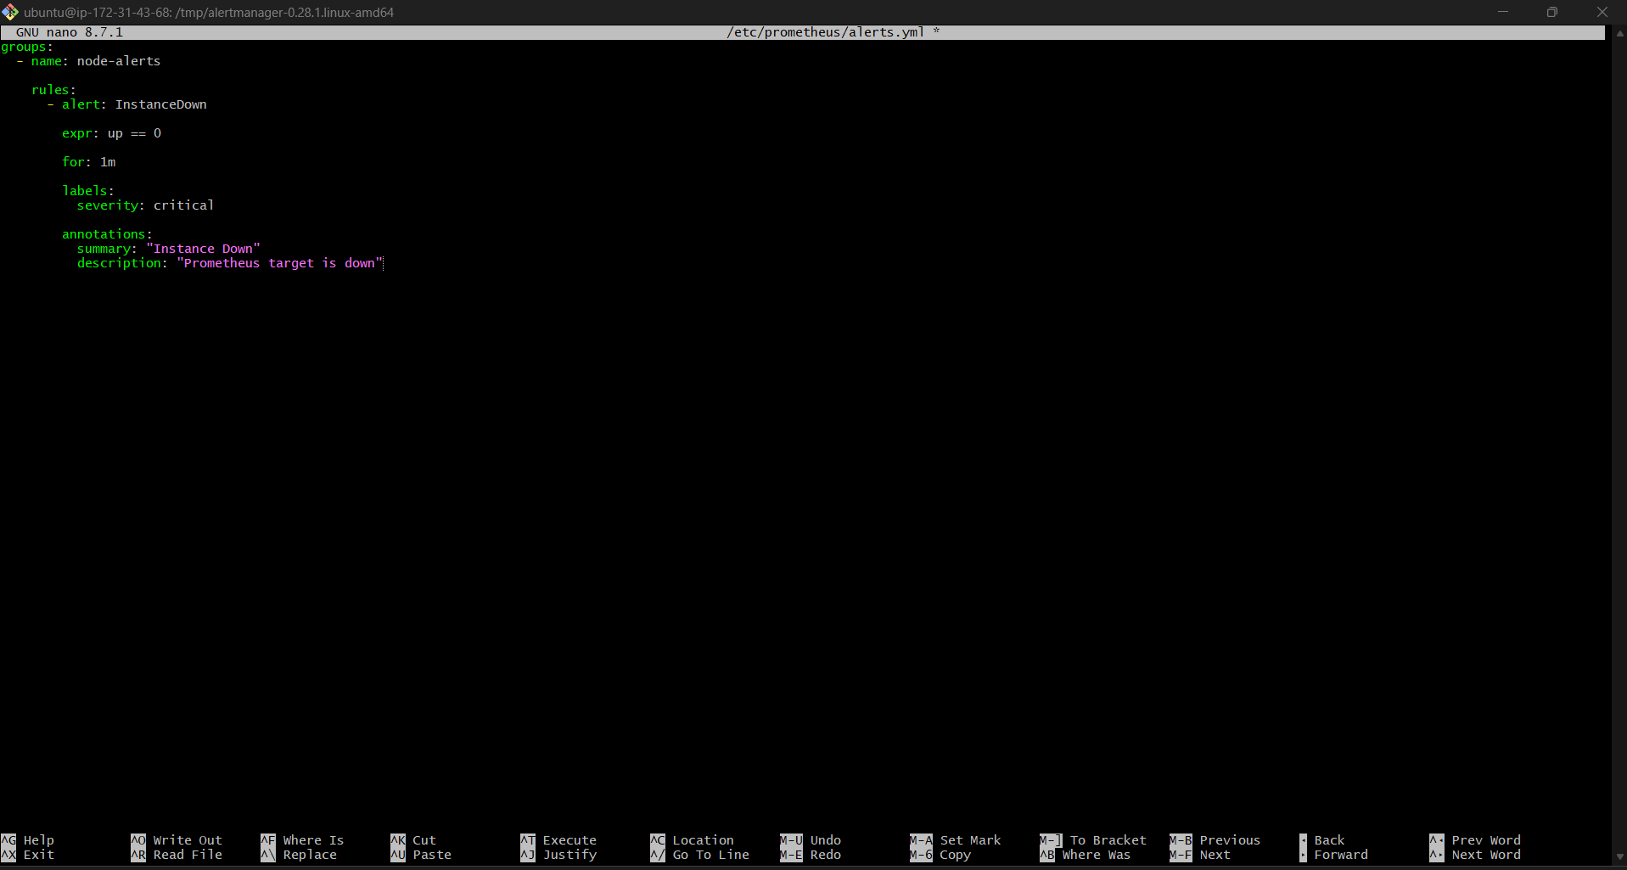

Step 14 — Add Rule File to Prometheus
Edit:
sudo nano /etc/prometheus/prometheus.yml
Add:
rule_files:
- "alerts.yml"
Example full config:
global:
scrape_interval: 15s
rule_files:
- "alerts.yml"
alerting:
alertmanagers:
- static_configs:
- targets:
- localhost:9093
scrape_configs:
- job_name: 'prometheus'

static_configs:
- targets: ['localhost:9090']
- job_name: 'node-exporter'
static_configs:
- targets: ['localhost:9100']
- job_name: 'snmp'
static_configs:
- targets:
- 13.61.12.72
metrics_path: /snmp
params:
module: [if_mib]
relabel_configs:
- source_labels: [__address__]
target_label: __param_target
- source_labels: [__param_target]
target_label: instance
- target_label: __address__
replacement: localhost:9116
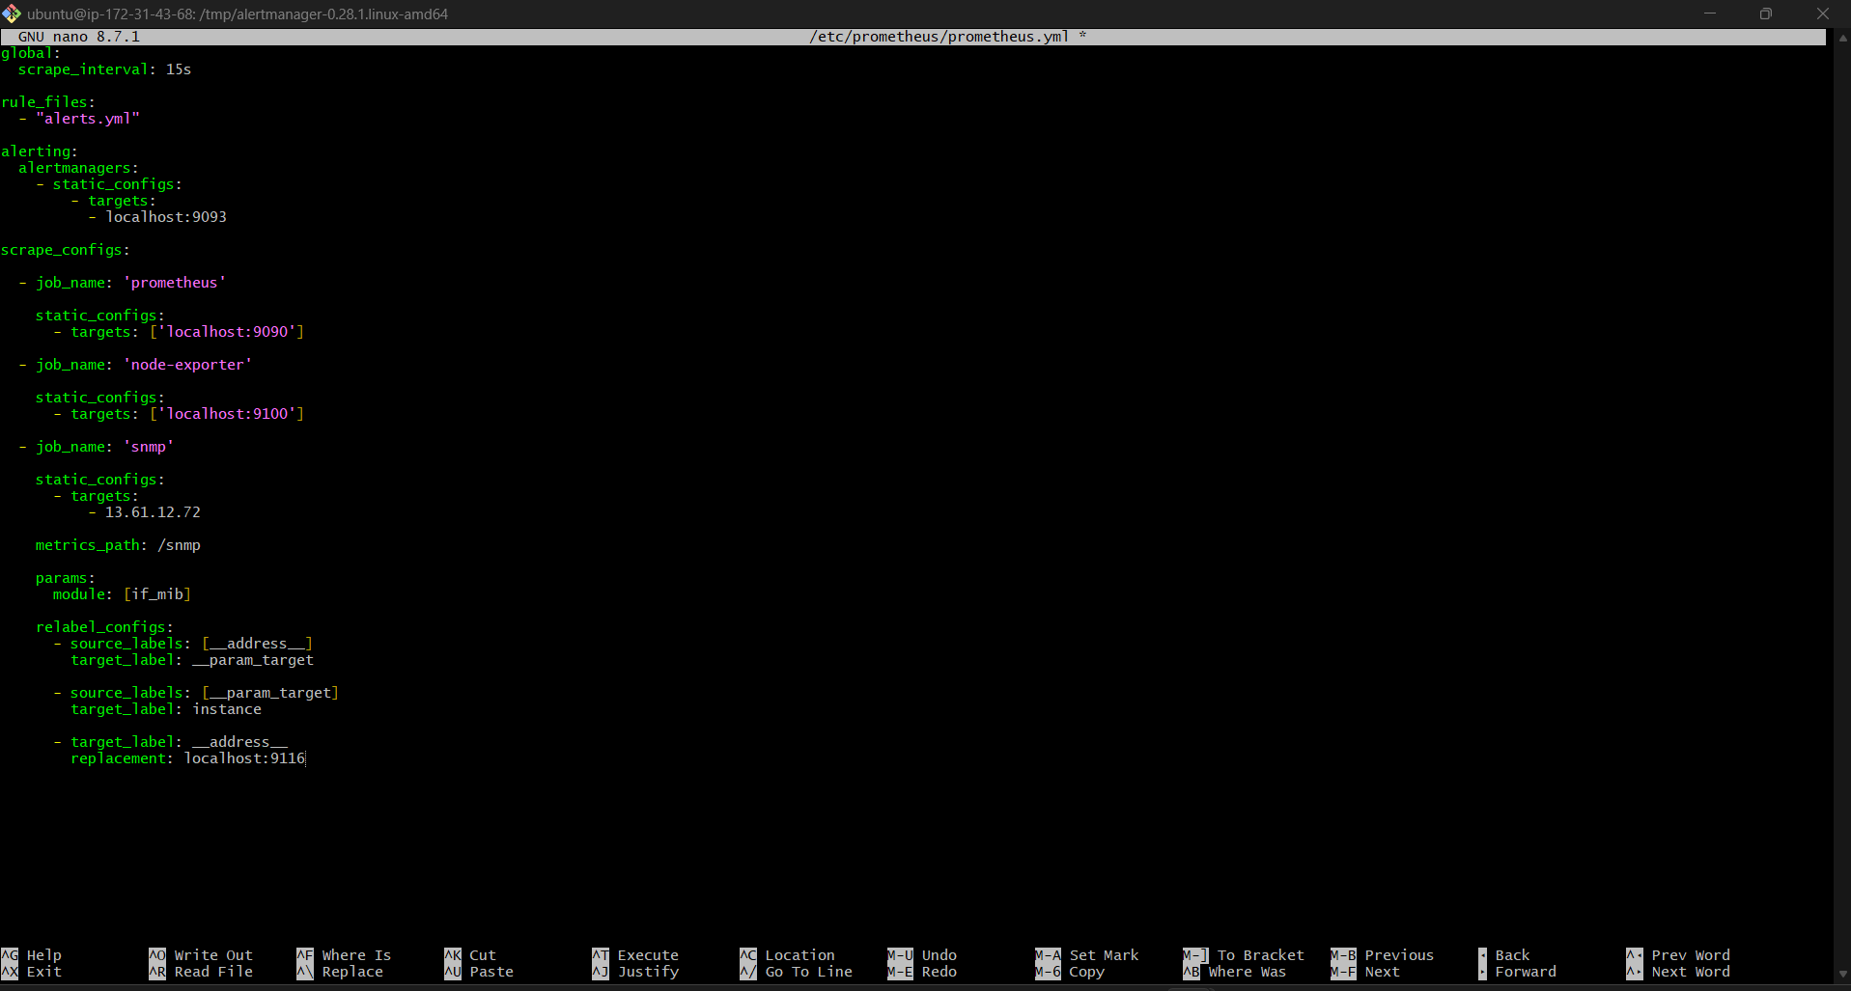

Step 15 — Validate Prometheus Config
promtool check config /etc/prometheus/prometheus.yml
Expected:
SUCCESS
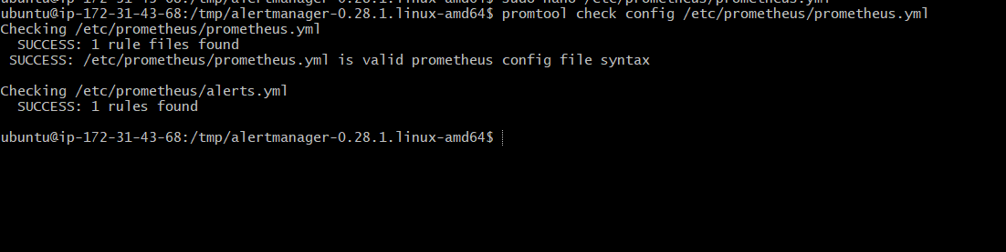

Step 16 — Restart Prometheus
sudo systemctl restart Prometheus

Step 17 — Trigger Test Alert
Stop Node Exporter:
sudo systemctl stop node_exporter
After 1 minute:
- Alert fires
- Alertmanager sends email

Step 18 — Verify Alert
Check:
- Gmail inbox
- Spam folder

Expected mail:
[ALERT] InstanceDown
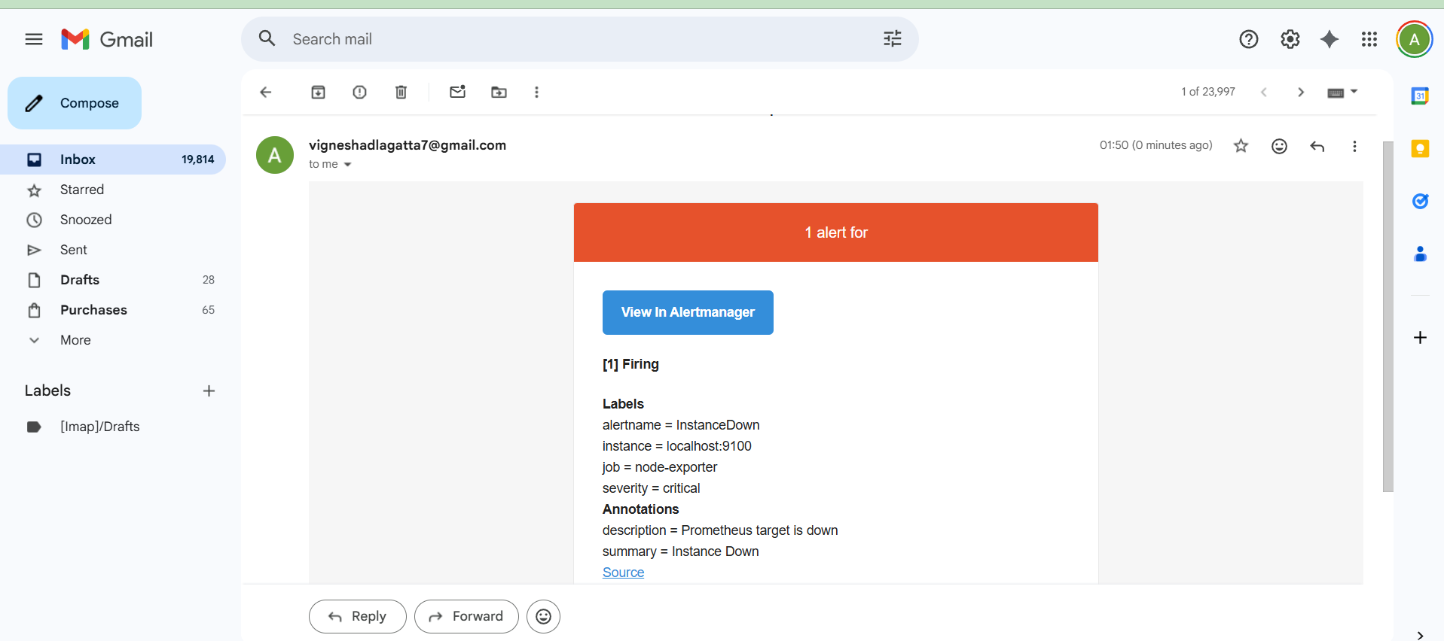

Step 19 — Verify in Prometheus UI
Open:
http://<SERVER-IP>:9090/alerts
http://13.61.12.72:9090/alerts

Expected:
- Firing alerts visible
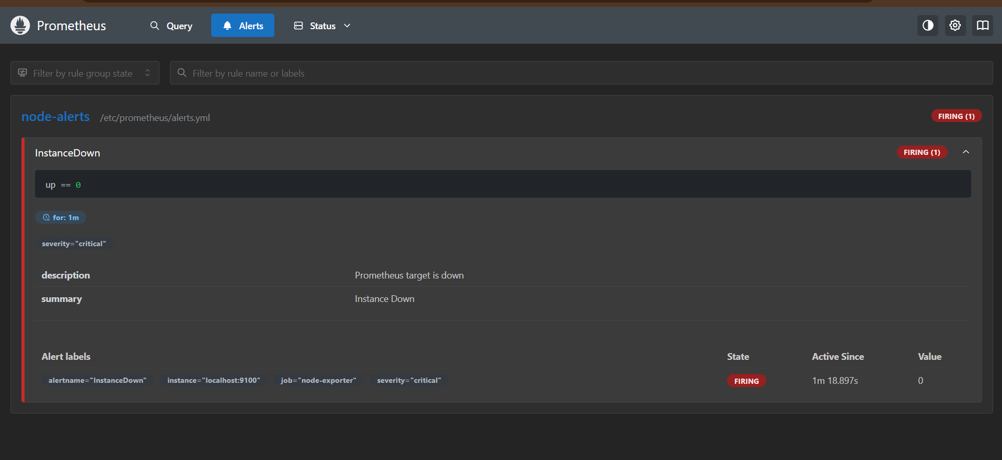

Important Commands
Restart Alertmanager
sudo systemctl restart alertmanager

Logs
journalctl -u alertmanager -f

Validate Config
amtool check-config /etc/alertmanager/alertmanager.yml

Common Issues
Email Not Sending
Check:
- Gmail app password
- SMTP settings
- 2FA enabled

Alert Not Firing
Check:
http://<SERVER-IP>:9090/rules

Alertmanager DOWN
Check:
sudo systemctl status alertmanager

Production Best Practices
Use:
- Slack alerts
- PagerDuty
- Teams
- Multiple receivers
- Alert grouping
- Silencing
- HA Alertmanager

Final Result
You now have:
✅ Alertmanager installed
✅ Prometheus integrated with Alertmanager
✅ Email alerts configured
✅ Automatic notifications working
✅ Production-ready monitoring alerts

6) Install Grafana and add Prometheus as a data source.
Install Grafana and Add Prometheus as a Data Source (Step-by-Step)
Grafana is used to visualize Prometheus metrics using dashboards and graphs.
With this setup you can monitor:
- CPU
- Memory
- Disk
- Network traffic
- Kubernetes
- Servers
- Network devices

Architecture
Node Exporter
|
Prometheus
|
Grafana
|
Dashboards
Prerequisites
Already installed:
✅ Prometheus
✅ Node Exporter
✅ Alertmanager (optional)
Prometheus should run on:
http://localhost:9090

Step 1 — Update Server
sudo apt update
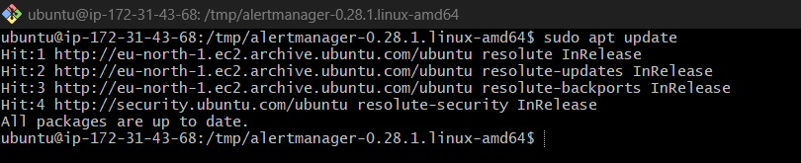

Install dependencies:
sudo apt install -y software-properties-common apt-transport-https wget
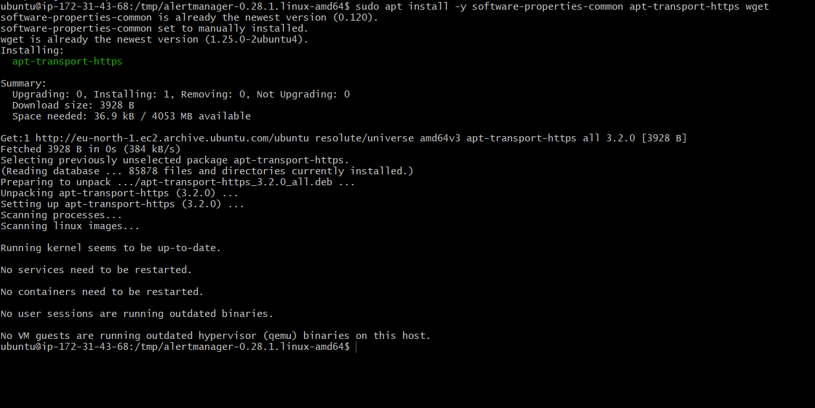

Step 2 — Add Grafana Repository
Download GPG key:
wget -q -O - https://packages.grafana.com/gpg.key | \
gpg --dearmor | \
sudo tee /usr/share/keyrings/grafana.gpg > /dev/null
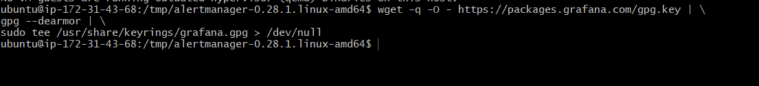
Add repository:
echo "deb https://packages.grafana.com/oss/deb stable main" | sudo tee /etc/apt/sources.list.d/grafana.list
Update packages:
sudo apt update
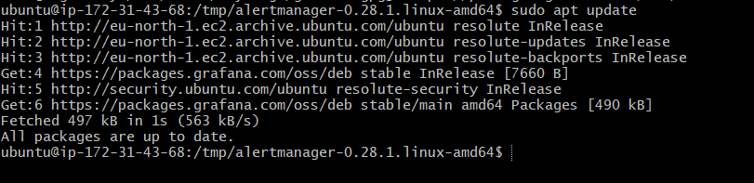

Step 3 — Install Grafana
sudo apt install grafana -y
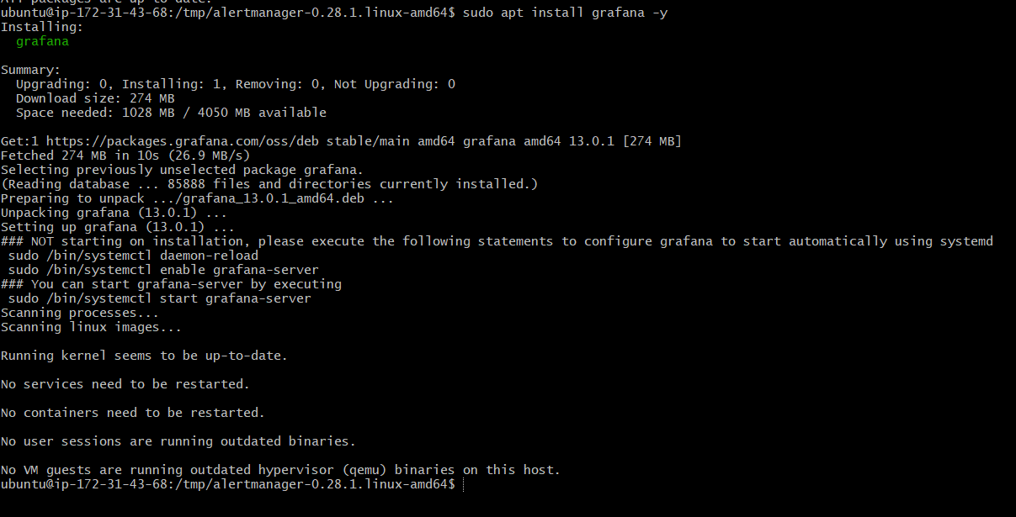

Step 4 — Start Grafana Service
Enable startup:
sudo systemctl enable grafana-server
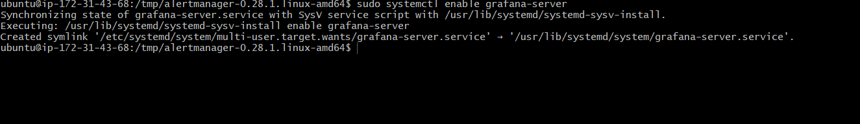
Start service:
sudo systemctl start grafana-server
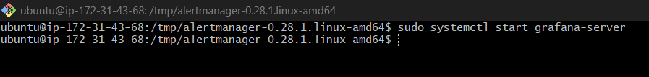
Check status:
sudo systemctl status grafana-server
Expected:
active (running)
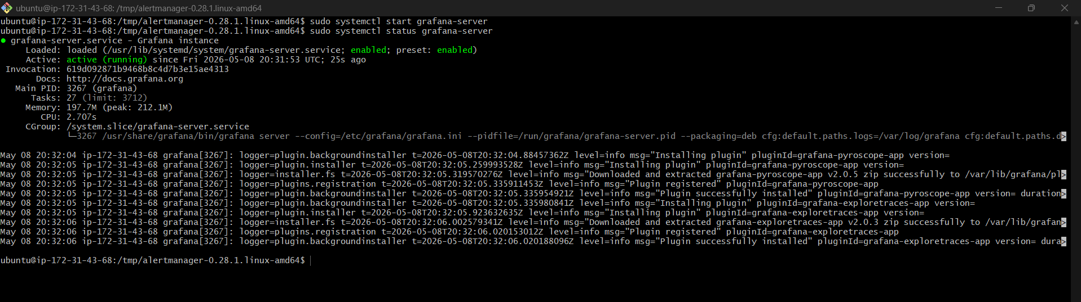
Step 5 — Open Firewall / Security Group
Allow:
- TCP 3000
AWS Security Group:
Type | Port
Custom TCP | 3000

Step 6 — Access Grafana UI
Open browser:
http://<SERVER-IP>:3000
http://13.61.12.72:3000/login

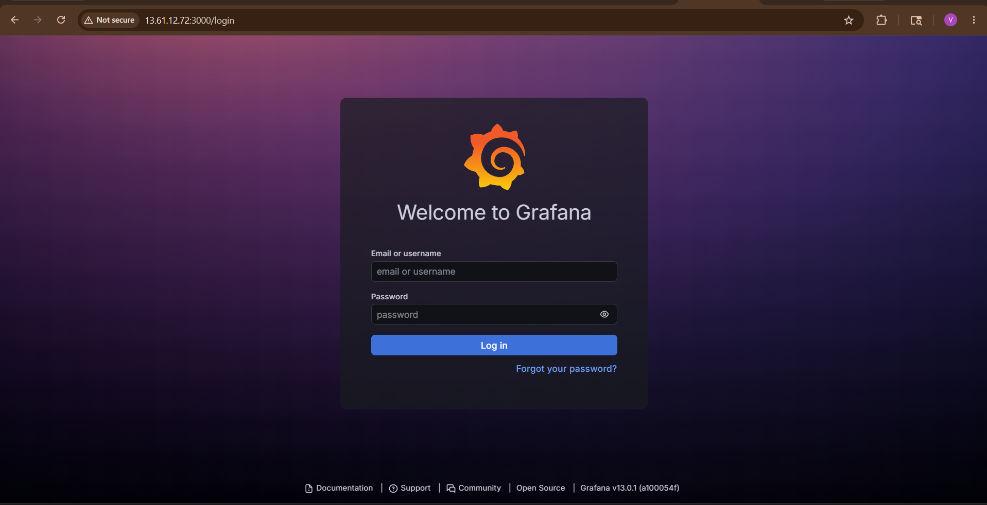

Default credentials:
Username: admin
Password: admin
Grafana asks to change password after login.
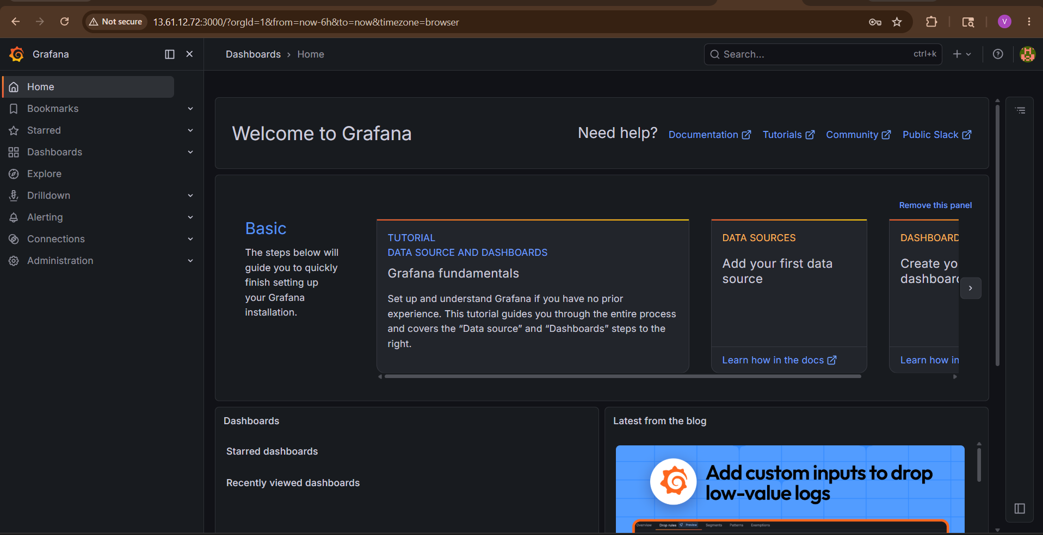

Step 7 — Add Prometheus Data Source
Inside Grafana:
Navigate
Connections → Data Sources
Click:
Add data source
Select:
Prometheus
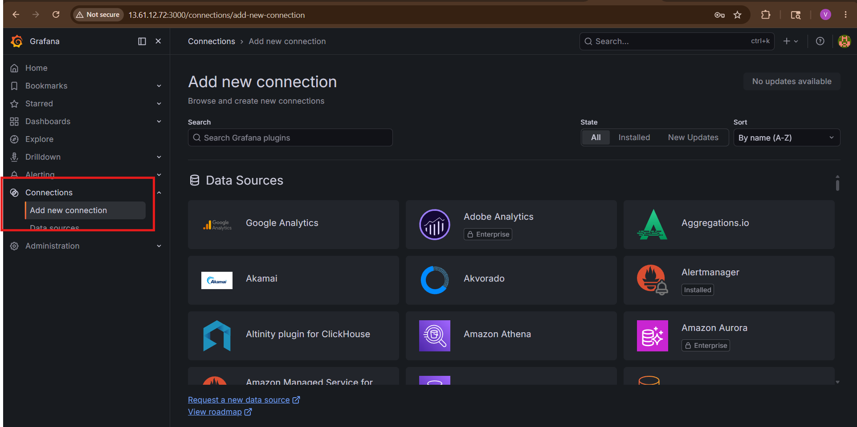

Step 8 — Configure Prometheus URL
In URL field:
http://localhost:9090
If Grafana and Prometheus are on different servers:
http://<PROMETHEUS-IP>:9090
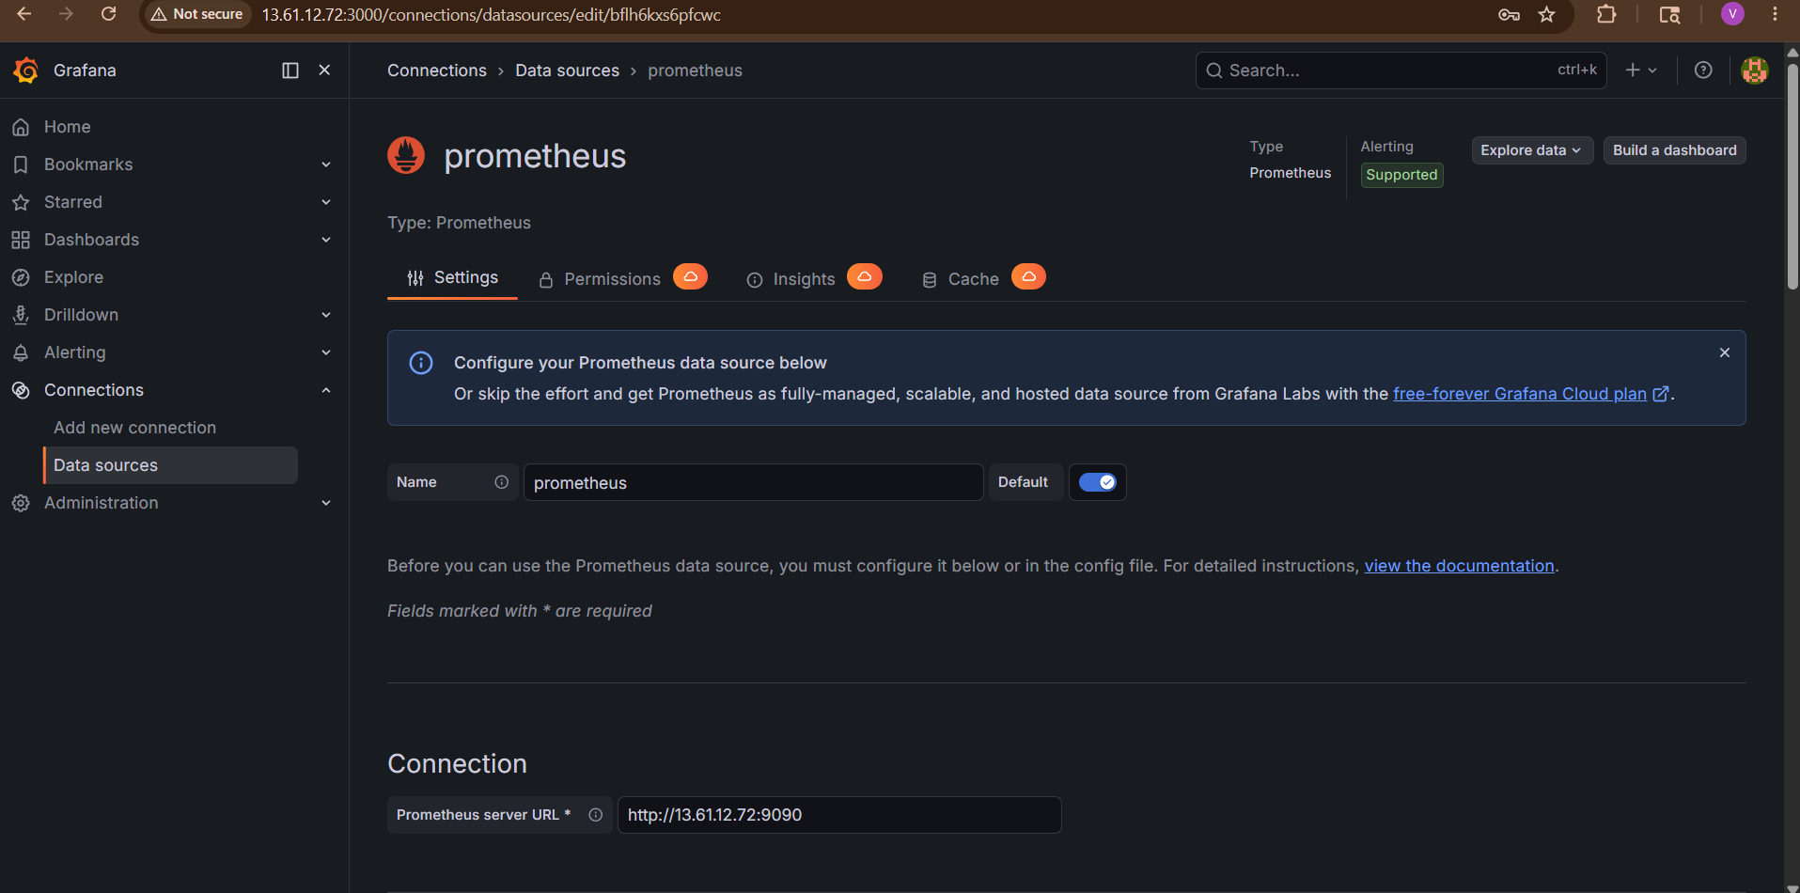

Step 9 — Save and Test
Click:
Save & Test
Expected:
Data source is working
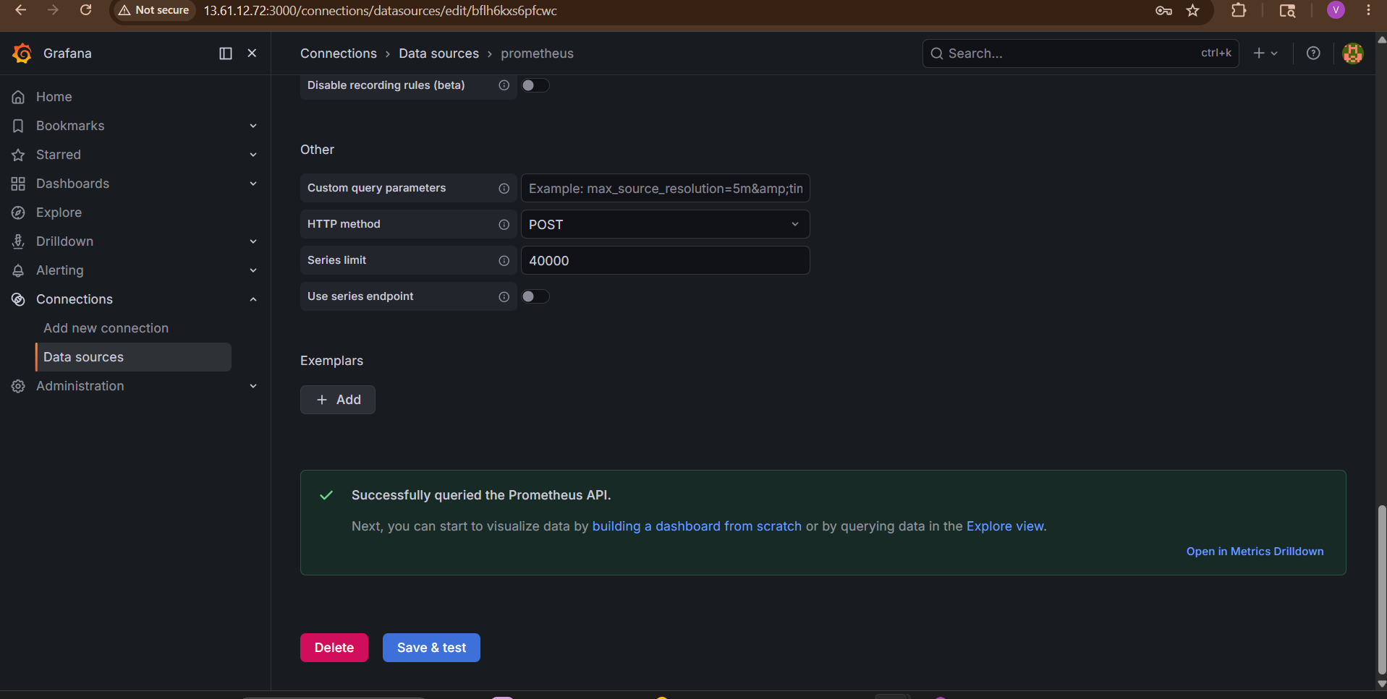
Step 10 — Import Node Exporter Dashboard
Grafana has ready-made dashboards.
Go to:
Dashboards
Then:
- Click the + icon (top right or left menu)
- Select: Import

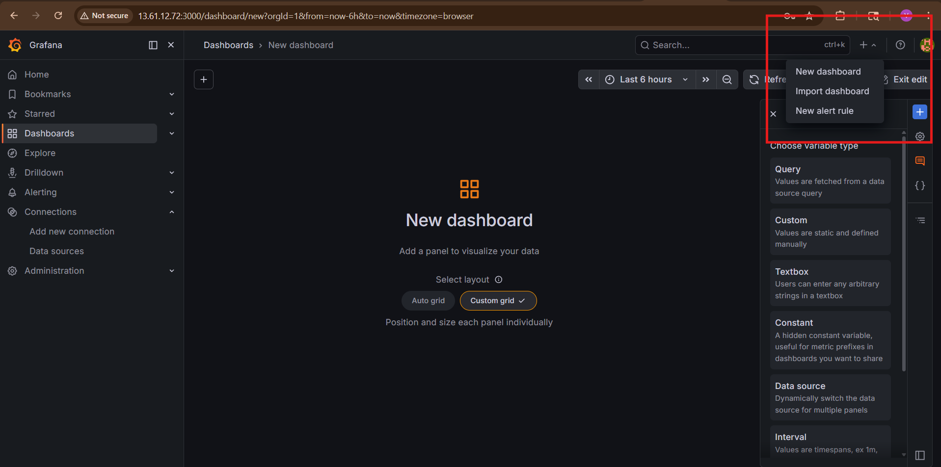
Use Dashboard ID: 1860
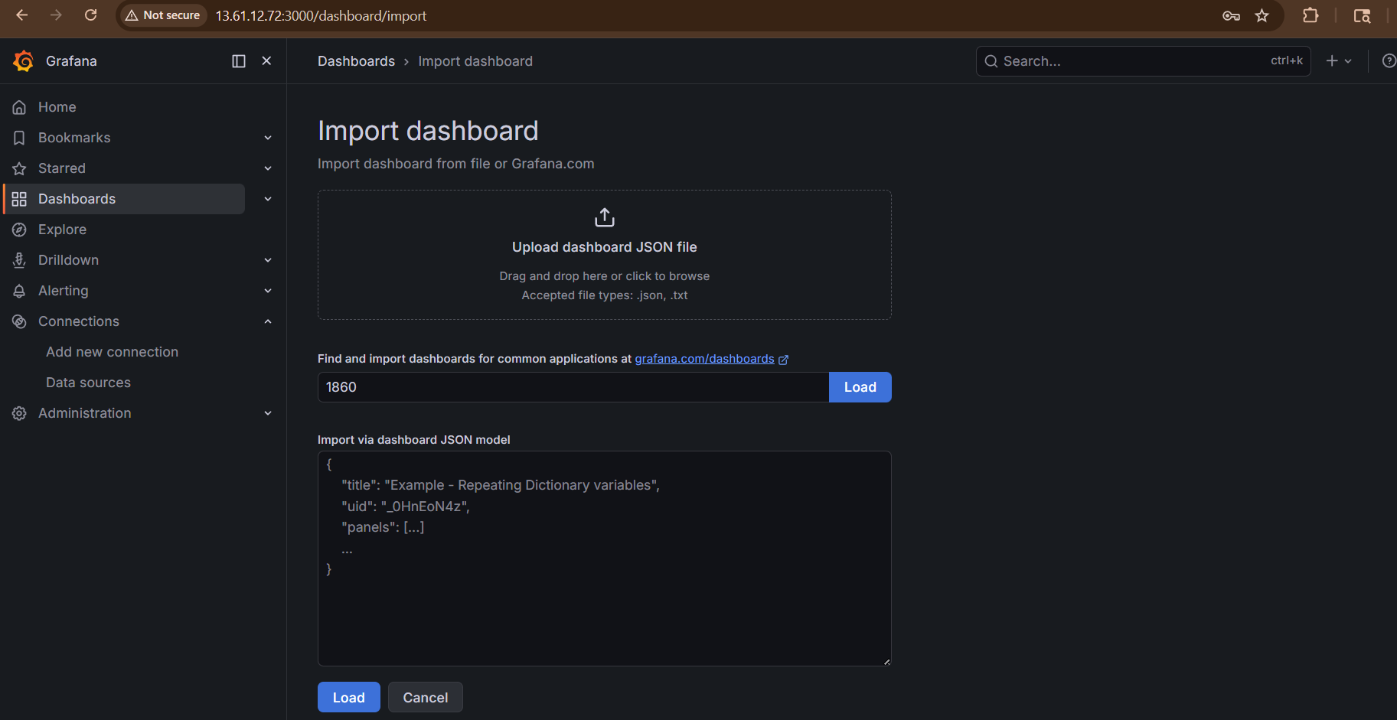
Dashboard:
- Node Exporter Full

Select:
- Prometheus datasource
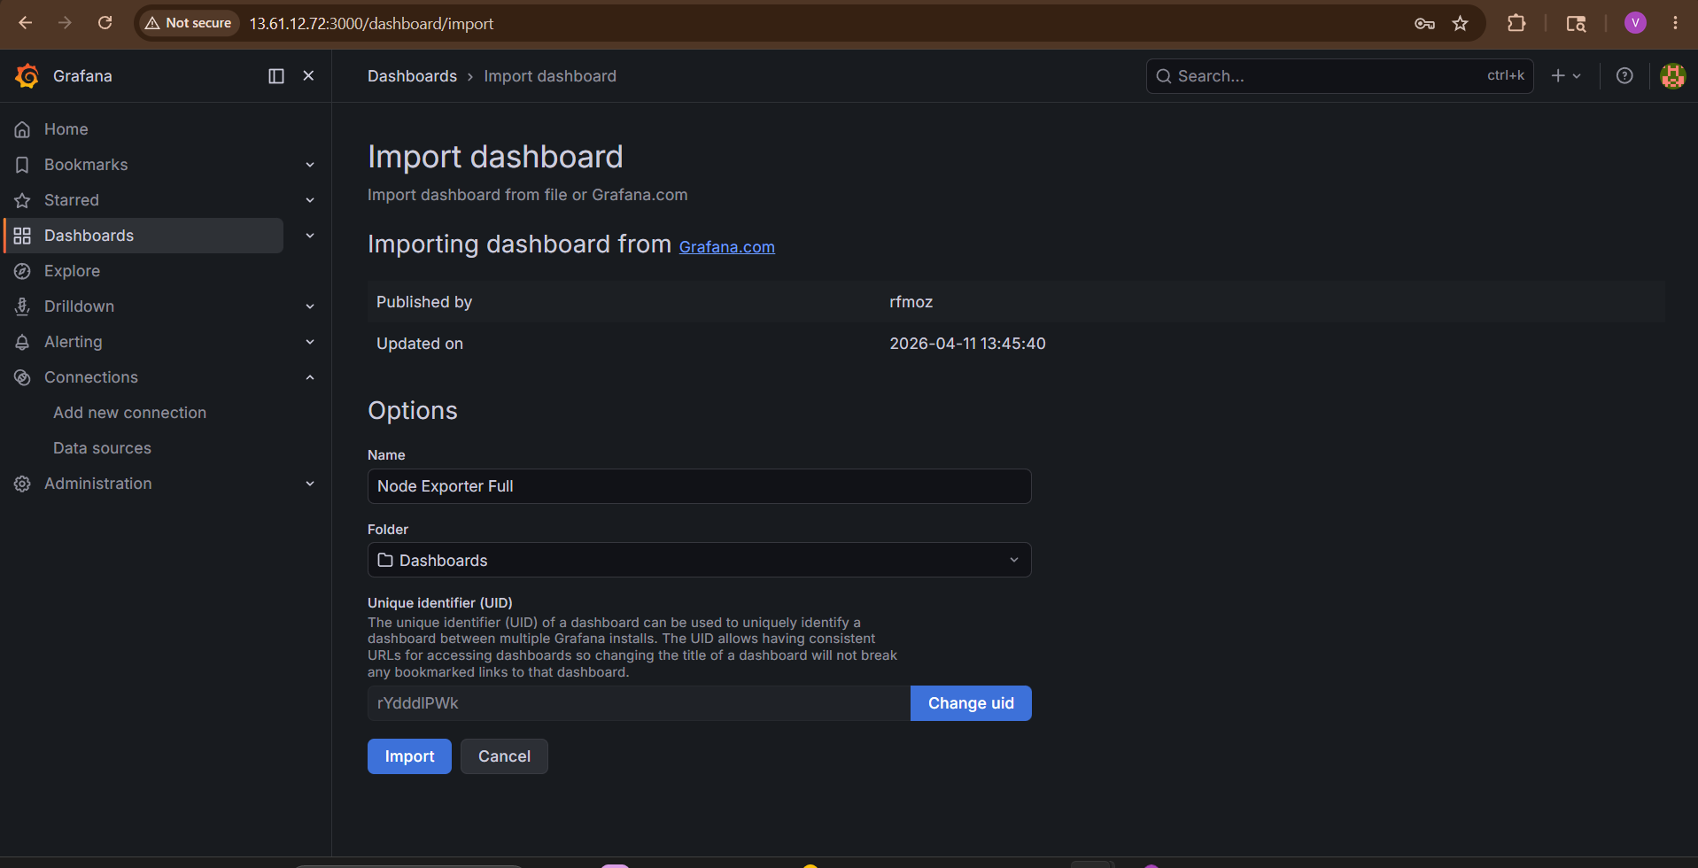
Click: Import
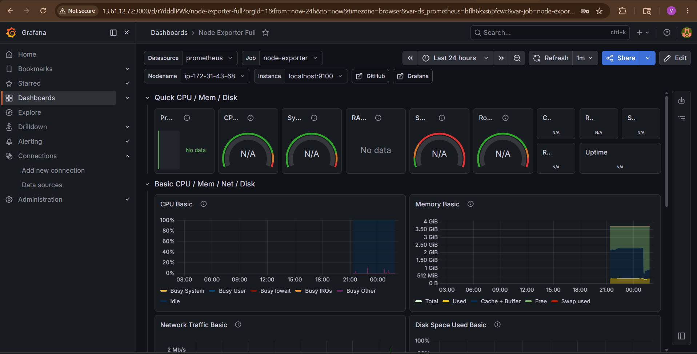
Step 11 — View Metrics Dashboard
You should now see:
- CPU usage
- RAM
- Disk
- Network
- Load average
- Processes
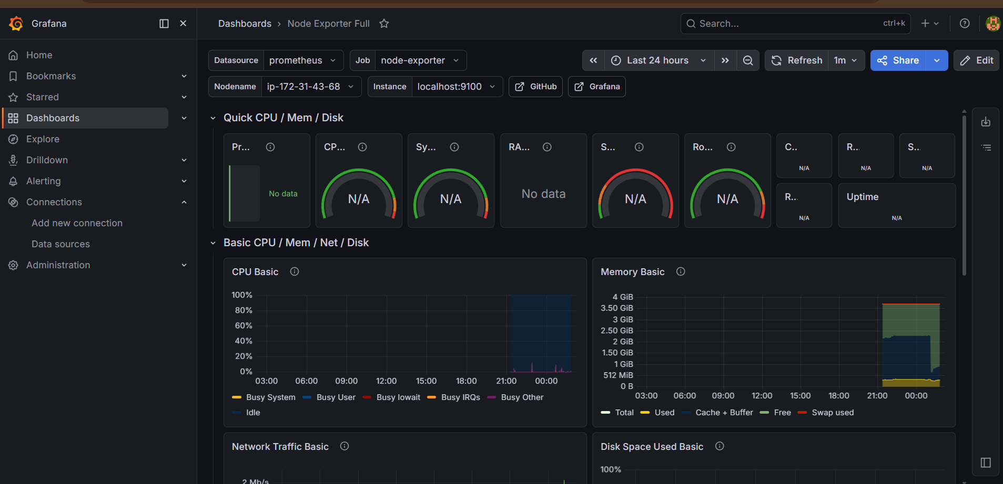
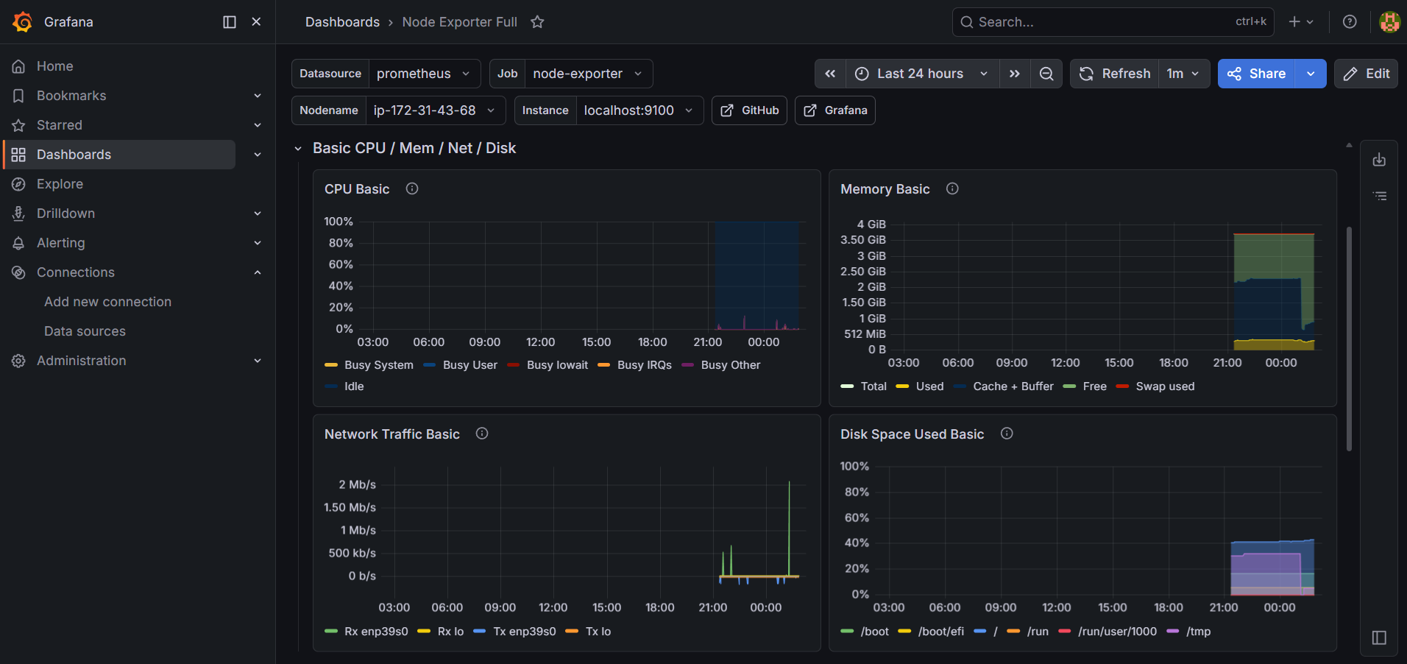
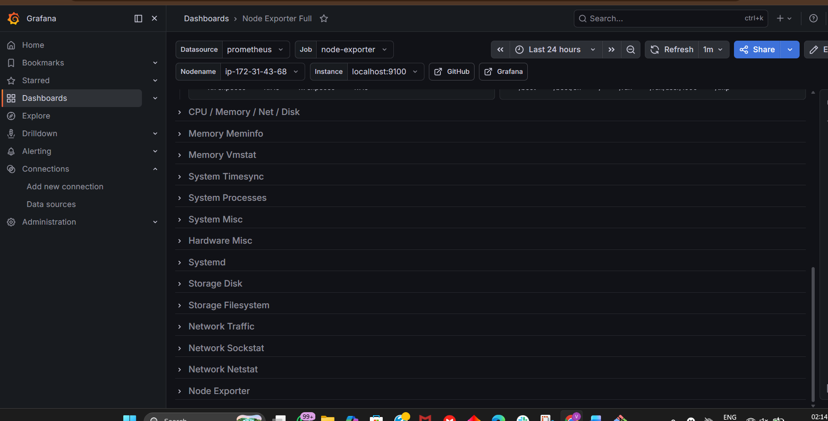
Step 12 — Verify Metrics in Grafana
Try query:
up
Expected:
1
meaning target UP.
Where to Enter up
Step 1 — Add Panel
Click the big + panel button in center/right side.
You’ll open panel editor.

Step 2 — Select Data Source
At bottom query section:
Choose:
Prometheus
as datasource.

Step 3 — Enter Query
In the query box, type:
up
Then click:
Run queries
or Grafana auto-runs

Expected Result
You should see:
1
Meaning:
Target is UP
If multiple targets:
up{job="prometheus"} = 1
up{job="node-exporter"} = 1
up{job="snmp"} = 1
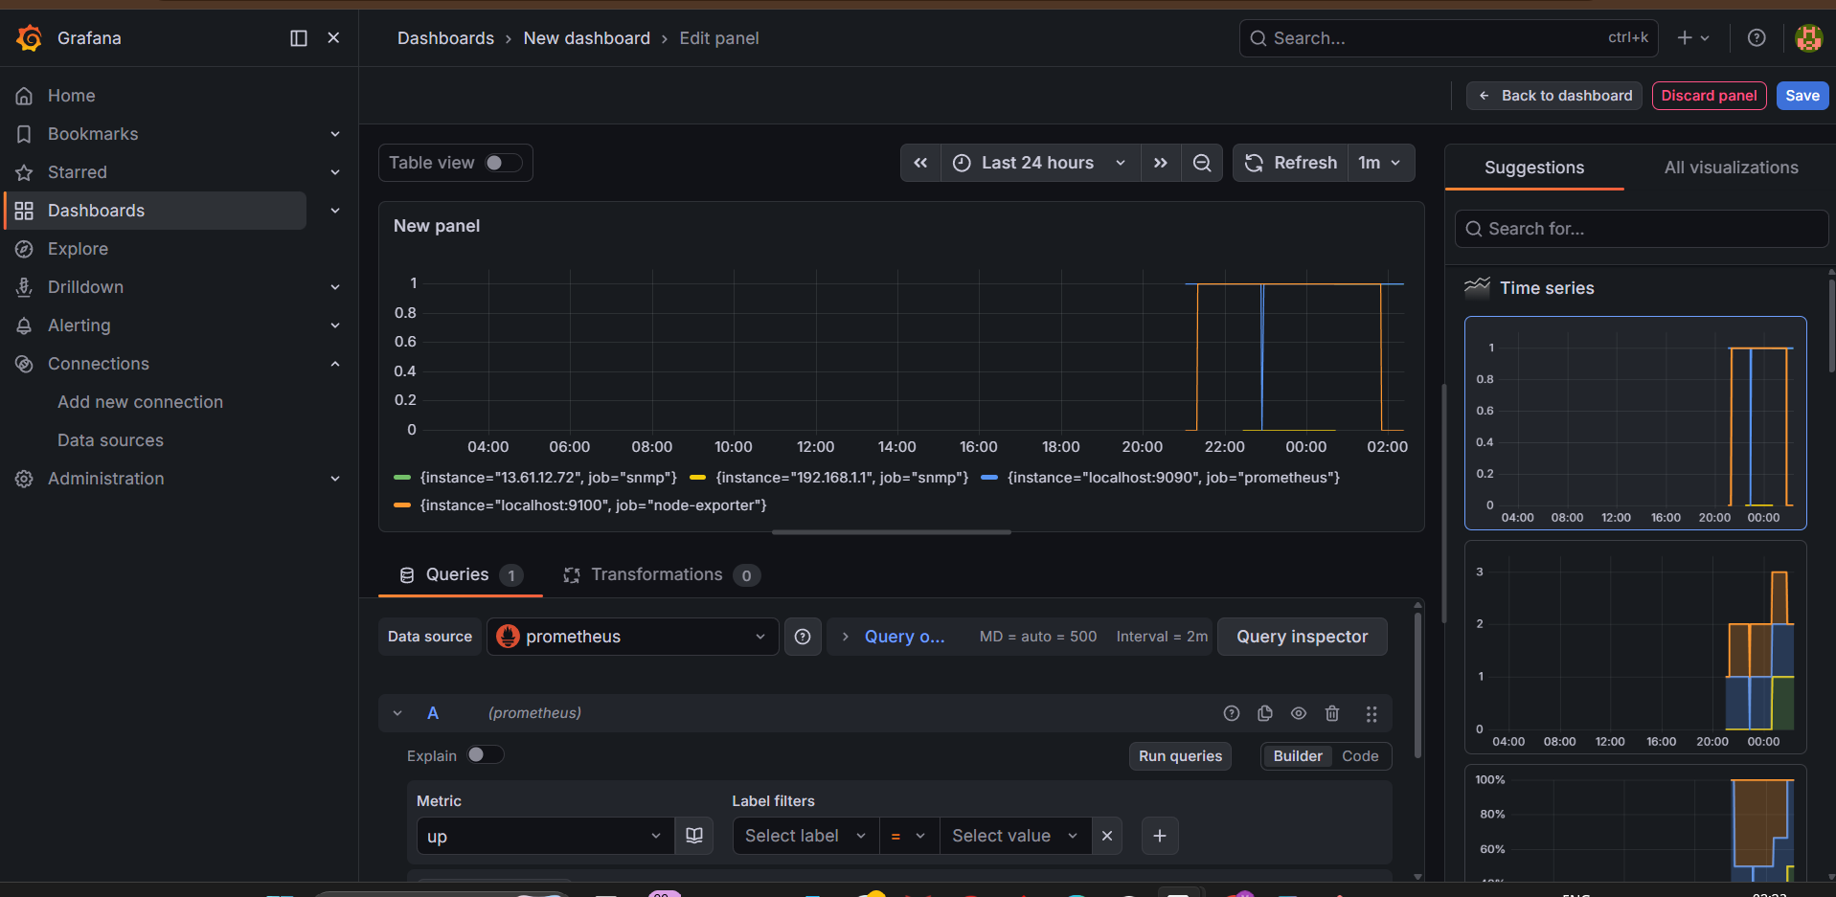

Visual Flow
Grafana
↓
Prometheus Datasource
↓
Query: up
↓
Result = 1

Important Grafana Commands
Start
sudo systemctl start grafana-server

Stop
sudo systemctl stop grafana-server

Restart
sudo systemctl restart grafana-server

Status
sudo systemctl status grafana-server

Logs
journalctl -u grafana-server -f

Troubleshooting
Grafana Not Opening
Check port:
ss -tulnp | grep 3000

Data Source Failed
Check:
- Prometheus running?
- Port 9090 open?
- URL correct?
Test:
curl http://localhost:9090
Login Failed
Reset admin password:
sudo grafana-cli admin reset-admin-password admin123
Production Best Practices
Use:
- HTTPS
- Reverse proxy (Nginx)
- LDAP/SSO
- Alerting
- Role-based access
- Persistent storage
- Backup dashboards

Popular Dashboard IDs
Dashboard | ID
Node Exporter Full | 1860
Kubernetes Cluster | 315
Docker Monitoring | 193
SNMP Network Devices | 1116

Real Production Stack
Node Exporter
SNMP Exporter
Kubernetes
Applications
|
Prometheus
|
Alertmanager
|
Grafana

Final Result
You now have:
✅ Grafana installed
✅ Grafana service running
✅ Prometheus connected as datasource
✅ Monitoring dashboards working
✅ Real-time metrics visualization enabled

7. Configure Prometheus for service discovery of dynamic targets.

Dynamic Service Discovery allows Prometheus to automatically discover targets instead of manually adding IPs in prometheus.yml.
Without service discovery:
targets:
- 10.0.1.10:9100
- 10.0.1.11:9100
Problem:
- Servers added/removed frequently
- Manual updates required
- Not scalable
With service discovery:
- Prometheus automatically finds targets
- Works well in cloud/Kubernetes/Auto Scaling

Common Service Discovery Types
Discovery Type | Used For
File-based | Dynamic target files
EC2 Service Discovery | AWS EC2
Kubernetes SD | Kubernetes
Consul SD | HashiCorp Consul
DNS SD | DNS-based
Docker SD | Containers

Real Production Architecture
EC2 Instances / Kubernetes Pods
|
Service Discovery
|
Prometheus
|
Grafana
Method 1 — File-Based Service Discovery

Step 1 — Create Targets File
Create directory:
sudo mkdir /etc/prometheus/targets
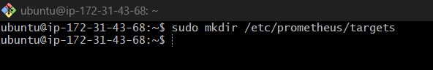
Create file:
sudo nano /etc/prometheus/targets/node_targets.json

Add:
[
{
"targets": [
"localhost:9100",
"10.0.1.10:9100",
"10.0.1.11:9100"
],
"labels": {
"env": "production"
}
}
]
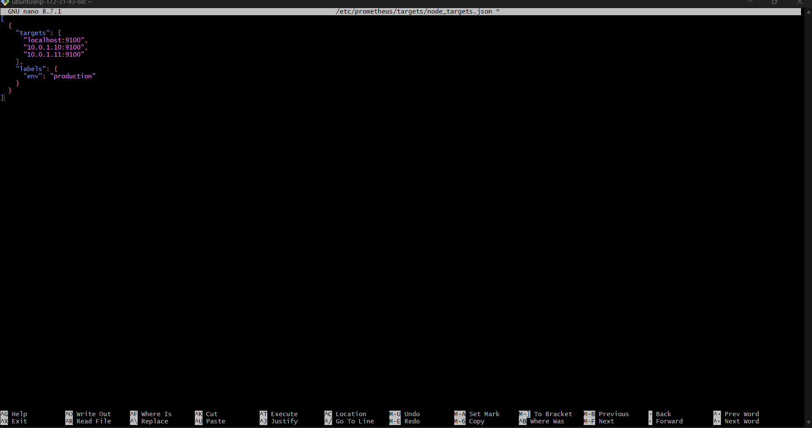

Step 2 — Configure prometheus.yml
Edit:
sudo nano /etc/prometheus/prometheus.yml
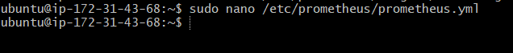
Add:
scrape_configs:
- job_name: 'node-exporter'
file_sd_configs:
- files:
- /etc/prometheus/targets/*.json
refresh_interval: 30s

Correct Full Example
Use this structure:
global:
scrape_interval: 15s
scrape_configs:

- job_name: 'prometheus'
static_configs:
- targets: ['localhost:9090']
- job_name: 'node-exporter'
static_configs:
- targets: ['localhost:9100']
- job_name: 'snmp'
static_configs:
- targets:
- 13.61.12.72
metrics_path: /snmp
params:
module: [if_mib]
relabel_configs:
- source_labels: [__address__]
target_label: __param_target
- source_labels: [__param_target]
target_label: instance
- target_label: __address__
replacement: localhost:9116
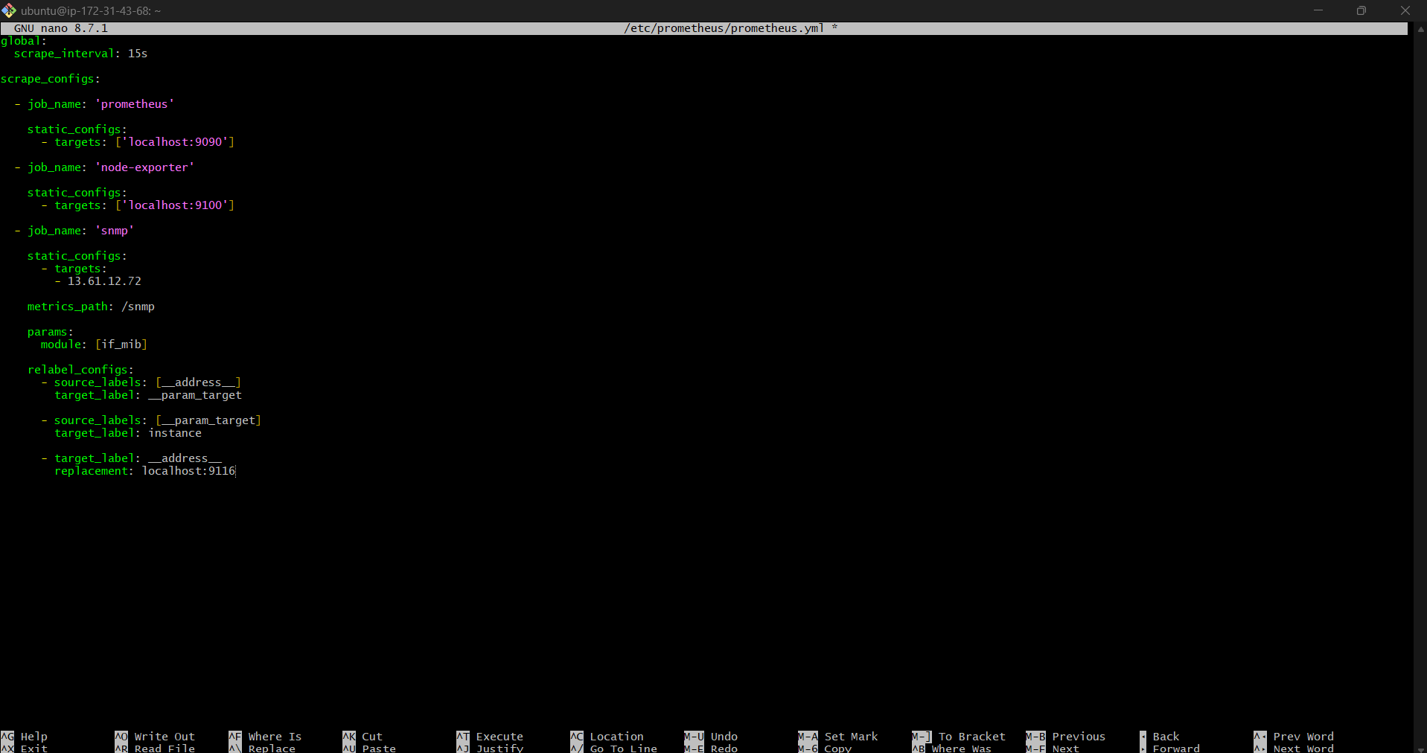

Step 3 — Validate Config
promtool check config /etc/prometheus/prometheus.yml
Expected:
SUCCESS
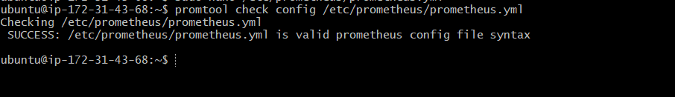

Step 4 — Restart Prometheus
sudo systemctl restart Prometheus
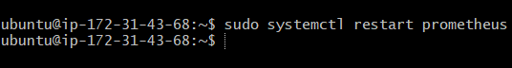

Step 5 — Verify Targets
Open:
http://<SERVER-IP>:9090/targets
http://13.61.12.72:9090/targets

Targets appear automatically.
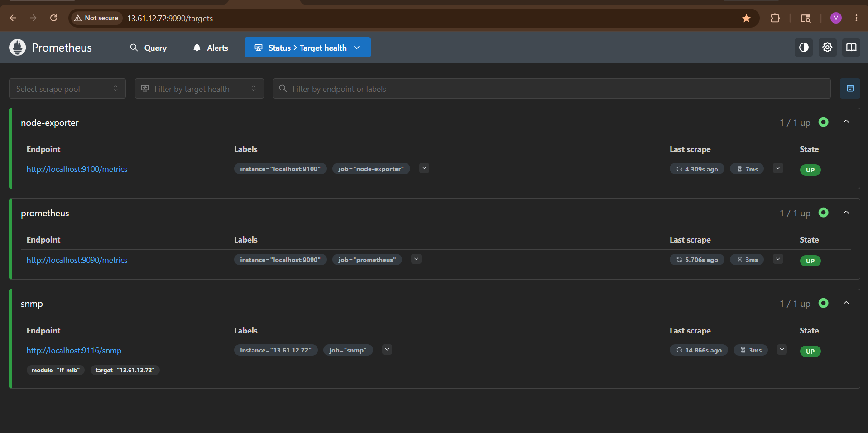

Dynamic Update Example
[
{
"targets": [
"localhost:9100",
"10.0.1.10:9100",
"10.0.1.11:9100",
"10.0.1.12:9100"
],
"labels": {
"env": "production"
}
}
]
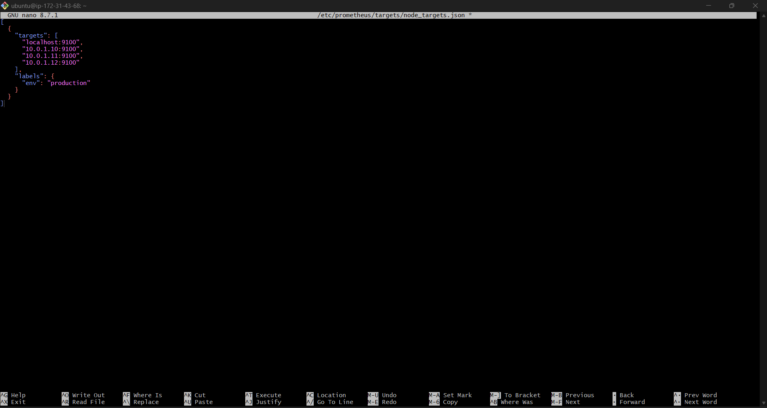
Restart Prometheus
sudo systemctl restart prometheus

Verify Dynamic Targets
Open:
http://13.61.12.72:9090/targets
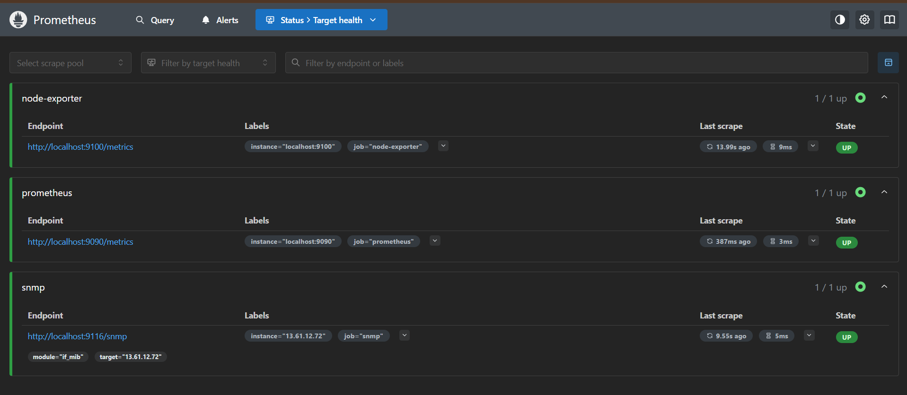
You should see targets discovered from:
/etc/prometheus/targets/node_targets.json

Prometheus auto-detects within 30 seconds.
No restart required.
Everything is now working correctly.
Your monitoring stack is fully operational:
✅ Prometheus → UP
✅ Node Exporter → UP
✅ SNMP Exporter → UP
✅ Targets scraping successfully
✅ Grafana connected
✅ Dynamic target discovery configured
✅ Alertmanager configured

Your Final Architecture
Node Exporter (9100)
|
SNMP Exporter (9116)
|
Prometheus (9090)
|
Alertmanager (9093)
|
Grafana (3000)

Method 2 — AWS EC2 Service Discovery
Best for AWS Auto Scaling.

IAM Permissions Required
Attach policy:
{
"Effect": "Allow",
"Action": [
"ec2:DescribeInstances"
],
"Resource": "*"
}

EC2 Discovery Config
Edit prometheus.yml:
- job_name: 'ec2-discovery'
ec2_sd_configs:
- region: us-east-1
port: 9100
relabel_configs:
- source_labels: [__meta_ec2_private_ip]
replacement: '${1}:9100'
target_label: __address__
- source_labels: [__meta_ec2_tag_Name]
target_label: instance

How It Works
Prometheus automatically:
- Discovers EC2 instances
- Reads instance metadata
- Scrapes Node Exporter

Useful EC2 Labels
Label | Meaning
__meta_ec2_private_ip | Private IP
__meta_ec2_tag_Name | EC2 Name tag
__meta_ec2_instance_id | Instance ID

Method 3 — Kubernetes Service Discovery
Most used in production DevOps.

Kubernetes SD Example
- job_name: 'kubernetes-pods'
kubernetes_sd_configs:
- role: pod

Common Kubernetes Roles
Role | Discovers
pod | Pods
service | Services
endpoints | Endpoints
node | Nodes

Example with Relabeling
- job_name: 'kubernetes-pods'
kubernetes_sd_configs:
- role: pod
relabel_configs:
- source_labels:
[__meta_kubernetes_pod_annotation_prometheus_io_scrape]
action: keep
regex: true

Method 4 — Docker Service Discovery
- job_name: 'docker'
docker_sd_configs:
- host: unix:///var/run/docker.sock

Method 5 — DNS Service Discovery
- job_name: 'dns-discovery'
dns_sd_configs:
- names:
- app.example.com
type: A
port: 9100

Best Practice Architecture
Applications
Containers
EC2
Kubernetes
Network Devices
|
Service Discovery
|
Prometheus
|
Grafana

Verify Service Discovery
Open:
http://<SERVER-IP>:9090/service-discovery
Shows:
- Discovered targets
- Labels
- Metadata

Troubleshooting
Targets Not Appearing
Check:
journalctl -u prometheus -f

Config Error
Validate:
promtool check config /etc/prometheus/prometheus.yml

AWS Discovery Not Working
Check:
- IAM role attached?
- EC2 permissions?
- Region correct?

Kubernetes Discovery Fails
Check:
- RBAC permissions
- Service account
- Cluster connectivity

Production Best Practices
Use:
- Relabeling
- Tag-based discovery
- TLS
- Authentication
- Label standardization
- Multi-region monitoring

Real Enterprise Flow
Auto Scaling Group
|
EC2 Instances
|
Prometheus EC2 Discovery
|
Grafana Dashboards
|
Alertmanager

Final Result
You now have:
✅ Dynamic target discovery configured
✅ Automatic infrastructure monitoring
✅ No manual IP updates needed
✅ Cloud-native monitoring setup
✅ Production-ready Prometheus discovery system

8. Create alerting rules for monitoring disk space.

Create Alerting Rules for Monitoring Disk Space in Prometheus
This setup creates alerts when disk usage becomes high.
Example:
- Warning at 80%
- Critical at 90%
Prometheus Alerting Rules work together with:
- Node Exporter
- Alertmanager
- Email notifications

Architecture
Linux Server
|
Node Exporter
|
Prometheus Alert Rules
|
Alertmanager
|
Email Alert
Prerequisites
Already installed:
✅ Prometheus
✅ Node Exporter
✅ Alertmanager
✅ Email alerts working
Node Exporter must expose filesystem metrics.

Step 1 — Verify Disk Metrics
Open Prometheus:
http://<SERVER-IP>:9090
Search:
node_filesystem_avail_bytes
If metrics appear:
- Node Exporter working correctly

Step 2 — Open Alert Rules File
Edit:
sudo nano /etc/prometheus/alerts.yml
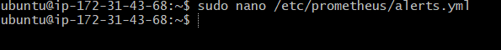

Step 3 — Add Disk Space Alert Rules
Add:
groups:
- name: node-alerts
rules:
- alert: HighDiskUsageWarning
expr: |
(
100 -
(
node_filesystem_avail_bytes{mountpoint="/",fstype!="tmpfs"}
* 100
/
node_filesystem_size_bytes{mountpoint="/",fstype!="tmpfs"}
)
) > 80
for: 2m
labels:
severity: warning
annotations:
summary: "High Disk Usage Warning"
description: "Disk usage on {{ $labels.instance }} is above 80%"
- alert: HighDiskUsageCritical
expr: |
(
100 -
(
node_filesystem_avail_bytes{mountpoint="/",fstype!="tmpfs"}
* 100
/
node_filesystem_size_bytes{mountpoint="/",fstype!="tmpfs"}
)
) > 90
for: 1m
labels:
severity: critical
annotations:
summary: "Critical Disk Usage"
description: "Disk usage on {{ $labels.instance }} is above 90%"
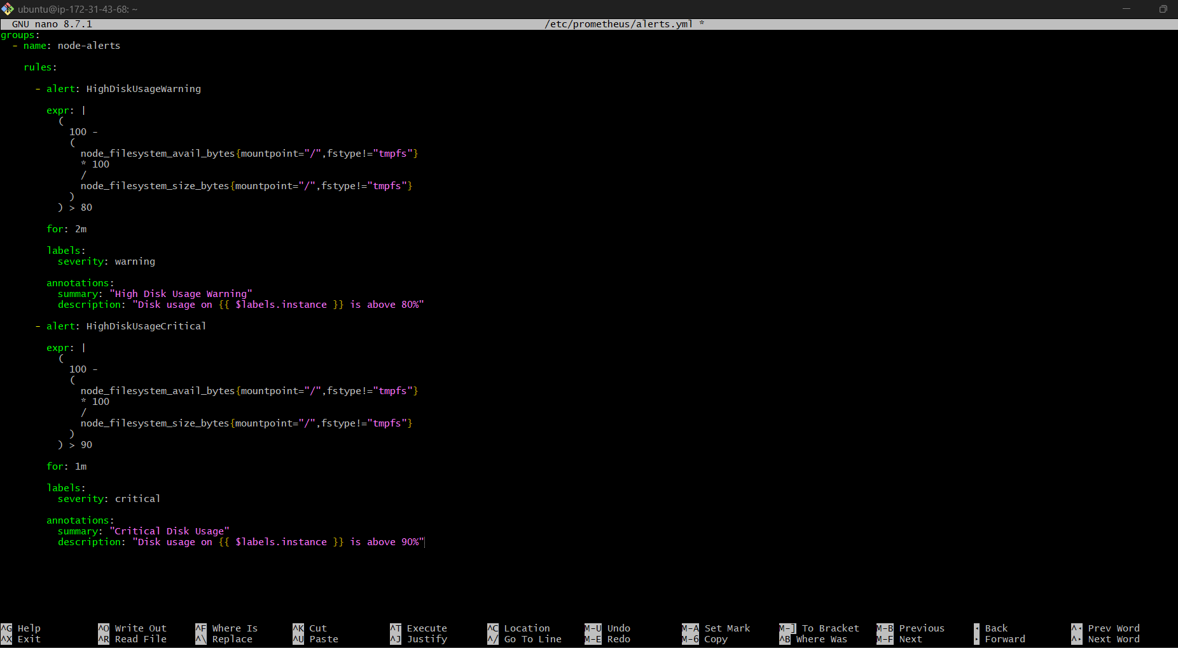

How Formula Works
Disk usage formula:
Used % = 100 - (Available * 100 / Total)
The expression monitors:
- Root filesystem /
- Ignores tmpfs

Step 4 — Validate Alert Rules
Run:
promtool check rules /etc/prometheus/alerts.yml
Expected:
SUCCESS
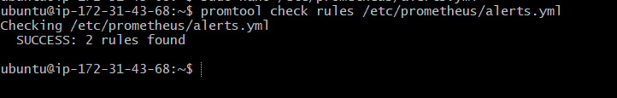

Step 5 — Verify prometheus.yml
Ensure this exists:
rule_files:
- "alerts.yml"
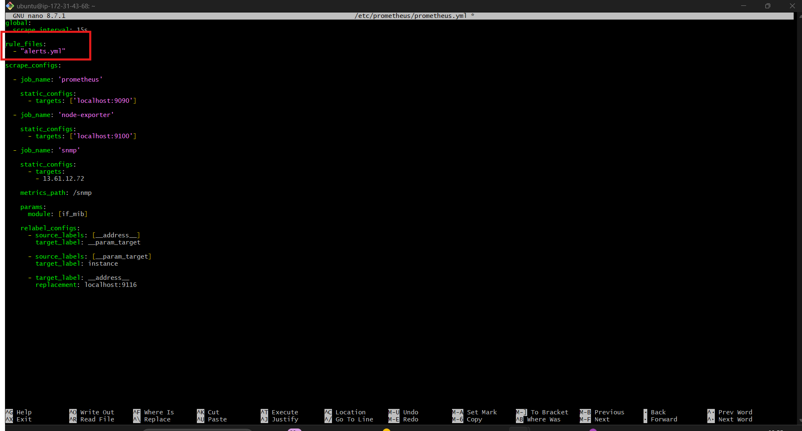

Step 6 — Validate Prometheus Config
promtool check config /etc/prometheus/prometheus.yml
Expected:
SUCCESS
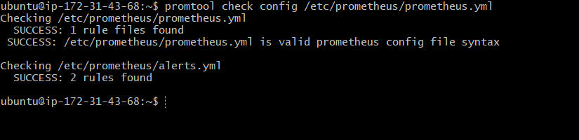

Step 7 — Restart Prometheus
sudo systemctl restart Prometheus
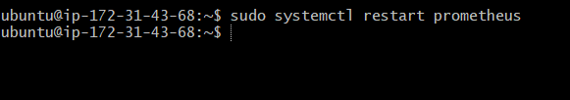
Check:
sudo systemctl status Prometheus
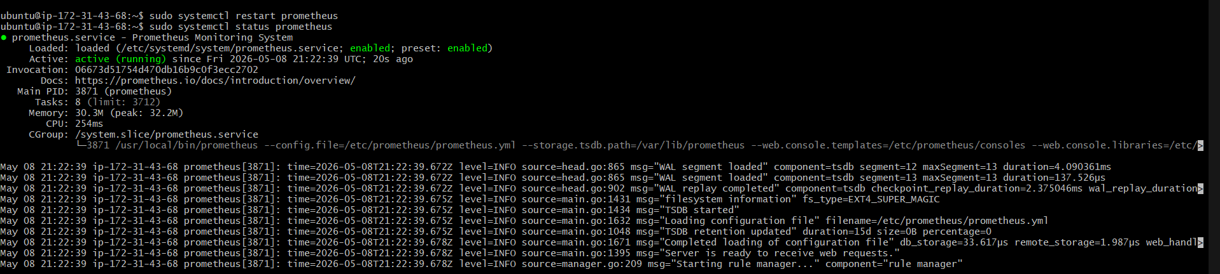

Step 8 — Verify Rules Loaded
Open:
http://<SERVER-IP>:9090/rules
http://13.61.12.72:9090/rules

You should see:
- HighDiskUsageWarning
- HighDiskUsageCritical

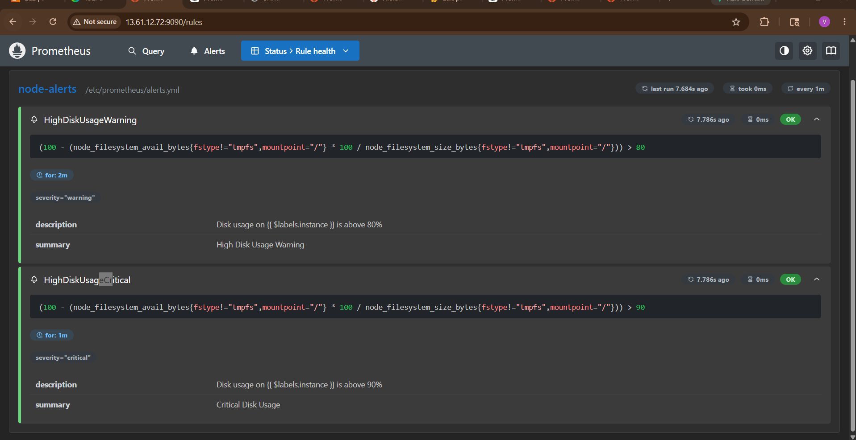
Step 9 — Test Alert
Create dummy large file:
fallocate -l 5G testfile.img
Or:
dd if=/dev/zero of=testfile.img bs=100M count=50
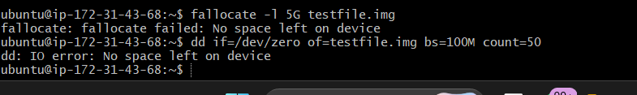
Disk usage increases.
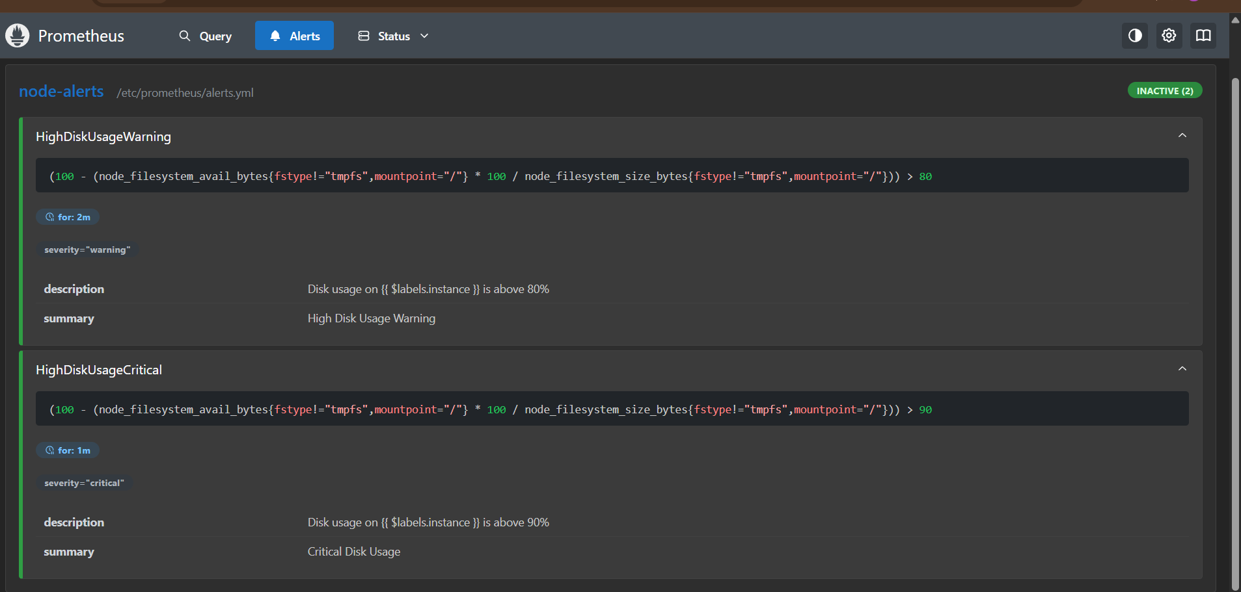

Step 10 — Verify Alert Fires
Open:
http://<SERVER-IP>:9090/alerts
Expected:
- Alert state = FIRING
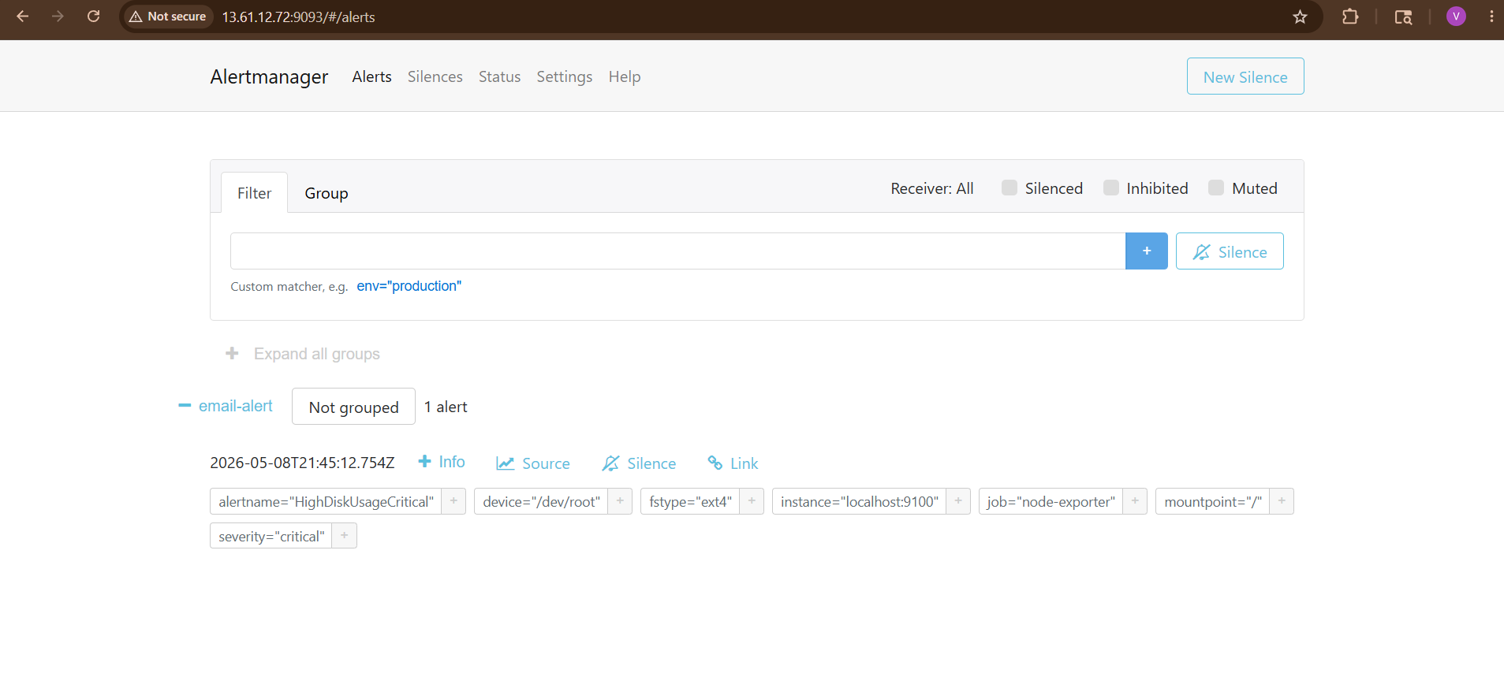

Step 11 — Verify Email Notification
Alertmanager sends email.
Check:
- Inbox
- Spam folder
Example:
[FIRING] HighDiskUsageCritical
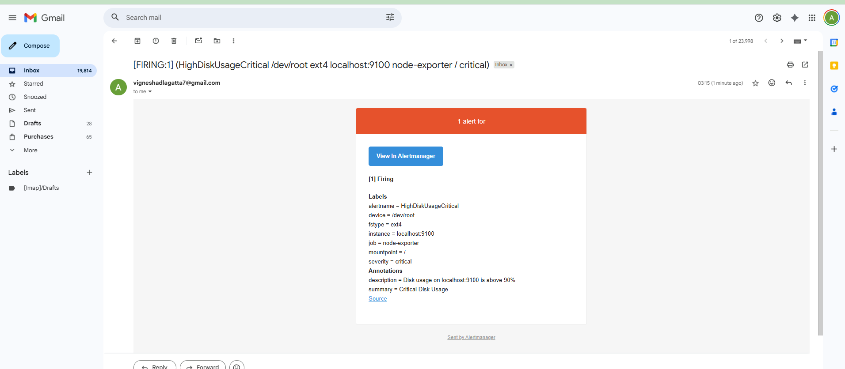
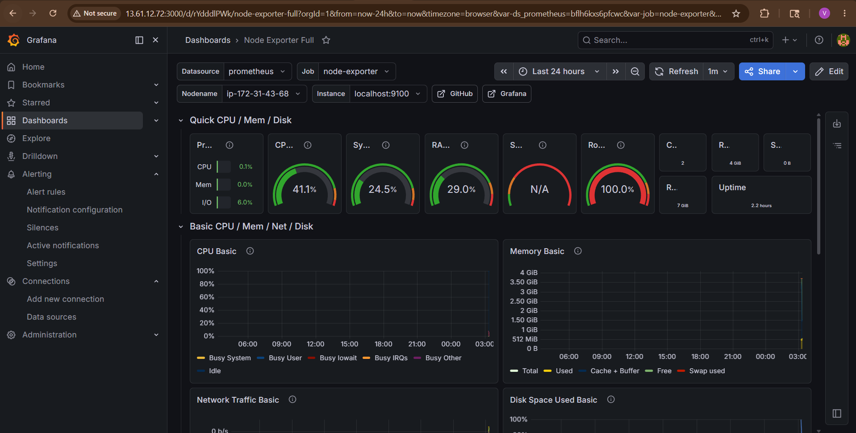

Step 12 — Remove Test File
rm -f testfile.img
Alert auto-resolves.
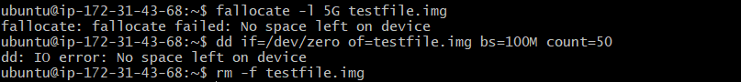
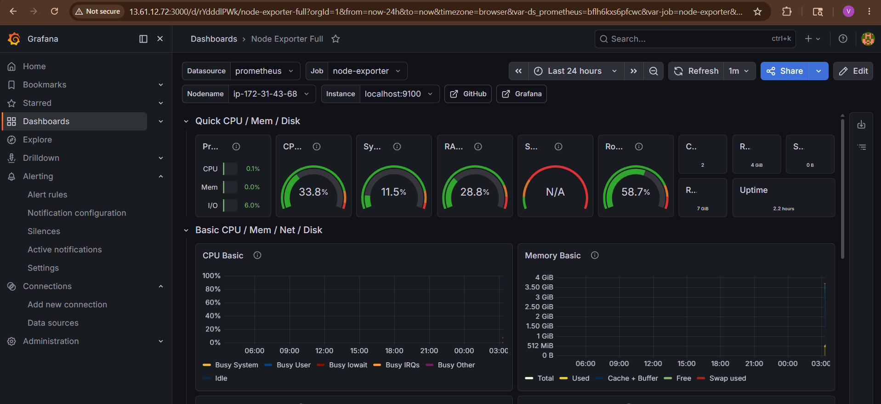

Advanced Disk Alert Example
Monitor all mount points:
expr: |
(
100 -
(
node_filesystem_avail_bytes{fstype!="tmpfs"}
* 100
/
node_filesystem_size_bytes{fstype!="tmpfs"}
)
) > 85

Inodes Alert
Very important in Linux.
- alert: LowInodes
expr: |
(
node_filesystem_files_free
/
node_filesystem_files
) * 100 < 10
for: 2m
labels:
severity: warning
annotations:
summary: "Low inode space"

Common Filesystem Metrics
Metric | Meaning
node_filesystem_size_bytes | Total size
node_filesystem_avail_bytes | Available space
node_filesystem_free_bytes | Free space
node_filesystem_files | Total inodes
node_filesystem_files_free | Free inodes

Production Best Practices
Use:
- Warning + Critical thresholds
- Exclude tmpfs/docker mounts
- Alert grouping
- Silence maintenance windows
- Grafana dashboards

Real Production Alert Flow
Disk Usage > 90%
|
Prometheus Rule Fires
|
Alertmanager
|
Email / Slack / PagerDuty
|
DevOps Team

9. Create a custom Grafana dashboard using Prometheus metrics for specific insights.

Create a Custom Grafana Dashboard Using Prometheus Metrics
This setup creates a custom Grafana dashboard using Prometheus metrics for:
- CPU usage
- Memory usage
- Disk usage
- Network traffic
- Server uptime
Instead of importing ready-made dashboards, you’ll build one manually — important for interviews and real DevOps work.

Architecture
Node Exporter
|
Prometheus
|
Grafana
|
Custom Dashboard

Prerequisites
Already installed:
✅ Prometheus
✅ Node Exporter
✅ Grafana
✅ Prometheus datasource added in Grafana
Prometheus datasource should show:
Data source is working

Step 1 — Login to Grafana
Open:
http://<SERVER-IP>:3000
Login:
- Username: admin
- Password: admin (or your changed password)
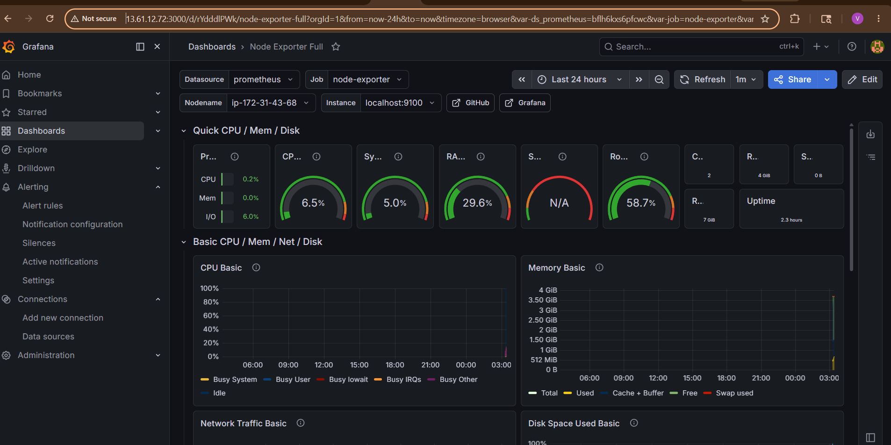

Step 2 — Create New Dashboard
Navigate:
Dashboards → New → New Dashboard
Click:
Add Visualization
Select datasource:
Prometheus
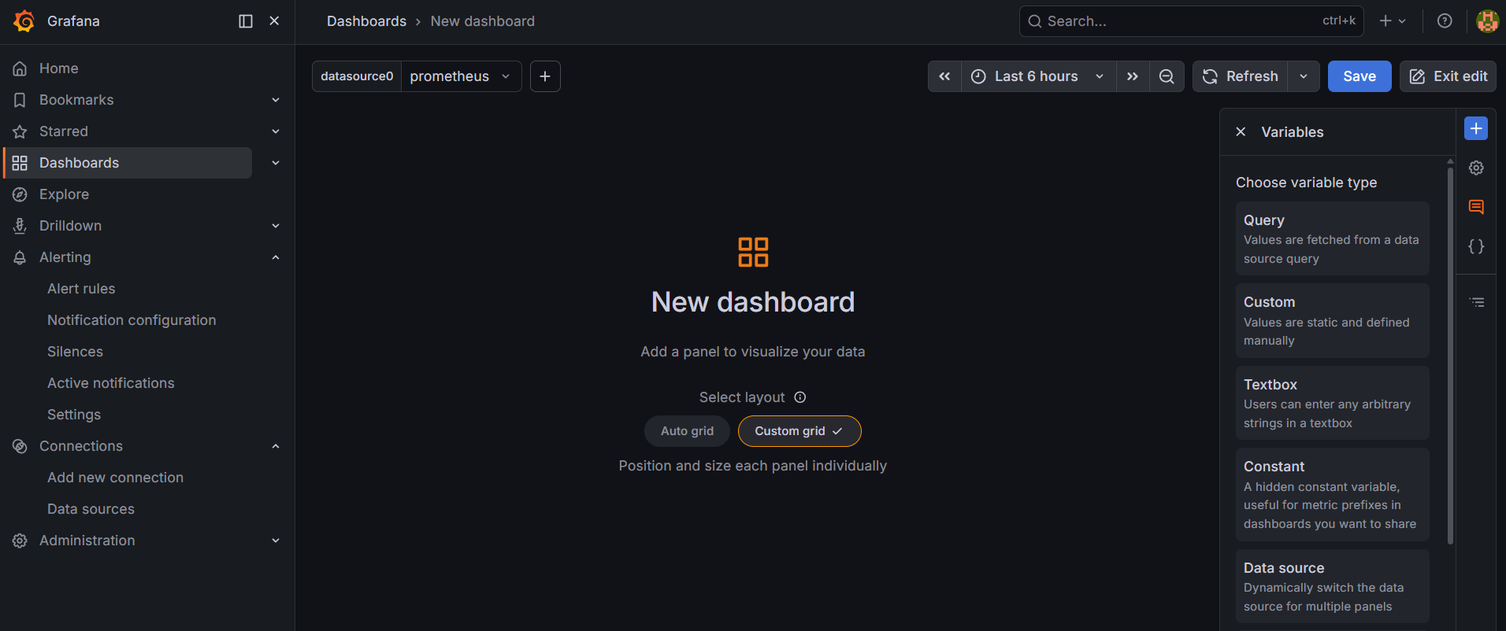

Step 3 — Create CPU Usage Panel
Panel title:
CPU Usage
Prometheus query:
100 - (avg by(instance)(irate(node_cpu_seconds_total{mode="idle"}[5m])) * 100)
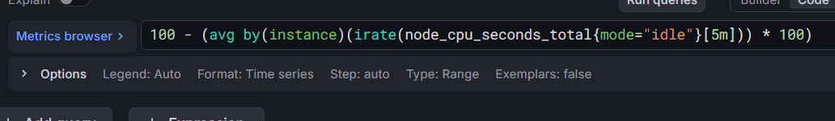
This calculates:
- Total CPU utilization %
Visualization:
- Time Series
- Gauge
- Stat
Recommended:
- Gauge
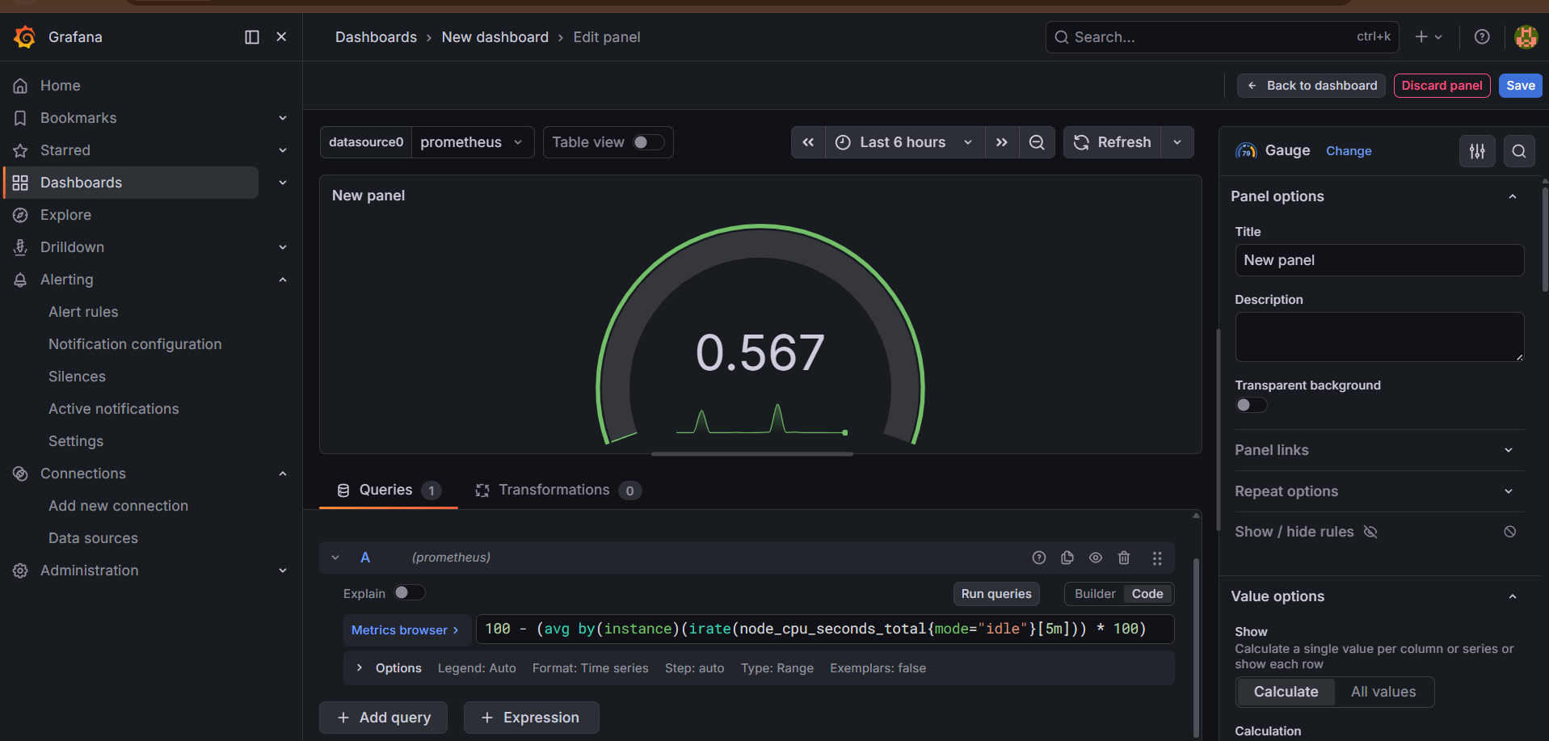

CPU Formula Visualization
CPU usage formula: $CPU Usage=100-(Idle CPU$
Step 4 — Configure Panel
Set:
- Unit → Percent (0-100)
- Min → 0
- Max → 100
Click:
- Apply
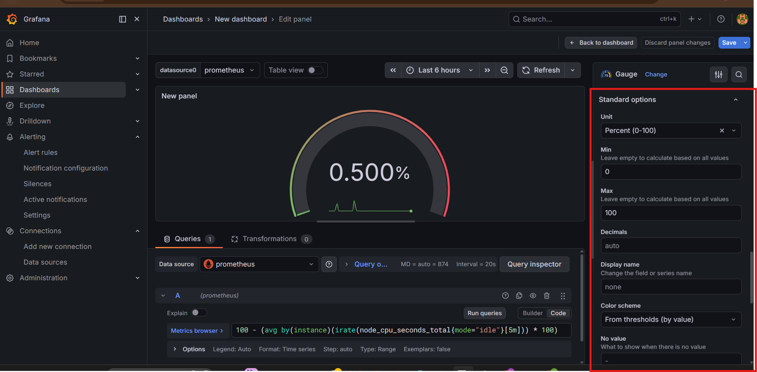

Step 5 — Create Memory Usage Panel
Add new visualization.
Title:
Memory Usage
Query:
(node_memory_MemTotal_bytes - node_memory_MemAvailable_bytes)
/
node_memory_MemTotal_bytes
* 100
Visualization:
- Gauge
Set:
- Unit → Percent
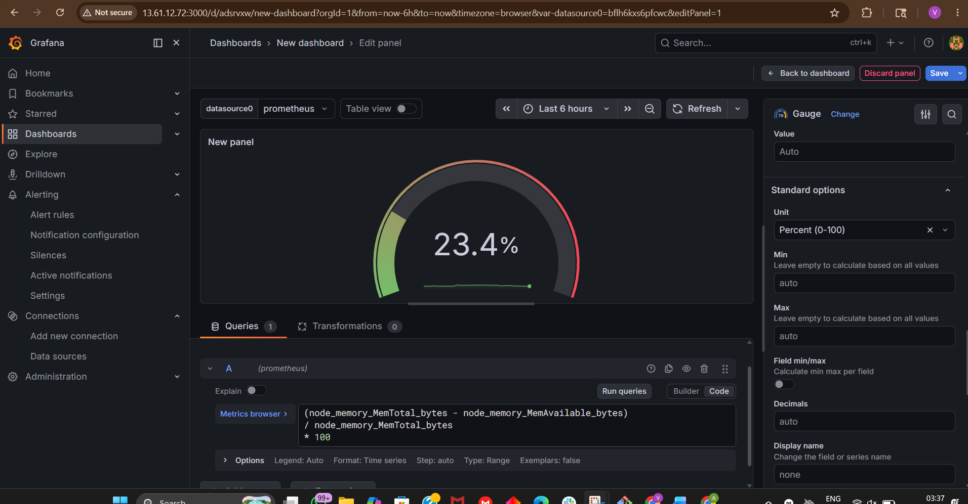

Memory Formula
$$Memory Usage=\frac{Used Memory}{Total Memory}×100$$

Step 6 — Create Disk Usage Panel
Add panel.

Title:
Disk Usage
Query:
100 -
(
node_filesystem_avail_bytes{mountpoint="/",fstype!="tmpfs"}
* 100
/
node_filesystem_size_bytes{mountpoint="/",fstype!="tmpfs"}
)
Visualization:
- Gauge
Unit:
- Percent
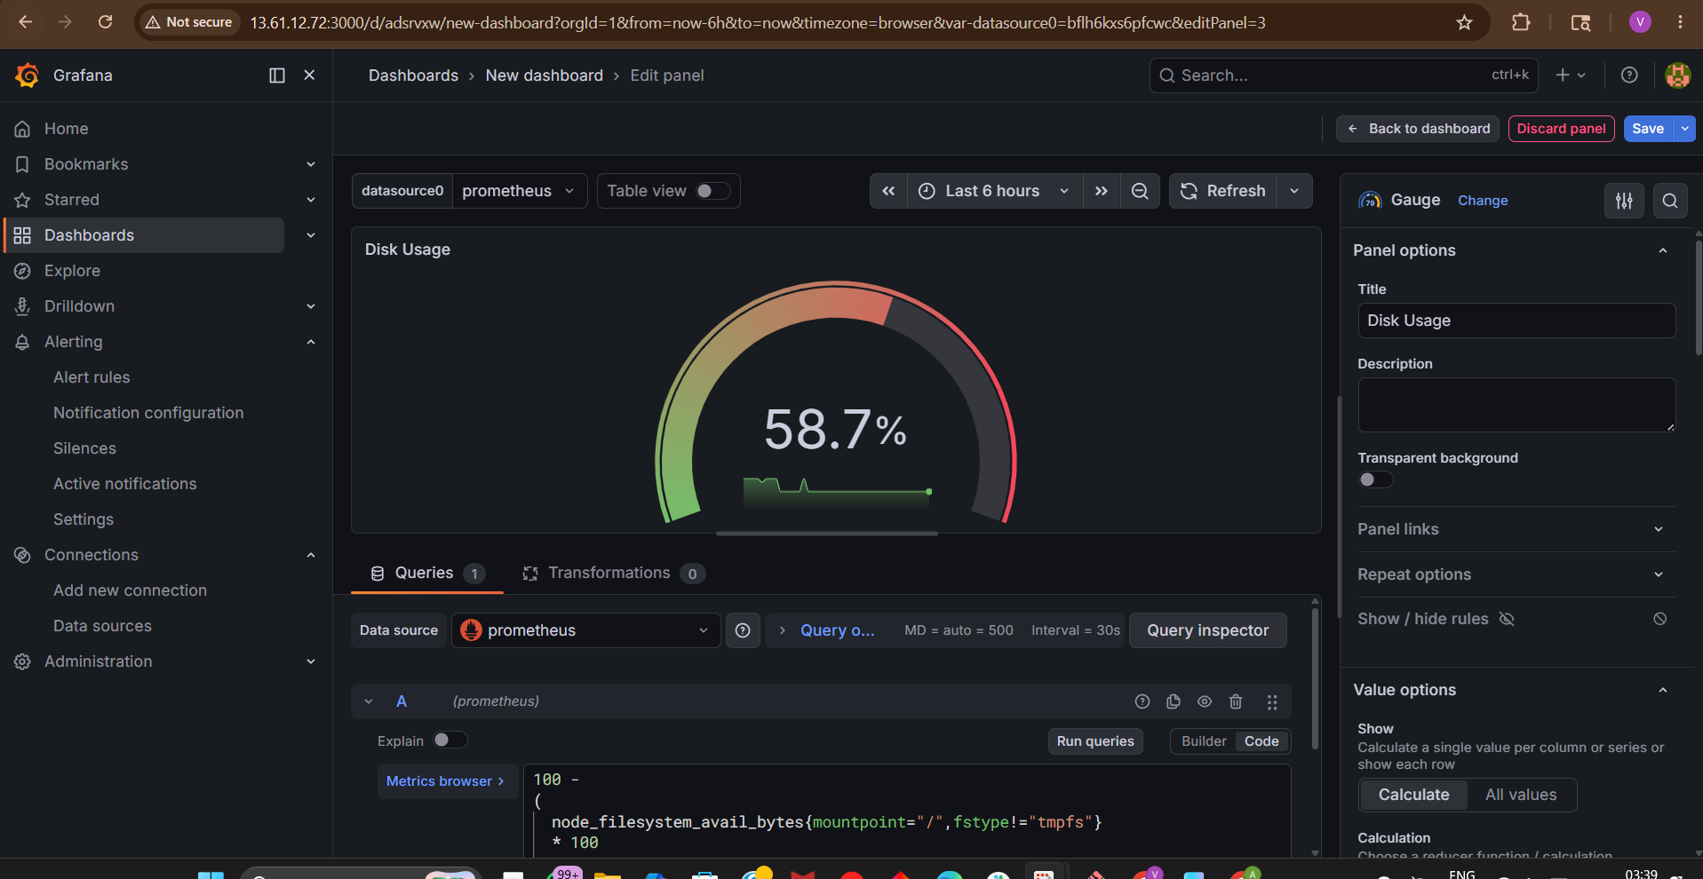

Disk Usage Formula
$$Disk Usage=100-\left(\frac{Available Space}{Total Space} × 100\right)$$

Step 7 — Create Network Traffic Panel
Add panel.
Title:
Network Traffic
Query:
rate(node_network_receive_bytes_total[5m])
Visualization:
- Time Series
Unit:
- bytes/sec
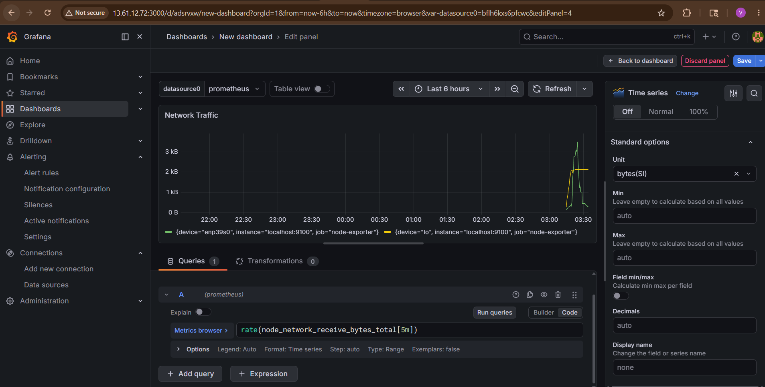

Step 8 — Create Server Uptime Panel
Add panel.
Title:
Server Uptime
Query:
node_time_seconds - node_boot_time_seconds
Visualization:
- Stat
Unit:
- seconds
- or duration
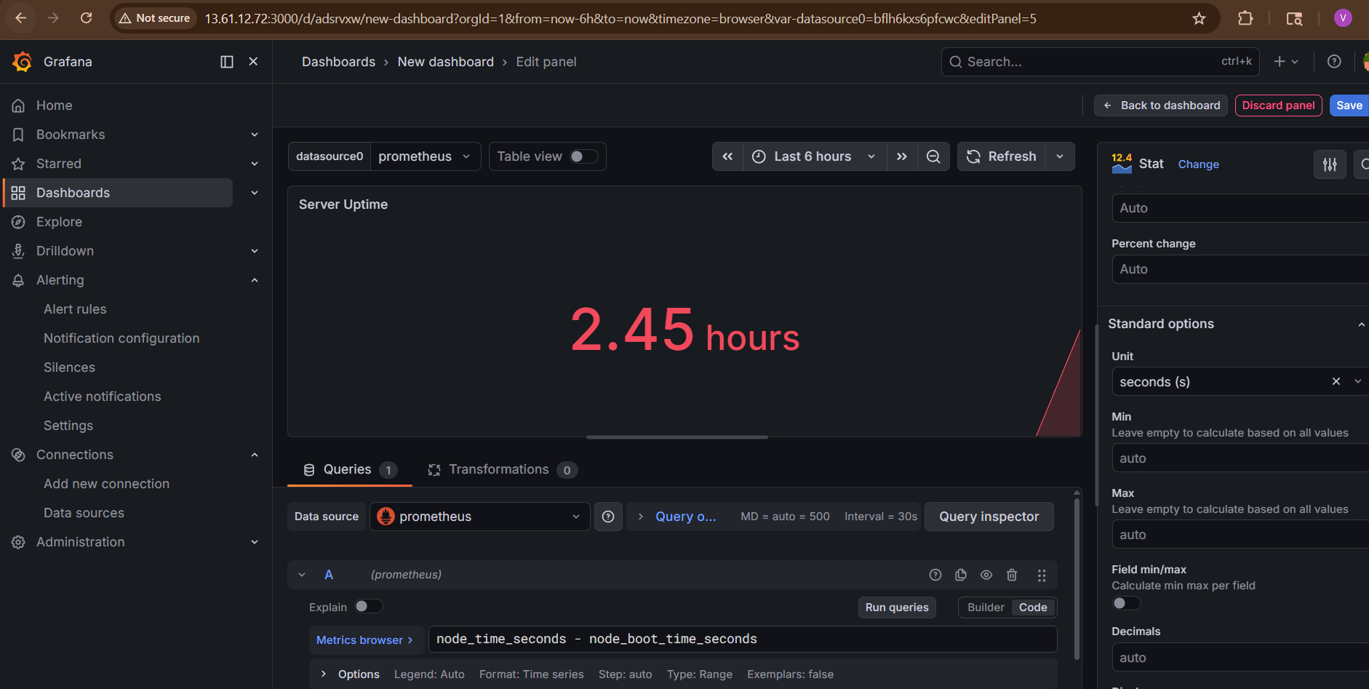

Step 9 — Arrange Dashboard Layout
Recommended layout:
+----------------+----------------+
| CPU Usage | Memory Usage |
+----------------+----------------+
| Disk Usage | Network |
+----------------+----------------+
| Server Uptime |
+---------------------------------+
Step 10 — Save Dashboard
Click:
Save Dashboard
Dashboard name:
Linux Server Monitoring
Click:
- Save
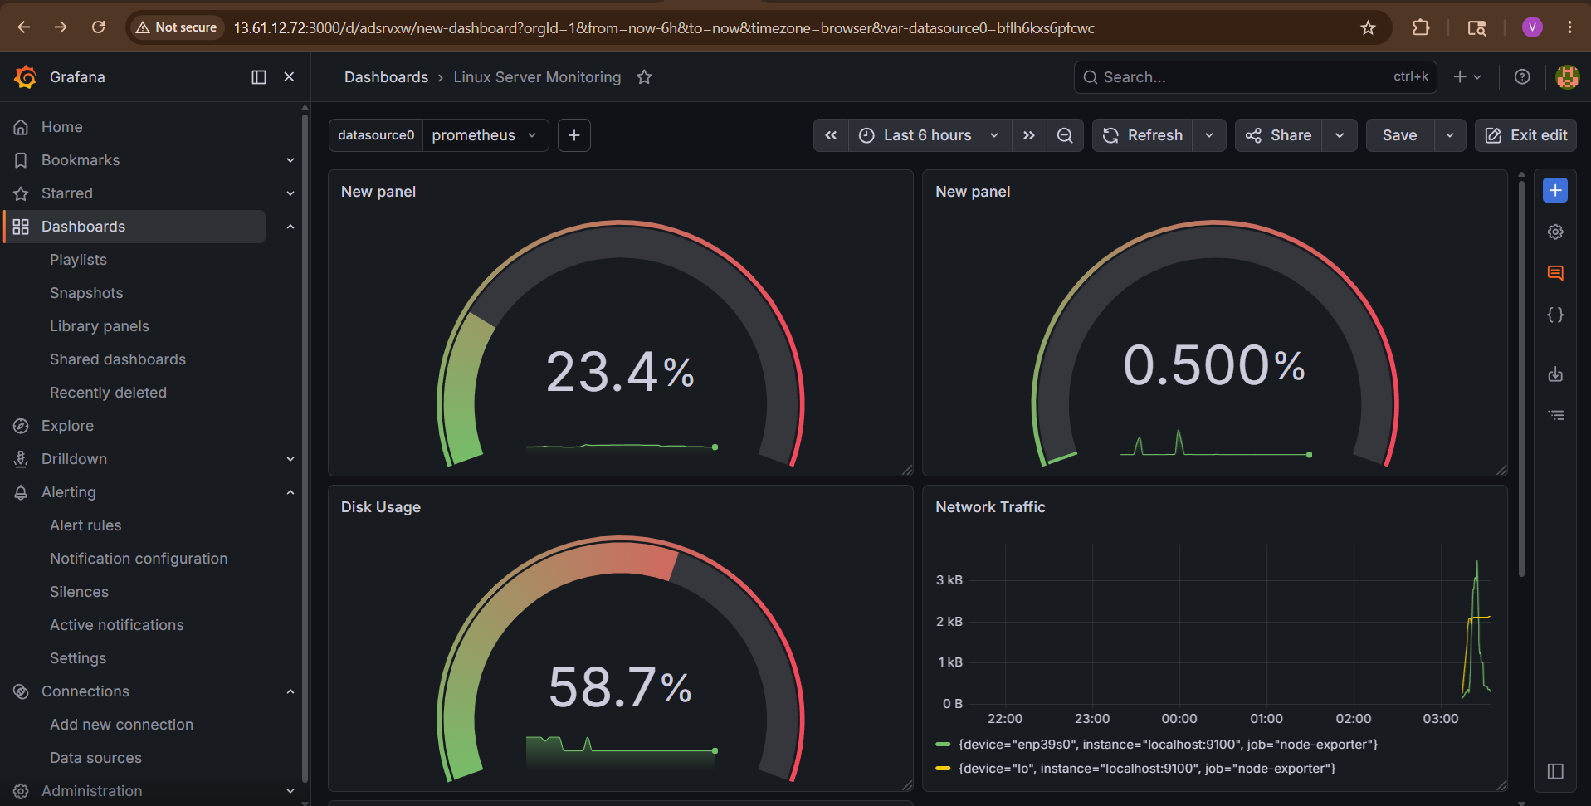
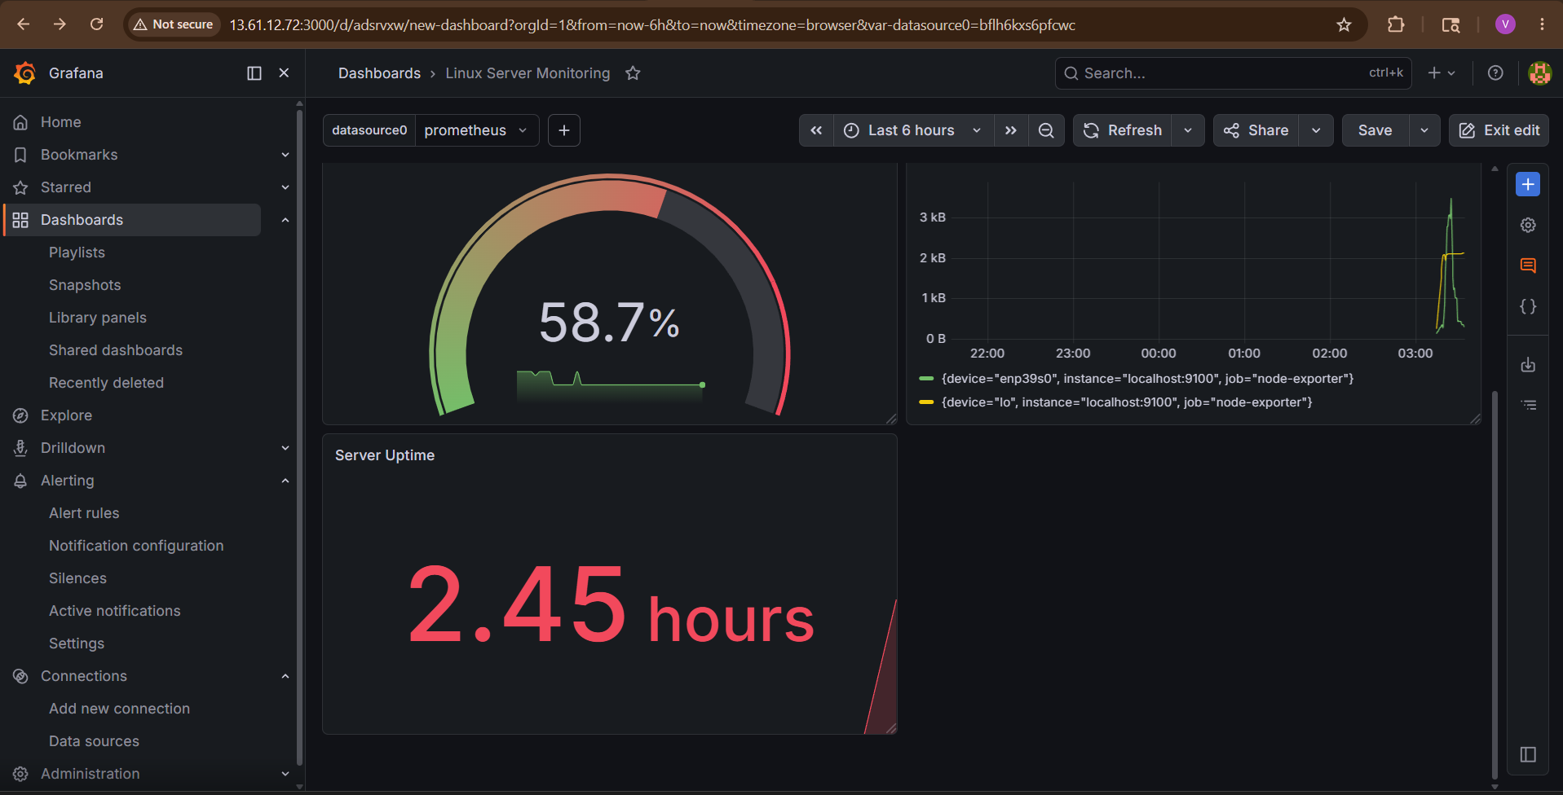

Step 11 — Add Variables (Optional Advanced)
Variables allow selecting servers dynamically.
Navigate:
Dashboard Settings → Variables
Add:
- Name: instance
Query:
label_values(up, instance)
Now dashboard supports multi-server selection.

Step 12 — Add Alert in Grafana (Optional)
Inside panel:
- Alert → Create Alert Rule
Example:
- CPU > 90%
Useful Prometheus Metrics
Metric | Purpose
node_cpu_seconds_total | CPU
node_memory_MemTotal_bytes | Memory
node_filesystem_size_bytes | Disk
node_network_receive_bytes_total | Network
node_load1 | Load average

Advanced Dashboard Ideas
You can create:
- Kubernetes dashboard
- Docker monitoring
- AWS EC2 dashboard
- SNMP network dashboard
- Application metrics dashboard
Recommended Visualization Types
Metric | Best Visualization
CPU | Gauge
Memory | Gauge
Disk | Gauge
Network | Time Series
Uptime | Stat

Production Best Practices
Use:
- Variables
- Repeating panels
- Alerting
- Folder organization
- RBAC
- Dashboard provisioning
- Git version control

Real Enterprise Stack
Servers
Containers
Kubernetes
Network Devices
|
Prometheus
|
Grafana Dashboards
|
Alertmanager

Final Result
You now have:
✅ Custom Grafana dashboard created
✅ CPU monitoring
✅ Memory monitoring
✅ Disk monitoring
✅ Network traffic visualization
✅ Real-time Prometheus insights
✅ Production-style observability dashboard

